APAS DIGITAL VIDEO CAPTURE PROCESS
February 2000

Introduction

The following instructions describe the installation and capture process using the SIIG 1394 DV-CAM KIT hardware and ULEADVIDEO STUDIO 3.0 software for use with the Ariel Performance Analysis System (APAS)/Microsoft Windows 98-Second Edition computer systems.

REQUIREMENTS

The following hardware/software is recommended for Digital Video capturing/editing.
- Pentium II 333-MHz computer (or equivalent)
- At least 64 MB RAM
- CD-ROM drive
- 200 MB of available hard disk space
- Video Card with 8 MB RAM (PCI or AGP)
- Windows 98 Second Edition or later.

Installation

Hardware:
The SIIG 1394 hardware is fully compliant with PCI Plug-n-Play 2.1. Follow the directions outlined in the SIIG 1394 DV-Cam Kit User’s Manual.

Software:
- Insert the software CD into the CD-ROM drive. Click on Start, and then Run. Type in X:\Utility\Setup\Autoexec.exe and click on “OK” (where X is the CD-ROM drive letter).

- Choose “Install Ulead VideoStudio 3.0” and follow the on-screen instructions to complete the installation. It is recommended to install Netshow Tools 3.0 and Quick Time 3.0 utilities that are also located on the CD. For additional information on the Ulead VideoStudio software, double-click on the Read Me icon in the Ulead VideoStudio startup menu.

NOTE: APAS computers, with the DV option, purchased directly from Ariel Dynamics, Inc. already have the hardware installed and the software options configured. Additionally, these systems have tested the DV capture hardware and software for correct operation.
Digital Video Capture Process

- Connect the 4-pin connector of the 1394 DV cable (i.Link cable) to the camcorder and power on the camcorder in the PLAY mode (the DV tape should already be inserted in the camcorder). Connect the other end of the DV cable to the IEEE 1394 Firewire capture board. The camcorder should be recognized by the system.

- Double-click on the UleadVideo Studio icon located in the APAS-System folder (or on the Windows desktop). This will open the UleadVideo Studio capture/edit software.

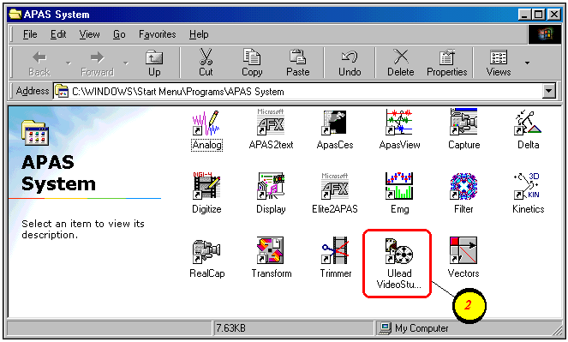

- Set the Device Control. This step is only required a single time. Once the Device control is set, the device control remains in memory until changed by the user.
- Select Global Commands button
- Select Device Control
- Set the Current Device to MS 1394 Device Control from the drop down list of capture drivers. This will allow the VideoStudio software to communicate directly with the JVC camcorder by utilizing the VCR-like buttons. NOTE: The camera must be powered on and connected, otherwise, this driver will not be available.
- Select OK to proceed.

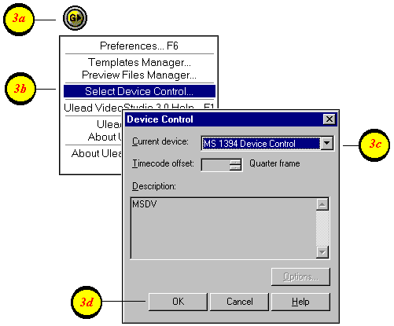

- Change the selected codec. This step is only required a single time. Once the desired codec is set, it remains in the template until changed by the user.
- Select the Global Commands button to make any changes to the selected template.
- Select the Templates Manager command
- The recommended template for the JVC GR-DVL9500 digital camcorder is AVI, 720x480 resolution, 29.97fps, DV NTSC. Click on this template and then select the EDIT button.
- Select the Compression tab and select the desired codec. The recommended codecs are either the Indeo 5.04 codec or the Morgan Multimedia MJPEG codec The user can also adjust the compression quality at this menu.
- Select the OK button to return to the Templates Manager menu.
- Select the CLOSE button to proceed.

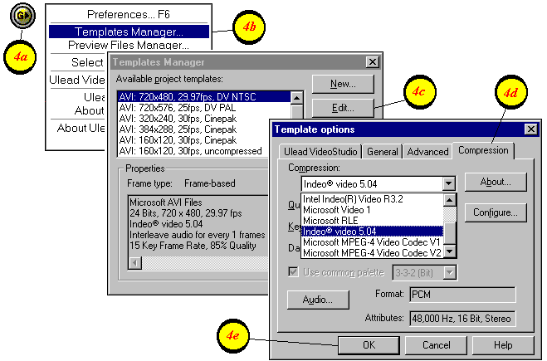

- Create a New Video Project.
a. Select the New Project icon.
- Type the name, subject, path and any other descriptive information. NOTE: The hard disk drive on computers supplied by Ariel Dynamics is partitioned into several logical drives. In this case, the E:\ drive has been reserved for storing the video files.
- Select the template with the desired settings. The recommended template for the JVC GR-DVL9500 digital camcorder is AVI, 720x480 resolution, 29.97fps, DV, NTSC with either the Indeo 5.04 codec or the Morgan Multimedia MJPEG codec. Refer to step #4 above for instructions on changing the template/codec settings.
- Select the OK button to proceed.

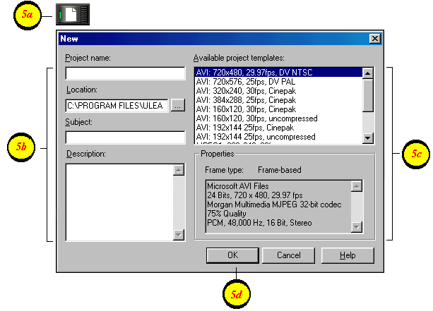

- Use the mouse and click the VCR buttons to position the videotape prior to the desired starting point. Then Pause the video. NOTE: The recorded image will not be displayed on the Ulead monitor until the Capture button is selected. However, the image can be viewed directly from the camcorder LCD display or by using an external monitor connected to the S-Video Out connector on the camcorder.
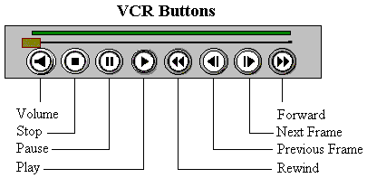

- Begin the Capture process.
- Select the Play button to start the videotape.
- Select the CAPTURE Video button prior to the desired starting point. This will start the image capture.
- Select the OK button to begin capturing video to the hard disk. If desired, this menu can be toggled on or off by selecting the F6 key on the keyboard, select the Ulead VideoStudio tab and then activate/deactivate the “Enable Press OK To Capture” option.
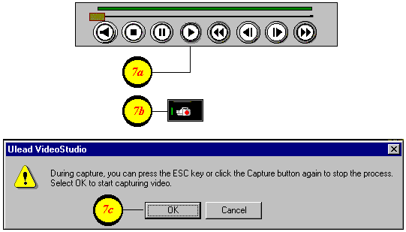

- Press the ESC key on the keyboard to stop the capture process.

- Select the PAUSE or STOP button to stop the videotape.

- Save the captured video file.
- Select the FINISH menu located in the upper right corner of the display.
- Save the video file by selecting either the Save or Save As buttons. The video is saved in Raw Digital Video (DV) format. The Ulead VideoStudio software provides the “Make Movie” option to compress the Raw DV file using the compression codec specified in the Global Options template. This process results in a smaller size video file, but is NOT recommended for APAS analysis. The Raw DV file will be compressed during the “trim” process in the Ariel Trimmer module.

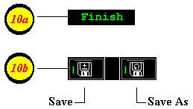

- Select the CAPTURE menu located at the top of the screen and repeat steps 6 through 10 to capture additional camera/control views. The captured AVI files are labeled sequentially (using the first 4 letters of the project name) and are stored in the location specified in Step # 5b. For example, if the project is named DISCUS, the captured video files would be named disc001.avi, disc002.avi etc…The user may choose to rename these files with a more descriptive name prior to performing the digitizing process.

- Exit the Ulead program
- 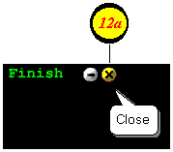Click the X in the upper right corner of the display to close and exit the Ulead VideoStudio program.

- The next step is to “trim” the captured video using the Ariel Trimmer module.

