Appendix 2 to Chapter 13:
The GREEN BROCHURE

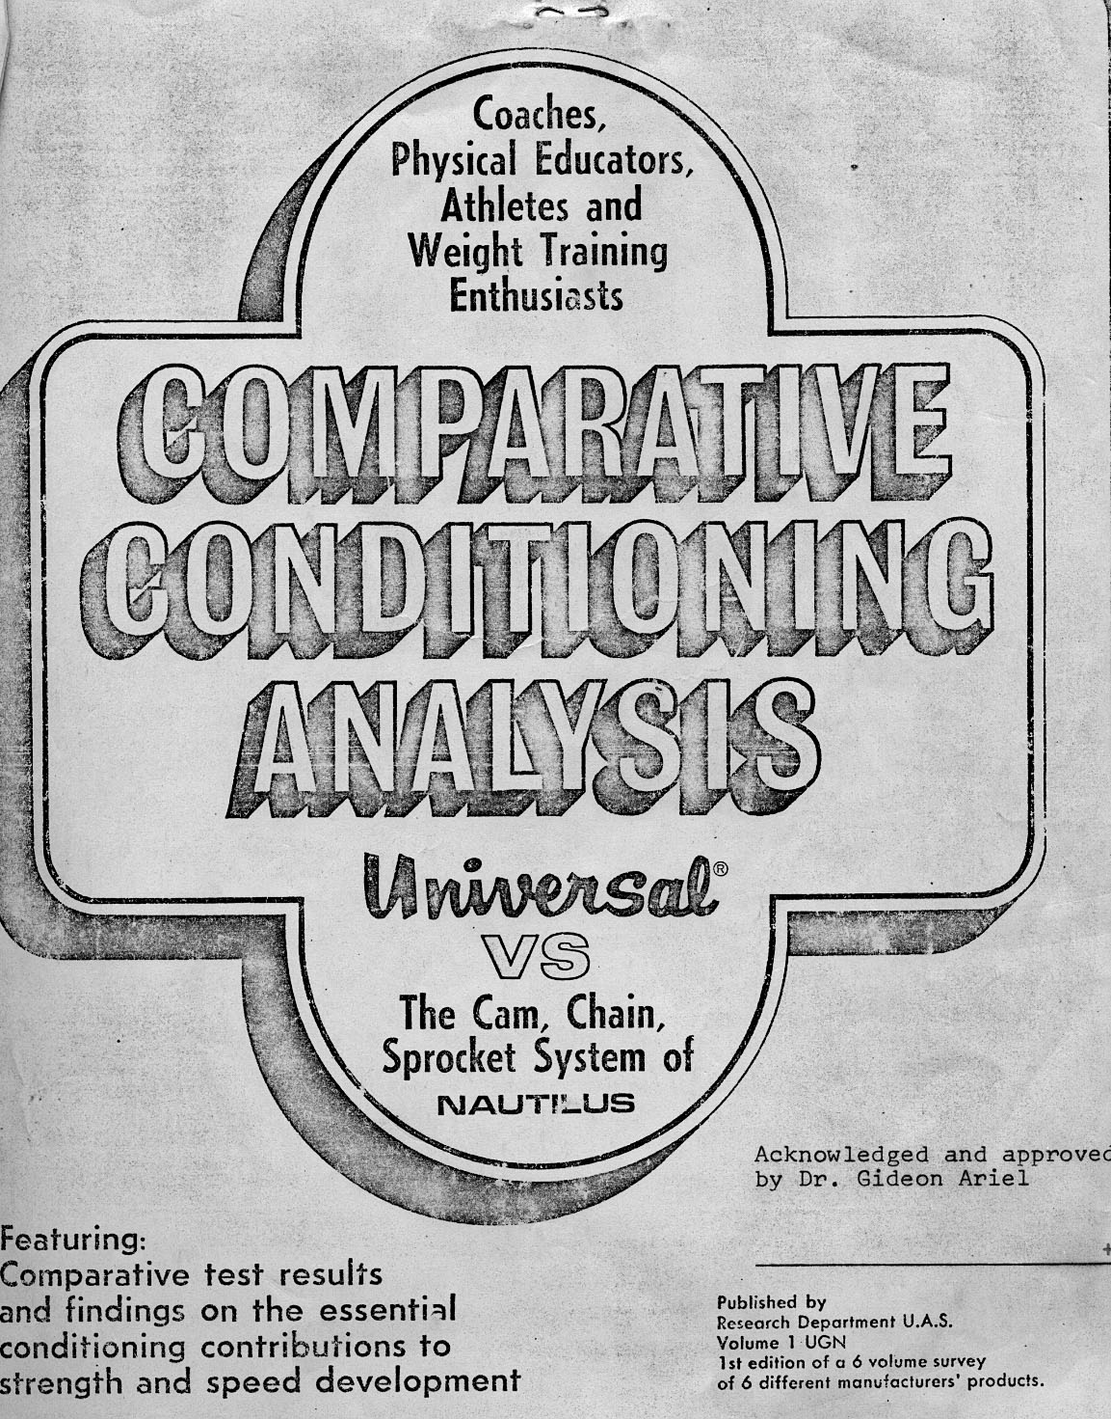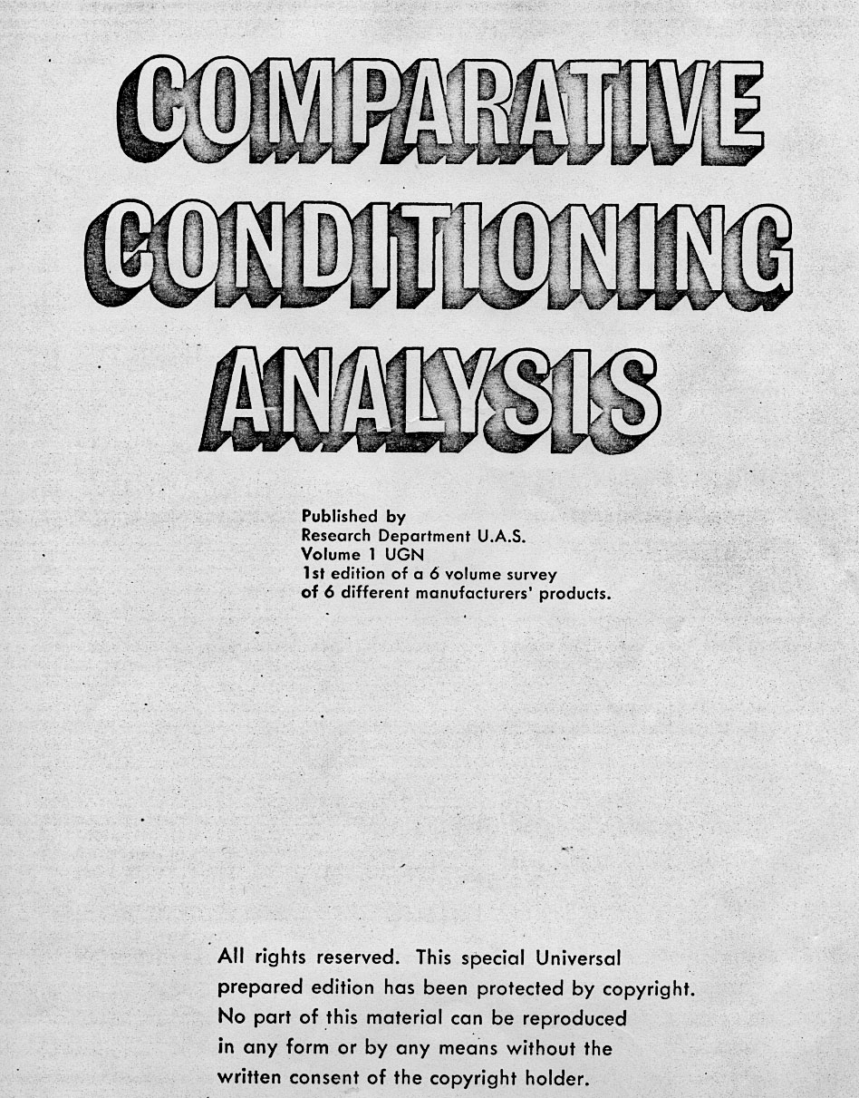

The purpose of this edition is two fold: (1) To present the significant conditioning differences as they presently exist between Universal and the Nautilus system; (2) To scientifically establish which system of conditioning is most capable of producing the highest level of human efficiency.
It is our further intention that the facts provided will stimulate the readers to further evaluate their present means of conditioning and to eventually resort to ONLY those methods which insure the greatest conditioning benefits.
The foregoing developments reflect the true findings from actual scientific assessments of lifting performances as they occurred on the two systems of conditioning in question. These findings will provide a sound understanding and overview of the essential differences between the two systems and will further provide a comprehensive and up-to-date source of useful data on problems related to specific conditioning theories.
We are again indebted to Chuck Coker, Harold Zinkin, Dr. Gideon Ariel for his
ingenious application of Computerized Biomechanical Analysis, Ed Burke and chief engineer Kenneth Gustafson. Along with their professional assistance and the combined efforts of our entire staff you can be assured that Universal will continue to develop only the finest conditioning equipment that provides for the greatest degree of physical improvement.
Universal will also continue in its efforts to provide you with ONLY the most-up-to-date facts in conditioning and hum an performance so that all may share the common thrill that comes with new ideas and the satisfaction that results from seeing greater progress in the efficiency of man and his movements.
Copyright© 1974 by Universal Athletic Sales

INTRODUCTION:
Since the beginning of modern weight training, there have been vast improvements in both the design and function of various resistive systems. Progress can mainly be contributed to man's quest for an easier and more comfortable means of assuring maximum muscular development.
This quest has given birth to many different conditioning systems, which have had their own unique but, somewhat, mystical conditioning theories. For the most part, many of these systems and theories were short-lived, as their development was largely due to mere speculation and guesswork which may have been derived from little or no practical experience.
Today, the theory in conditioning and equipment design has often been referred to as "variable" resistance. Variable resistance refers to a resistance intensity which is capable of increasing or decreasing to accommodate man's changes in leverage and muscular force. The theory is obviously physiologically correct, however, the majority of conditioning machines on today's market are not capable of performing as required. Despite the many failures that do exist, manufacturers have resorted to making wild conditioning claims to lure customers into believing conditioning miracles will occur. Unfortunately, many have fallen for these promotional gimmicks, only to be extremely disappointed with the actual end results.
This study will be the first scientific attempt to determine the true conditioning value of the Universal and Nautilus variable resistance systems and their related conditioning theories. The word scientific has often been misused, however, in this case, it refers to computerized biomechanical analysis — the perfected science which investigates the effect of internal and external forces upon living bodies.
The following conclusive findings will again provide the reader with the true conditioning effectiveness presently provided by the Universal and Nautilus systems. The conclusive Nautilus findings may also hold true, in some degree, for other manufacturers using similar components.
For those who have been searching for scientific comparisons rather than visual inspections arid unsubstantiated claims, this will be a welcomed change!

In order to scientifically evaluate the Universal Gym and the Nautilus conditioning machines, it is necessary to establish the standards by which they should be analyzed. These essential standards must be incorporated into the design of conditioning equipment if superior athletic performances are to be achieved:

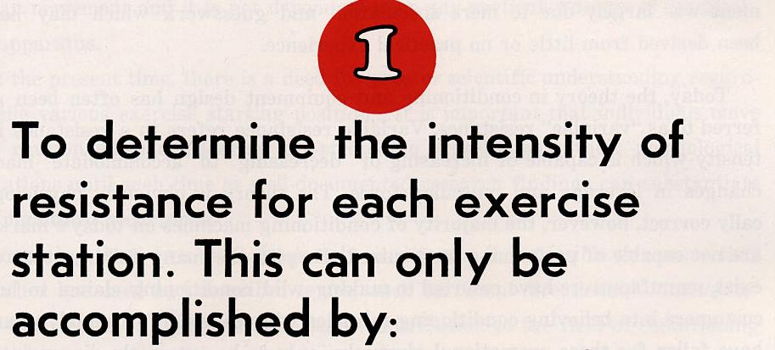

- An accurate assessment of man's biomechanical system.
- An accurate assessment of the variability of kinematic and kinetic factors imposed by the apparatus including its mass and inertias.
The evaluation of the resistance intensity provided by Universal and Nautilus can be determined by the muscular efforts generated by the body segments at each particular exercise station. Actual muscular force data will be provided on Universal and Nautilus exercise stations and direct comparisons will be made when applicable.

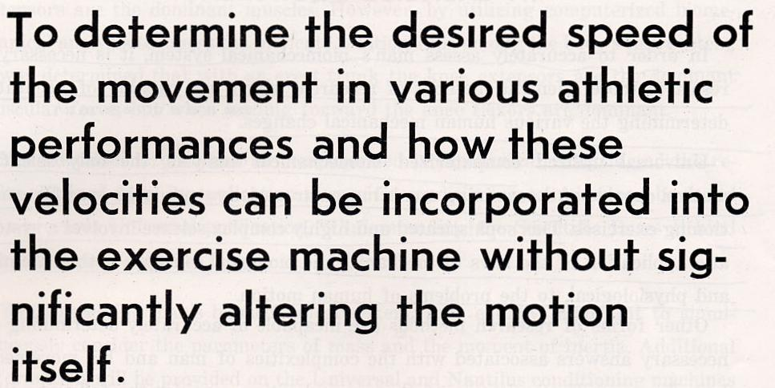
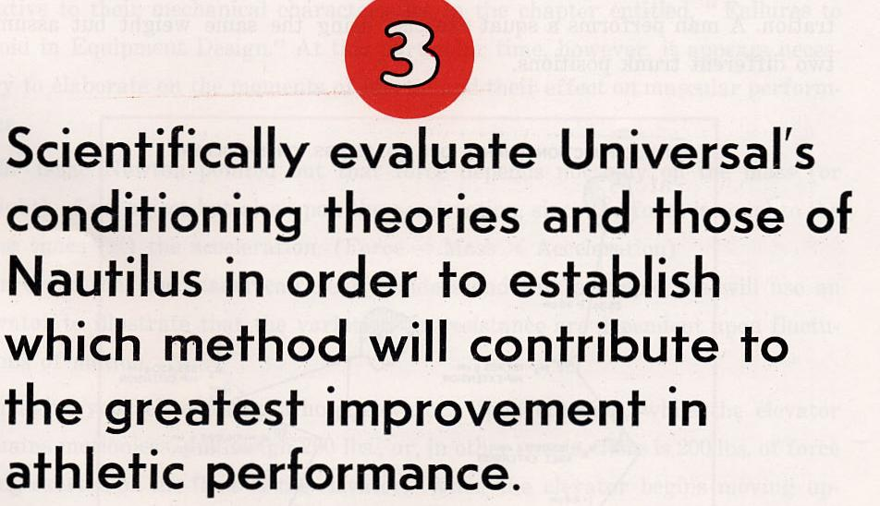

The comparative analyses of the two systems involving these scientific standards will clearly substantiate which of the two products is superior for athletic and human performance.

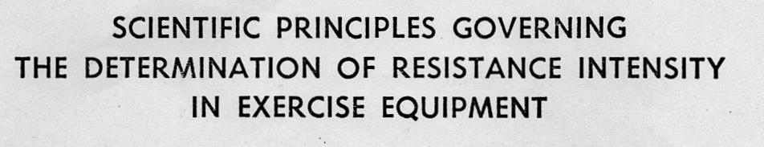

In order to accurately assess man's biomechanical system, it is necessary to resort to those scientific methods of research which are capable of accurately determining, the various human mechanical changes. (12-30, 45, 46, 48, 131, 180-195, 203, 207)
Universal utilized computerized biomechanical analysis, the only scientific method capable of determining man's muscular resistive needs in specific conditioning exercises. This sophisticated and highly complex science involves a systematic application of the laws of mechanics and biological concepts, both anatomical and physiological, to the problems of human motion.
Other forms of research methods are incapable of accurately determining the necessary answers associated with the complexities of man and his movements. In order to understand some of these complexities, consider the following illustration. A man performs a squat exercise using the same weight but assuming two different trunk positions.

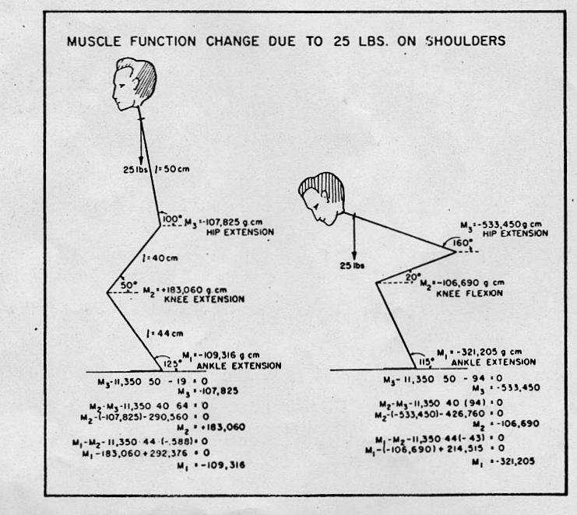

The traditional kinesiological approach utilizing conventional methods of determination of origins and insertions of various muscles may conclude that the knee extensors are the dominant muscles. However, by utilizing computerized biomechanical analysis to assess the intricate relationships among the body's link system, it was determined that with an erect trunk the knee extensors are the dominant muscular force, but when leaning forward the knee flexors are dominant.
More detailed information on computerized biomechanical analysis and the results obtained from its application to specific conditioning exercises can be found in a previous Universal publication, "Understanding the Scientific Bases Behind the Universal Centurion."
While assessing man's biomechanical system, it is equally important to simultaneously consider the parameters of mass and the moment of inertia. Additional information will be provided on the Universal and Nautilus conditioning machines relative to their mechanical characteristics in the chapter entitled, "Failures to Avoid in Equipment Design." At this particular time, however, it appears necessary to elaborate on the moments of inertia and their effect on muscular performance.
Sir Isaac Newton pointed out that force depends not only on the mass (or weight) of an object but also upon the acceleration, since the force is equal to the mass times (X) the acceleration. (Force = Mass X Acceleration)
In order that the reader can clearly understand this principle, we will use an elevator to illustrate that the variations in resistance are dependent upon fluctuations of motion.
Imagine yourself entering a hotel elevator. Upon entering, while the elevator remains motionless, you weigh 200 lbs., or, in other words, there is 200 lbs. of force being exerted on the floor of the elevator. When the elevator begins moving upward, the elevator starts from 0 velocity and increases in speed. From experience one may recall a sensation of being forced down or of feeling heavier as the elevator continues upward. The passenger feels himself pressing down on the floor with a force which is greater than when he and the elevator were at rest, and this phenomenon is commonly observed by most elevator riders. We can measure this sensation by having the passenger stand on a scale in the elevator while the elevator ascends at a slow speed (2 ft./sec.2). Observing the dial on the scale for the 200 lb. person, it would now read 212.5 lb.!!
The reader can easily compute this result by using the following formula:

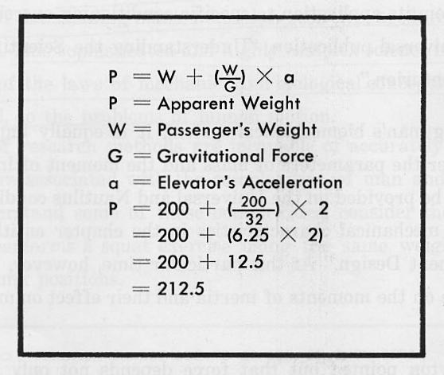

As the elevator approaches its final destination and slows down (-2 ft./sec.2), then the 200 lb. passenger feels lighter and often experiences the sensation that he is continuing upward without the elevator. In this particular stopping situation the 200 lb. person would observe the scale reading at 187.5 lb.!
Human dynamics are concerned with man in motion and include any external implements with which he interacts. Both the object and any body part may resist changes of motion and these changes in motion are directly related to both the mass of the segment and its moment of inertia. For example, when lifting a 100 lb. barbell, it is generally assumed that the resistance applied to the body is 100 lbs. and that this barbell imparts a 100 lb. resistance throughout the complete range of motion. However, as in the case of the elevator, when the 100 lb. barbell is moving, the resistance it provides can vary from more than 100 lbs. to less than 100 lbs., depending upon the acceleration of the motion.
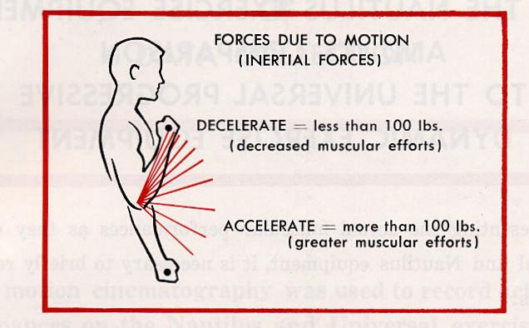

Since these inertial forces (acceleration and deceleration) affect the weight of the 100 lb. barbell, the magnitude with which the muscle has to contract is also affected. The less the inertial forces, naturally, the greater the muscular contraction and vice versa.
In order to effectively cope with the problems of inertia associated with resistive exercise equipment, it is essential to accurately identify their particular motion patterns. Since acceleration and deceleration are factors in all human movement and can be modified through mechanical means, they, therefore, must be incorporated in the design of the exercise equipment. In order to maintain maximum, muscular efforts, it is necessary that the resistance be varied throughout the range of motion according to the motion parameters and the biomechanical changes previously discussed.
The success of one's assessment of these important parameters can be clearly determined by calculating the actual muscular efforts as they occur on the various exercise stations. Actual force curve data will be provided in the following section on both Universal and Nautilus exercise stations. It can only be assumed that some scientific means of research was conducted by Nautilus in order to assess these essential parameters. However, it appears that Universal's scientific analysis is far superior to that of Nautilus, which enabled Universal to assess Nautilus exercise equipment with perhaps greater expertise than their original designers.

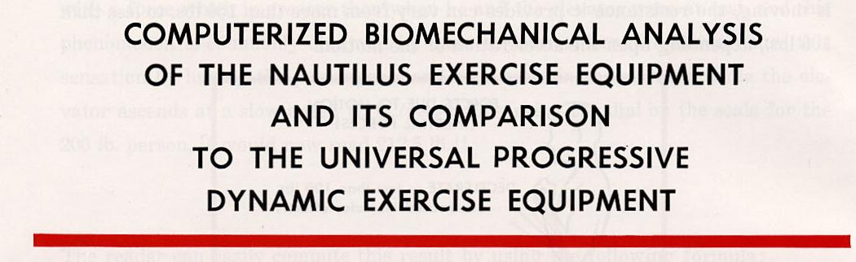

Prior to presenting the actual muscular performances as they occur on both Universal and Nautilus equipment, it is necessary to briefly repeat the following facts:
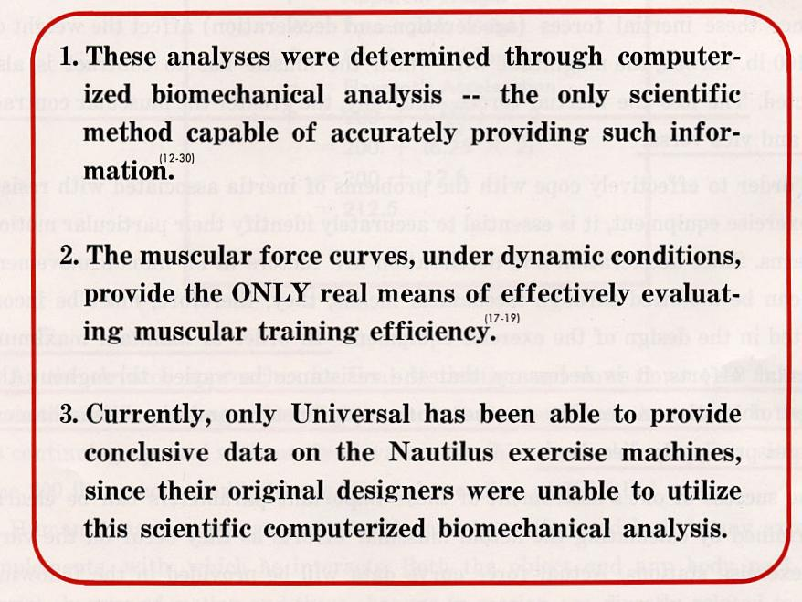

A brief introduction to the scientific procedures of data collection and processing along with the scientific interpretation of the moment curves will be provided in order that the reader can truly understand their scientific significance.

Slow motion cinematography was used to record actual exercise performances on the Nautilus and Universal exercise machines. Special tracing equipment allowed the data to be processed directly by a high speed computer. The appropriate computer programming resulted in a segmental breakdown of information of the whole exercise motion. Data obtained included the total body center of gravity, segment velocities and accelerations, joint forces, and moments of force. A unique feature of this analysis procedure yielded the significant contribution of each body segment to the whole motion and the interaction between the exercise equipment and the body's segments. This sophisticated program provided findings pertaining to the magnitude of the muscle action at each joint; the vertical and horizontal forces at all joints; the magnitude of the shearing force at the joint; the timing or coordination of motion between the segments; and the differences due to body builds. Each exercise possesses its own unique pattern of moments of force and body segment sequences enabling determination of the efficiencies and limitations of each particular exercise machine.
.
UNDERSTANDING MUSCULAR PERFORMANCE:
There are natural changes that occur in the human lever system while performing any movements that necessitate different levels of muscular involvement. (89)
If one were to completely examine the human body, it would be possible to determine the force ranges generated by the muscle. These ranges can vary from a light load to a maximum load. Variations in load result from different levels of muscle fiber recruitment. (64, 65, 68, 69)
When determining the maximum load that the muscle can lift, it is possible to observe that the muscle remains capable of moving this maximum load, regardless of its relative length (or degree of stretch). In other words, the relative force produced by a muscle does not significantly vary due to its constantly changing length. (16, 58-60, 90-95, 99)
However, when the muscle is returned to the human link system, the muscle force can vary throughout the range of movement while lifting the same maximum external load. This variation in muscular force results from the biomechanical advantages and disadvantages of the human lever system. When the human lever is in the position of the greatest biomechanical disadvantage, commonly referred to in weight training as the "sticking point," maximum muscular efforts are required at this particular point. When the human lever system is in its greatest advantage, the muscular force diminishes in order to lift the same maximum external load. Therefore, the variability that exists in muscle force is due primarily to the changing advantages and disadvantages created by the human lever system.
The following examples will illustrate the changes in muscular forces that do occur from different leverage positions.

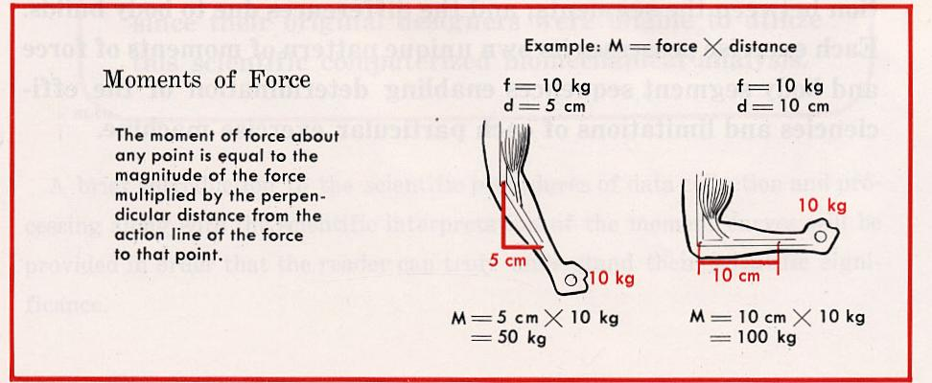

By understanding this important human phenomenon, it is relatively easy to establish that muscles work at their maximum potential during only a very small range of the total movement (normally only at the "sticking points").
In traditional weight training equipment there occurs a vast waste in muscle performance, which may range as high as 705 of the total movement. For example, the following force curve reveals what normally occurs when lifting near maximum resistance with a conventional Olympic bar. Data for plotting this force curve was provided by the computer output taken from the actual performance.

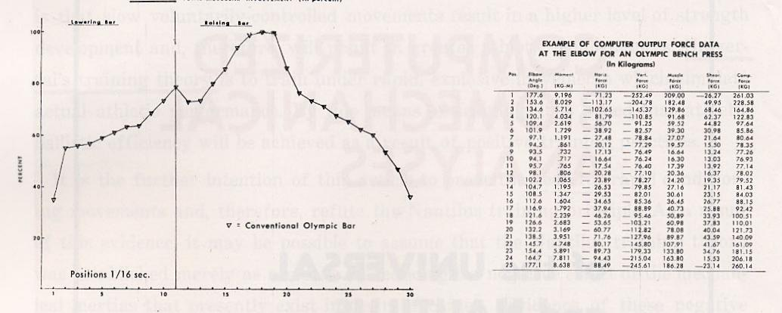

In order to develop maximum conditioning effectiveness, it is an absolute requirement to accurately vary the resistance. The variations in resistance intensity must occur only when there are biomechanical advantages or disadvantages which decrease or increase the required muscular efforts.
By varying the resistance accurately, it is possible to maintain the same degree of muscular involvement (efforts) throughout the entire range of movement.
In the following computerized biomechanical analysis comparison between the Universal exercise equipment and the Nautilus equipment, the force-mass-acceleration method of deriving the equations of motion of the body's segments was used to determine the values of the moments of force around the various body segments at successive instances in the performance of the exercise. Subsequently, the fluctuations in muscular performance were analyzed in relation to the total movement. (16)

The following muscular force curve pages contain frames taken from the original slow motion cinematography resulting in reproduction difficulty, however, the essential (lifting) body angles remain easily detectable.
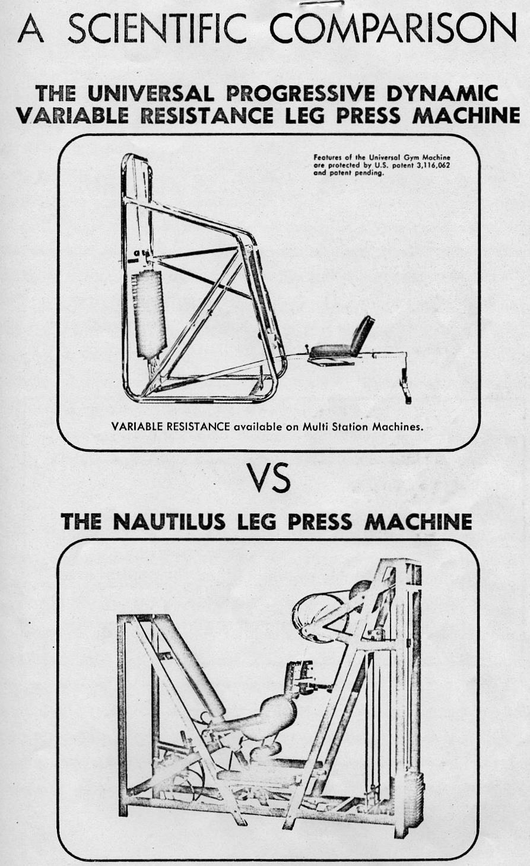
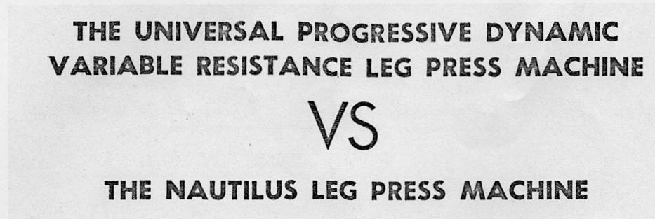

In order to scientifically evaluate these two leg press machines, it is necessary to define the standards which they should maintain.
It can be assumed that the leg press machine was originally developed in order to strengthen the leg extensors around the knee joint. In order to achieve this function, the ideal machine should provide for the following factors:

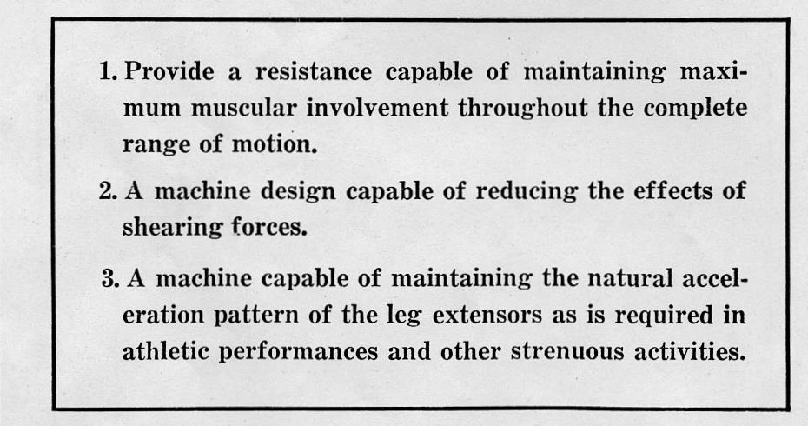

Actual computer outputs on the Nautilus leg press machine have been included along with a brief interpretation of their findings. (Universal computer outputs have been previously provided in an earlier publication, "Understanding the Scientific Bases Behind the Universal Centurion.")
The computer outputs provide the necessary data for plotting the actual muscular force curves. The muscular force curves are the only significant means of evaluating which machine is capable of insuring greater muscular performances (conditioning benefits).
The following muscle force curve for the Nautilus leg press machine reveals that the resistance provided fails to maintain maximum muscular efforts throughout the entire range of movement. Maximum muscular efforts are required only in the initial phase of movement and then the required muscular efforts diminish rapidly to a point of less than 10% muscular involvement (or exertion).
On the other hand, Universal is capable of maintaining a muscle performance level above 90% throughout the range of motion. Observing Universal's muscular force curve, one can see that the muscular efforts vary only slightly throughout the range of movement and yet never fall below 90%. This results in a far superior conditioning benefit to the leg extensor muscles.

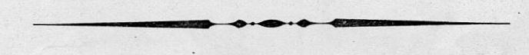

CONCLUSION: It is possible to assume that the failure to provide accurate variable resistance in the Nautilus leg press occurred as a result of their inability to accurately assess human movement and the other external motion parameters. Their lack of knowledge resulted in a machine incapable of accommodating the biomechanical changes necessary for maximum muscular performance. In addition, the mass of the machine's moving parts is capable of creating inertia forces which further reduce the required muscular efforts.
Universal, through accurately assessing man and machine, developed a far superior leg press machine resulting in near maximum muscular performance throughout the entire range of movement.
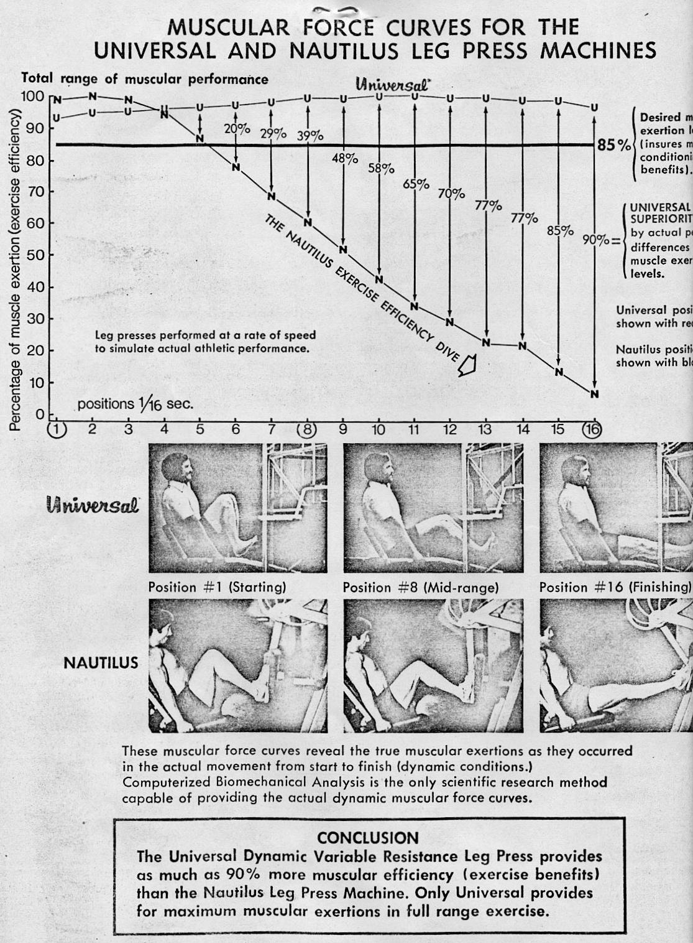
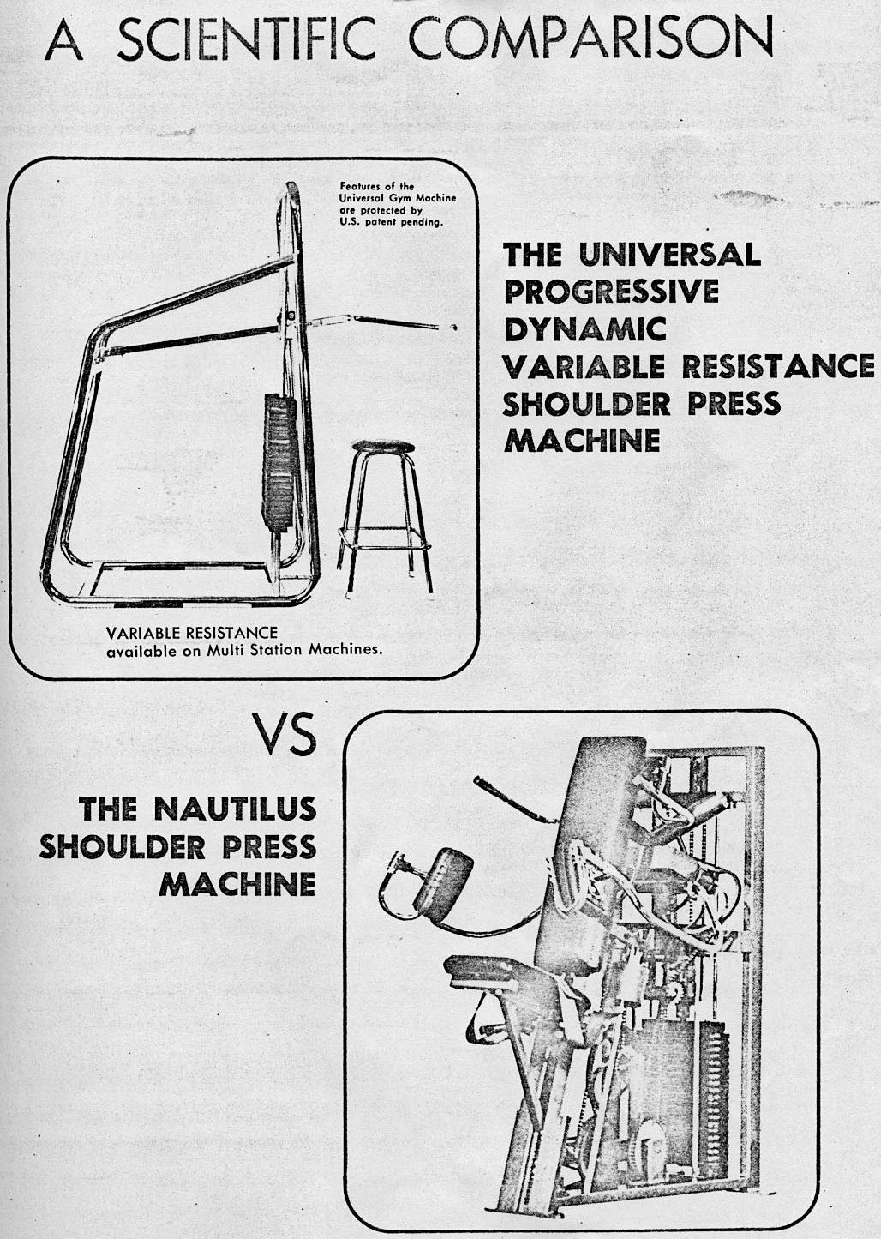
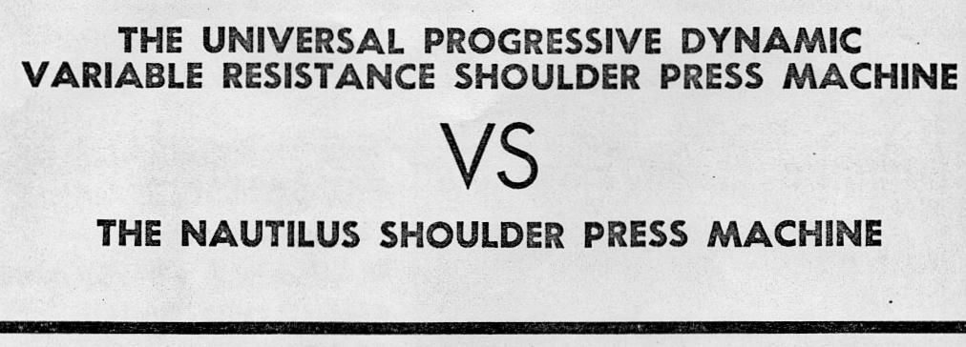

In order to scientifically evaluate these two shoulder press machines, it is again necessary to resort to the previous standards of (1) maintaining maximum muscular involvement in the complete range of movement, and (2) maintaining the natural accelerations of movement as found in athletic performances and other strenuous activities.
The shoulder press machine was developed primarily to strengthen the shoulder girdle muscles which normally play a significant role in most athletic and strenuous activities. In the shoulder press exercise, it is virtually impossible to identify the magnitude and the direction of the many separate muscle groups that function during a dynamic situation. (This limitation occurs in all multiple joint exercises.) In the shoulder joint there are various groups of muscles which act upon the shoulder joint as well as the synergistic function of the elbow extensors. Due to the complexities of these many muscles, it is necessary to take the sum (resultant muscle forces) of their total effort, which represents the amount of muscular involvement.
Actual computer outputs on the Nautilus shoulder press machine have been included along with a brief interpretation of their findings. Universal computer outputs were previously provided in the earlier publication, "Understanding the Scientific Bases Behind the Universal Centurion."
The force-mass-acceleration method was, again, used to determine the values of the torques at successive instances in the total movement pattern. Also, the variations in the pattern of movement as functions of time were investigated in relation to the kinematics (description of movement) and kinetics (forces due to movement) of motion.
The following graph represents the moment (muscle force) curve which denotes the total muscular involvement in percentages as it occurred throughout the entire range of the exercise. Observing the Nautilus' force curve, it is revealed that the machine provides for only 30% muscular efforts from positions 1 through 10, which is nearly half of the entire exercise movement. From position 10 until completion of the stroke, the resistance increases which provides for greater muscular efforts.
The Universal shoulder press machine insures more than 75% muscular involvement throughout the entire range of movement and over 90% muscular involvement for approximately two-thirds of the entire movement.

CONCLUSION: The exercise benefits, as revealed by the muscular force curves, indicate that the Nautilus shoulder press station has increasing resistance. However, the variation in their resistance is inaccurate in its intensity and occurs at the wrong time in the exercise stroke. The Nautilus cam profile has inaccurately dealt with the proper biomechanical requirements. Again, it is possible to assume that the conditioning deficiency in the Nautilus shoulder press is due to their inability to accurately assess the necessary biomechanical requirements for this particular exercise.
Universal, as a result of scientific research, developed a shoulder press machine which insures maximum muscular performance throughout the range of movement. The result of Universal's efforts is the only shoulder press machine capable of providing maximum conditioning effectiveness.

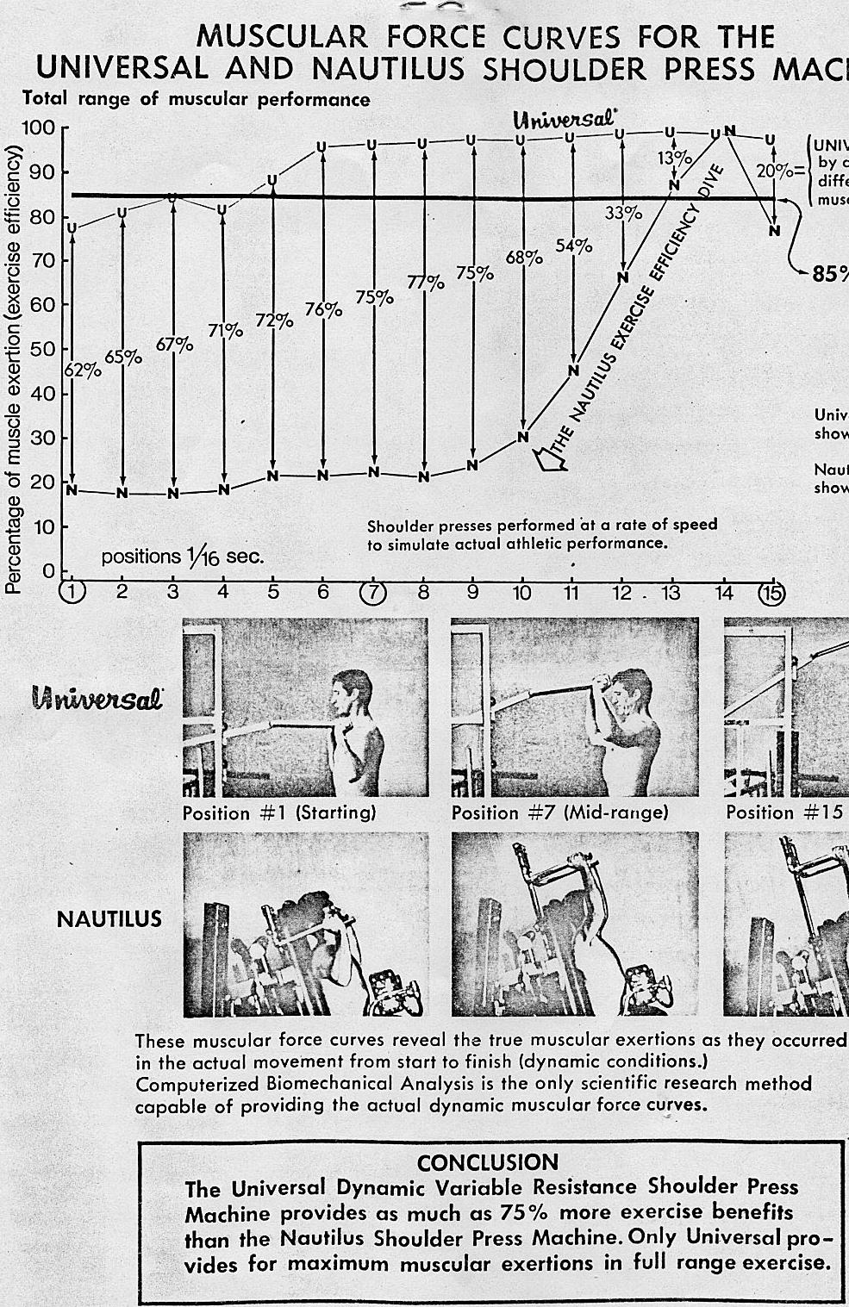
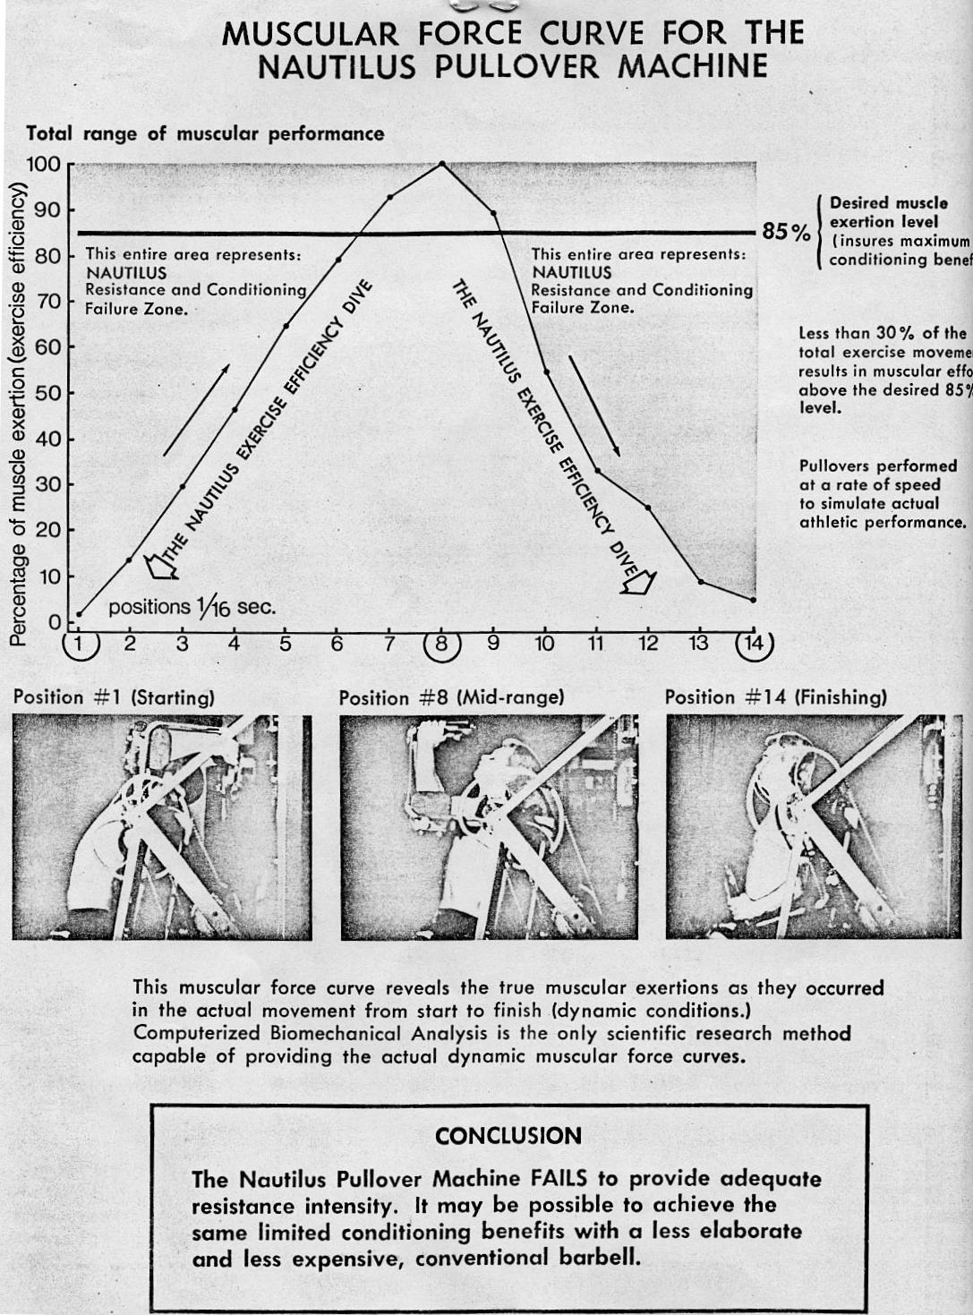
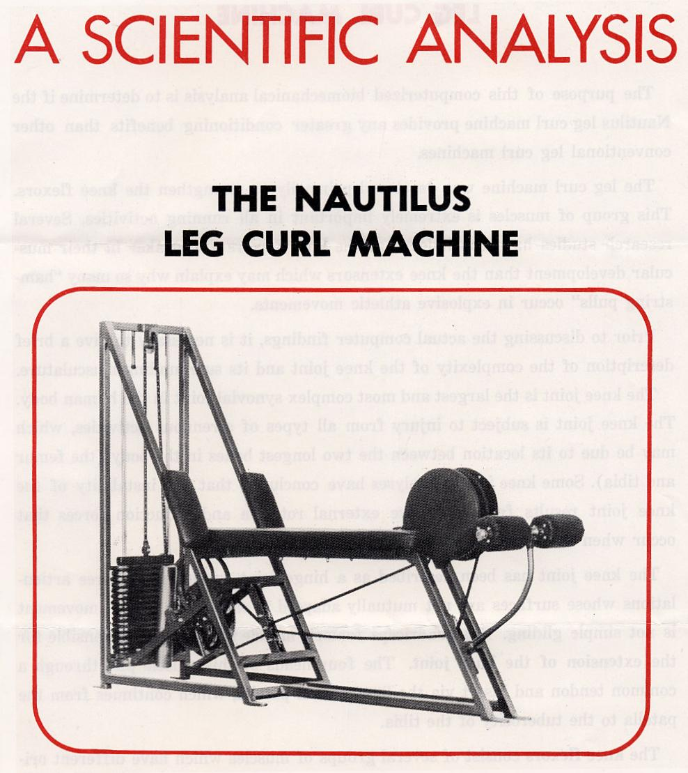

The purpose of this computerized biomechanical analysis is to determine if the Nautilus leg curl machine provides any greater conditioning benefits than other conventional leg curl machines.
The leg curl machine was developed primarily to strengthen the knee flexors. This group of muscles is extremely important in all running activities. Several research studies have concluded that the knee flexors are weaker in their muscular development than the knee extensors which may explain why so many "hamstring pulls" occur in explosive athletic movements.
Prior to discussing the actual computer findings, it is necessary to give a brief description of the complexity of the knee joint and its surrounding musculature.
The knee joint is the largest and most complex synovial joint in the human body. The knee joint is subject to injury from all types of strenuous activities, which may be due to its location between the two longest bones in the body (the femur and tibia). Some knee injury analyses have concluded that the instability of the knee joint results from excessive external rotation and abduction forces that occur when in a fixed weight-bearing position.
The knee joint has been described as a hinge joint consisting of three articulations whose surfaces are not mutually adapted to each other so that movement is not simple gliding. The quadriceps femoris muscle is primarily responsible for the extension of the knee joint. The four heads of this muscle pull through a common tendon and insert via the ligamentum patella, which continues from the patella to the tuberosity of the tibia.
The knee flexors consist of several groups of muscles which have different origins and insertions.
The movements around the knee joint are primarily flexion, extension, and internal and external rotation.
Considering these many complexities, it is most difficult to develop a machine capable of accommodating the many different muscular functions.
The computerized biomechanical analysis of the Nautilus leg curl machine will again evaluate the areas of total muscle involvement and the essential movement patterns (accelerations). The computer outputs provide substantial evidence as to the true effectiveness of this particular machine (see pages 45 and 46).
The following muscle force curve graph reveals that only maximum muscular efforts are required in the initial phase of movement. After the initial phase of the movement the muscular efforts diminish rapidly to a value of zero (0). Observing the computer output, a negative sign (—) indicates that the machine's moving parts create adverse inertial forces which sustain the movement instead of the muscle's driving force. This factor can also be determined by examining the following pictures taken in the actual dynamic sequence of the movement.

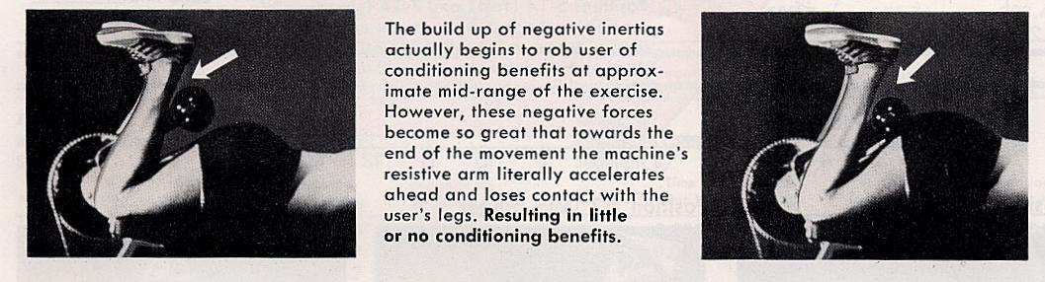

CONCLUSION:
The Nautilus leg curl machine fails to accommodate the biomechanical changes which results in limited ranges of conditioning effectiveness (benefits). The machine's moving parts create adverse inertial forces robbing the user of additional conditioning benefits. It is possible to assume that the mechanical failures of this machine resulted from the lack of accurately assessing the biomechanical and motion parameters.
The only effective resistance is provided in the early stage of the movement (approximately 40% of total movement).
It may be possible to achieve the same conditioning effects on conventional leg curl machines. At the present time, Universal is conducting scientific research necessary for the development of the optimal leg curl machine.
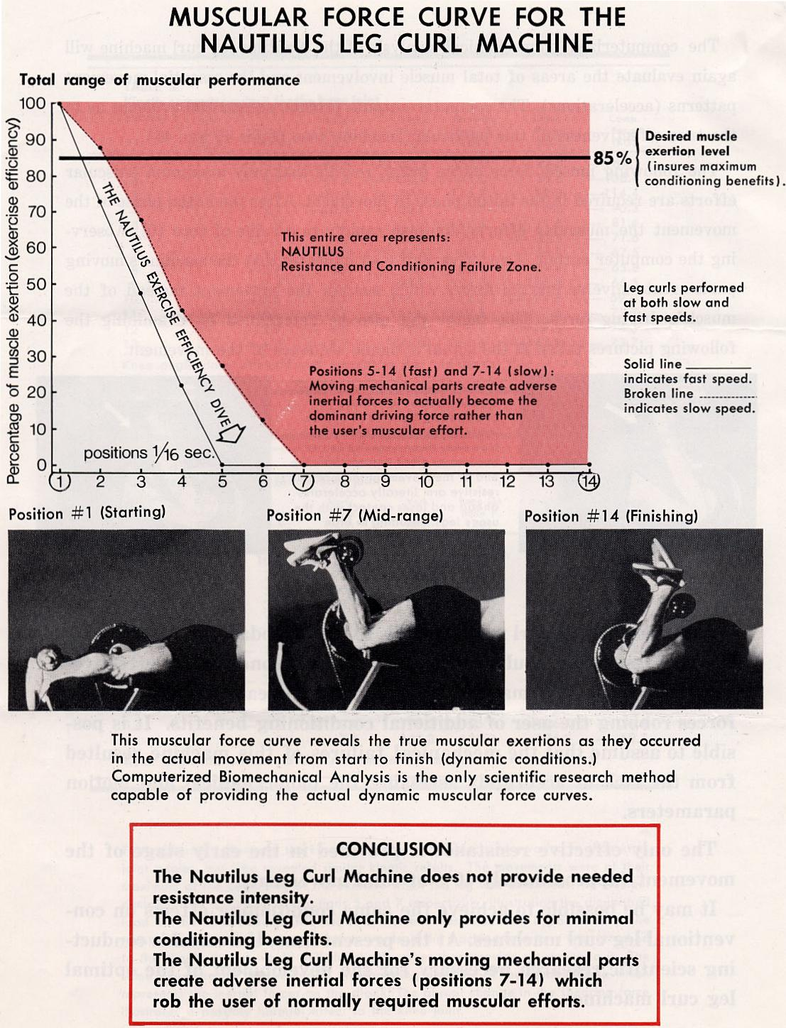
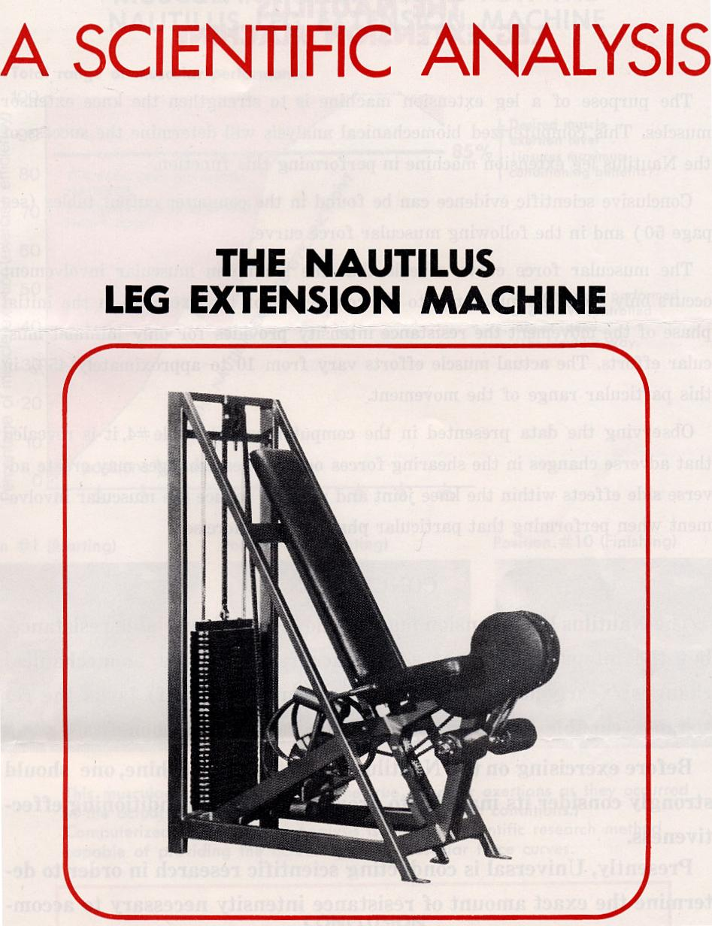

The purpose of a leg extension machine is to strengthen the knee extensor muscles. This computerized biomechanical analysis will determine the success of the Nautilus leg extension machine in performing this function.
Conclusive scientific evidence can be found in the computer output tables (see page 50) and in the following muscular force curve.
The muscular force curve reveals that the maximum muscular involvement occurs only from the mid range to the completion of the exercise. In the initial phase of the movement the resistance intensity provides for only minimal muscular efforts. The actual muscle efforts vary from 10 to approximately 45% in this particular range of the movement.
Observing the data presented in the computer output Table #4, it is revealed that adverse changes in the shearing forces occur. These changes may create adverse side effects within the knee joint and possibly reduce the muscular involvement when performing that particular phase of the exercise.

CONCLUSION:
The Nautilus leg extension machine does provide variable resistance, but the intensity does not adjust accurately to the biomechanical changes! Nearly half of the total movement (first half) lacks the resistance capable of insuring maximum conditioning benefits.
Before exercising on the Nautilus leg extension machine, one should strongly consider its inability to provide maximum conditioning effectiveness.
Presently, Universal is conducting scientific research in order to determine the exact amount of resistance intensity necessary to accommodate the biomechanical changes and external motion parameters.
This research will provide scientific data necessary for the development of the first leg extension machine capable of insuring maximum, muscular efforts throughout the complete range of movement.
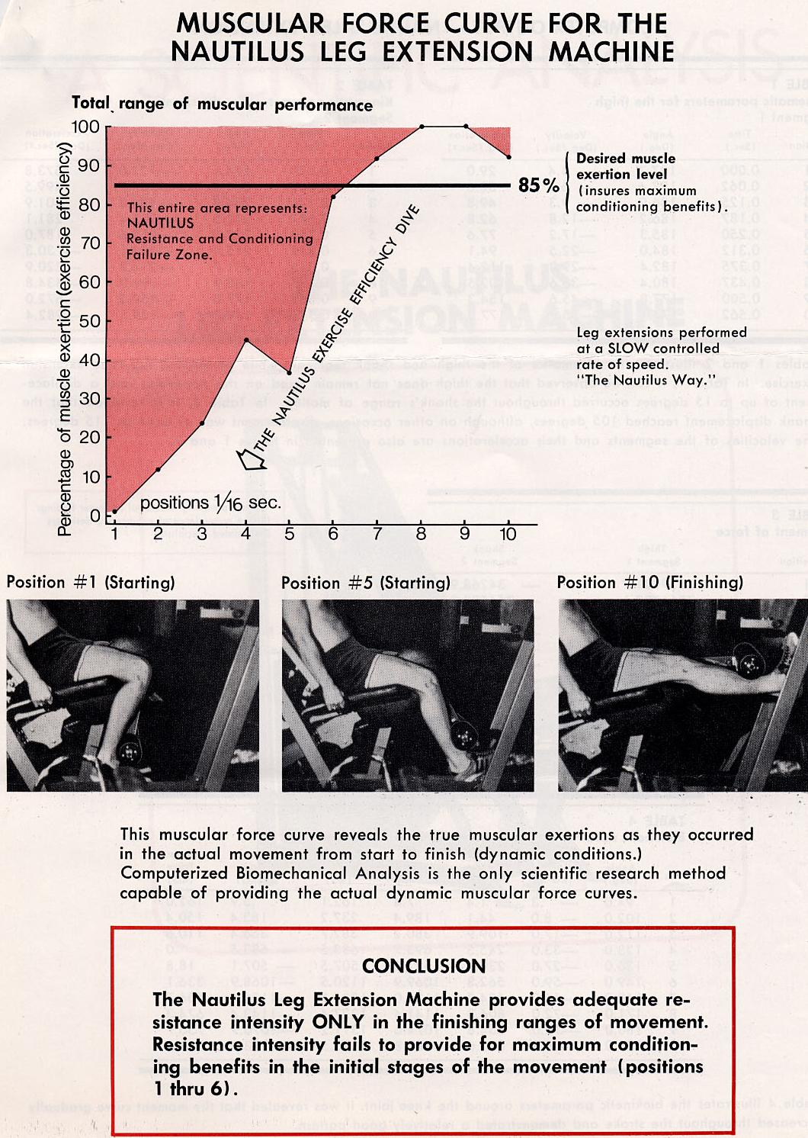

EVALUATION OF CONDITIONING PRINCIPLES & TERMS:
The purpose of this chapter is to briefly discuss the differences between the Universal and Nautilus training principles and their relative conditioning effectiveness.
The previous chapter provided documented evidence to support Universal's claim that to insure superior athletic performances it is necessary to train at rapid, explosive movements rather than slow voluntarily-controlled movements so advocated by Nautilus. Additional information on this training principle is available in "Ballistic Training" and "Resistance Exercises And Muscle Fiber Typing" published in Understanding The Scientific Bases Behind The Universal Centurion.
In addition to the "training speed" principle, there are several other Nautilus training principles that need to be evaluated in order to fully realize the true conditioning benefits that can be derived from their application.
Presently, negative resistance training is being advocated by Nautilus as a means of developing superior achievements in athletic strength. The following information will provide a realistic view of this newly, advocated method of conditioning.

NEGATIVE RESISTANCE TRAINING:
ANOTHER MISCONCEPTION IN ATHLETIC TRAINING
Negative resistance training is simply the exertion of maximum muscular efforts while lowering a weight from the extended or ending position back to its original starting position. The muscular activity that takes place during this reverse action is often referred to as eccentric or lengthening contraction. In this activity, the muscle contracts while merely returning from its shortened or fully contractile state to its normal resting length.
This is a natural muscular function that occurs when exercising; however, Nautilus is now advocating that greater emphasis be placed on this lowering or negative phase of movement rather than the actual lifting or positive phase of movement. Presently, there appears to be no scientific basis that training in a negative fashion will improve the degree of positive or FUNCTIONAL STRENGTH. Contrary to this belief, there are several factors that should be considered before training in this manner as a means of developing strength for athletic performances.
In previous chapters it was made clear that any resistance to a muscle may be beneficial to increase the muscular force; however, in athletics as well as other physical activities, the primary concern is the development of "FUNCTIONAL STRENGTH." FUNCTIONAL STRENGTH may be defined as the force variations in a particular displacement (direction). The ability to exert a maximum force at only one isolated joint angle has no bearing on the efficiency of human performance.
The characteristics of athletic FUNCTIONAL STRENGTH include the ability to
instantaneously, change the degree of speed, force, direction, and intensity.
When exercising a muscle in a negative fashion, the motion or direction as well as the speed of movement is opposite to the required (positive) motion and develops a negative central pattern, which may be detrimental to FUNCTIONAL STRENGTH. Negative training over a long period of time may further result in an impairment of coordination and a reduction in athletic ballistic efficiency (speed of the movement) as well as reductions in the biochemical activities within the muscle.
The first rule in any weight-training program should be to train the muscle in a positive manner to insure a FUNCTIONAL STRENGTH.
The second rule in weight training is to TRAIN TO PERFORM. Every athletic activity has its own unique muscular demands. For example, some activities may require greater leg strength while other activities require greater arm strength. In addition, they also may differ in the direction in which the force is required. A high jumper requires vertical leg strength while a long jumper requires horizontal leg strength.
Due to these differences, it is essential that training routines develop FUNCTIONAL STRENGTH in a manner, which closely simulates the desired activity.
It would appear rather obvious that maximum athletic performances cannot be achieved through negative training as well as training all athletes under the same training program. The key to Universal's success has been superior resistive equipment and the ability to provide meaningful conditioning programs specifically to a sport.

MISLEADING CONDITIONING TERMS:
Various misleading conditioning terms have recently been introduced into the field of muscular training. The majority, of these terms, is unscientific and only cloud the field of conditioning with meaningless terminology. The exact origin and the physiological significance of these terms have yet to be clearly determined.
There are basic scientific principles that govern man and his movements, and it is essential that these principles be adhered to in the development of resistive exercise equipment. It would appear that many of these terms, such as "rotary," "pre-stretch," "omni-directional," "infltonic," "inflmetric," etc., have been used in an attempt to avoid discussing the failure to adhere to the scientific principles which are essential for maximum muscular development. Unfortunately, many coaches, doctors, trainers, and athletes have been misled by these terms and have also overlooked the essential scientific requirements for muscular development. In addition, many have assumed that the various pieces of conditioning equipment actually possess some exclusive miraculous power. In other educational fields such as chemistry, physics, anatomy, physiology, etc., very seldom do new terms evolve, and yet, a vast number appear annually in the field of weight training.
Universal has previously introduced the scientific principles governing man and his movements and has, further, documented their success in maintaining these principles in the development of their exclusive resistive equipment.
In order to recognize the true insignificance of many of these new conditioning terms, it is necessary to examine several of them and their mysterious muscular implications.
Recently, Nautilus has publicized the word "rotary" as being an exclusive Nautilus feature and an essential requirement in muscular development.
The human body while in motion naturally exhibits rotary motions, as well as the ability to move in translatory, linear, or curvilinear motion. Rotary, or angular motions, is characterized by movement about an axis, with all parts of the object moving in an arc, like the movement of the spoke of a wheel. The design in the human body is capable is producing only rotary movements around a fixed joint. In moving two segments simultaneously it is apparent that the motion is translatory; however, the motion is actually rotary movement around two simultaneous joints. Due to the fact that the human body naturally moves in rotary motions, there is no need to develop an exercise machine that may visually appear to move in a rotary fashion. The relative design of the machine is not capable of changing a natural bodily function as in the case of rotary movements. The majority of exercise equipment requires human movement to occur in a rotary fashion. Therefore, the term "rotary" is not a new or significant factor in conditioning.
Another conditioning term frequently used by Nautilus is the word "pre-stretch." Unfortunately, the word "pre-stretch" has not been clearly defined and, therefore, it is difficult to determine its actual conditioning significance. By observing the Nautilus equipment, it may be possible to assume that this word refers to the actual exercise starting position as dictated by each individual machine. Some of the machines require a lower starting position than other conventional exercise equipment.
It is important to understand that the effect of pre-stretching a muscle can either be inhibitory or excitatory. In the case of Nautilus, the stretching force is exerted by the actual resistance provided by the lifting arms and cams. In these lower starting positions the muscle may suffer harm if it is stretched in excess of its physiological limitations. In addition, even though the muscle is elastic in nature, it may be over stretched and not capable of recoiling from its extended length. In a previous chapter, documented evidence was given to support the fact that the relative length of a muscle may only slightly influence the magnitude of the contractile force.
This recently documented discovery opposes the previous muscle tension length theory which indicated that the greater the initial length of a muscle the greater the muscular force capability. In general, the optimal length of a muscle is close to the muscle's maximum body length. This is approximately 1.2 to 1.3 times a muscle's resting length. It is possible to cause muscle injury when exercising a muscle from a starting position that exceeds this physiological limitation, particularly if the individual has not sufficiently warmed up and is lacking in needed flexibility.
Another possible interpretation of the word "pre-stretch" has been known for years in the earlier feedback theory based on the stretch reflex. This is a more sophisticated concept which involves an understanding of the neuromuscular basis for stretch reflexes; however, the stretch reflex concept occurs naturally in all human movement and it is not dependent upon any particular design of conditioning apparatus.
At the present time, there is a need for greater scientific understanding regarding the various exercise starting positions. It is important that individuals move with caution when considering pre-stretching muscles past their physiological limitations until such time as well-documented research findings can substantiate this unnatural occurrence.
Examining these two more frequently used terms, it is possible to assume that the other less used and described terms, such as "omni-directional," "infltonic," and "inflmetric," provide no significant contribution to the field of conditioning or to the relative design of conditioning equipment.
Furthermore, when describing the benefits derived from various conditioning machines, all attempts should be made to resort to only scientific terms based on scientific principles and not mystical terminology that has no significant bearing on the final conditioning outcome.

FAILURES TO AVOID IN EQUIPMENT DESIGN:
In weight training, the ultimate objective is for the muscle to function at maximum force throughout the range of movement.
To accomplish this objective, it is necessary to assess man's biomechanical changes and then develop a resistance intensity that will accommodate those changes. The variations in resistance intensity must be precisely incorporated into a variable resistance lifting mechanism. It is likewise essential that the overall machine design and operation do not adversely affect the performance of this mechanism.
To prevent machine design failures and operational failures, it is necessary to understand the relative effects of inertia. Inertial forces affect the motion and the magnitude of the muscle's involvement. The smaller the inertial force produced by the machine's moving parts, the greater the muscular involvement. In order to maintain small inertia forces, it is important to retain proper mechanical balances in the lifting ratios and in the relative distribution of all moving parts. These two factors cannot be ignored in optimum equipment design. Only Universal has provided conclusive scientific data to support their success in building the optimum conditioning machines.
In addition, only Universal has provided conclusive scientific findings on Nautilus equipment. The following information and illustrations will further emphasize the Nautilus mechanical failures and their related effect on conditioning performances.

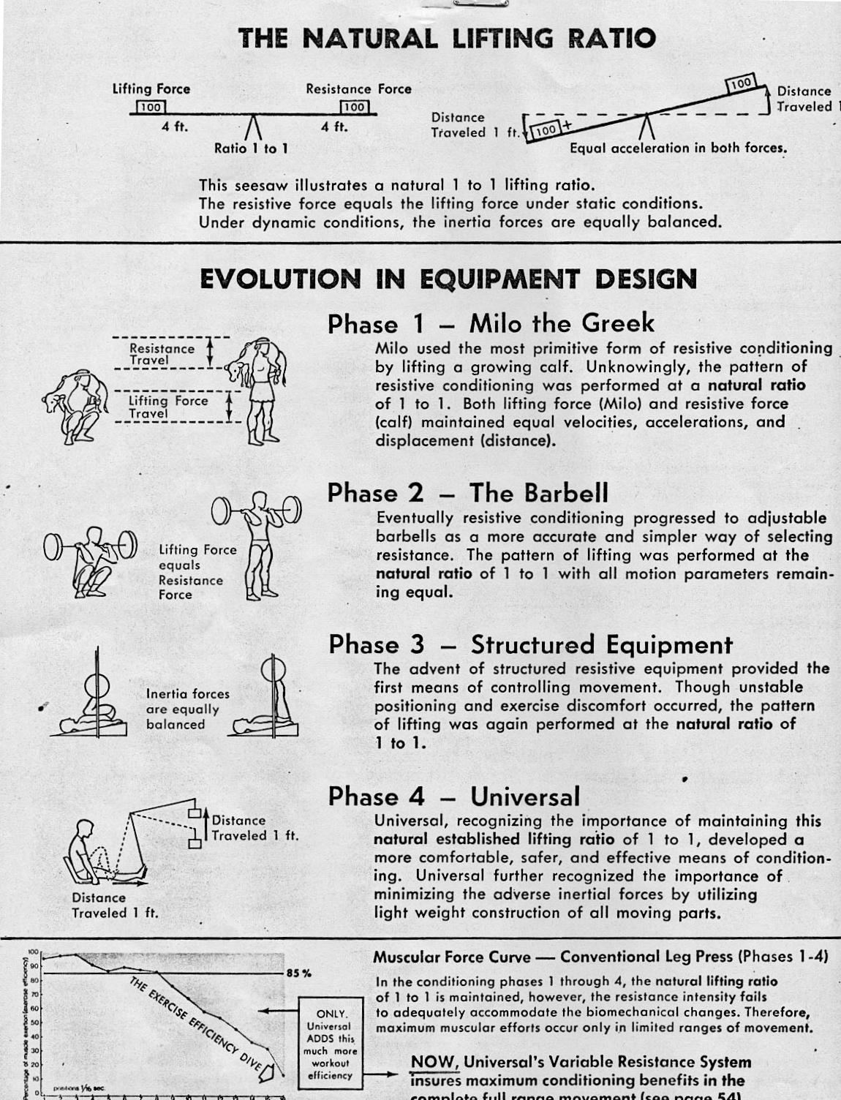
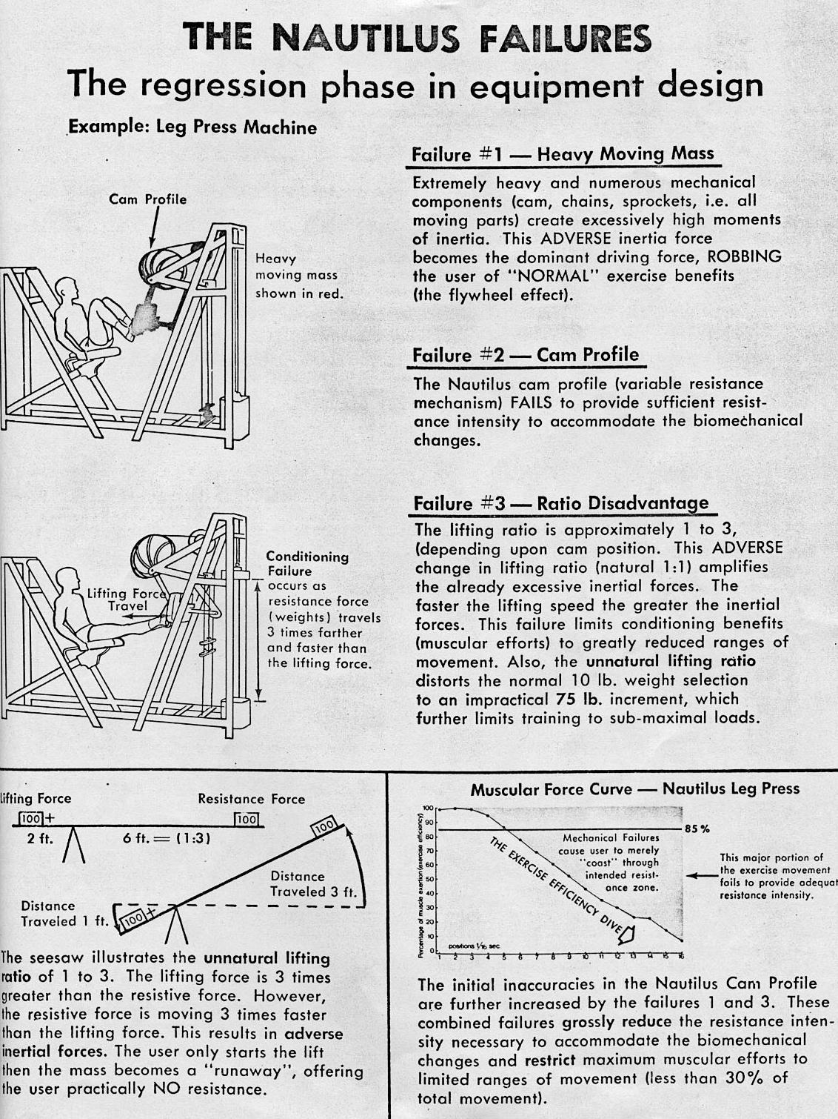

THE UNIVERSAL PROGRESSIVE, DYNAMIC VARIABLE RESISTANCE is the greatest technological advancement in resistive equipment.
Only Universal has been able to accurately determine man's complete resistive needs, and successfully employ them into a failure-proof lifting system. The natural lifting ratio is maintained while the resistive intensity instantaneously adjusts to accommodate the mechanical changes.
This results in maximum muscular efforts throughout the entire range in motion.
These Results: ONLY POSSIBLE WITH UNIVERSAL.
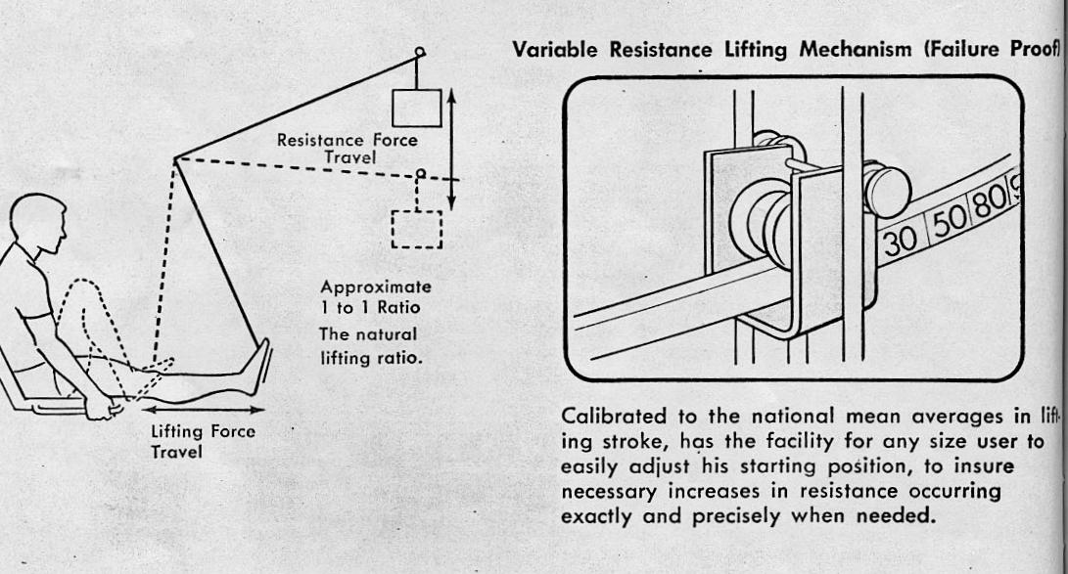

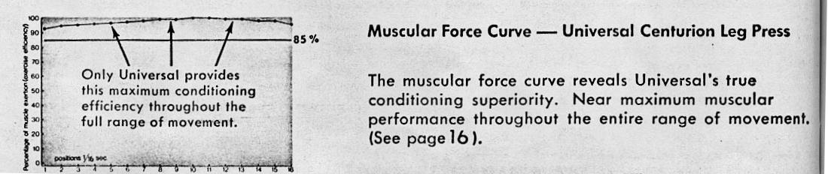

FINAL CONCLUSION:
This comprehensive study reveals Universal's unequaled technological capabilities in the field of physical exercise equipment and conditioning. Universal is the first to provide conclusive scientific facts to support the reliability and accuracy of their new resistive system.
Thorough examination of both Universal and Nautilus Computerized Biomechanical test results clearly substantiate Universal's superiority in all of the major conditioning requirements.
This scientific investigation further reveals the tremendous technological responsibility required in both research and engineering necessary for the development of new and better methods of conditioning. Universal has successfully remained purely scientific in their development of a new conditioning system capable of producing superior muscular achievements.
When all these conclusive facts are digested, the basic appeal of Universal lies in the uncompromising dedication and the unbeatable technical know-how provided by Universal's research staff. As a result of Universal's supreme efforts, millions of athletes will witness impressive new achievements in both muscular development and performance.
It is the obligation of the coach, trainer, educator, or buyer to consider all of these important facts before purchasing any resistive equipment.

