Appendix 1 to Chapter 16: The RED BROCHURE

The Universal Brochure: How My Designs Were Applied

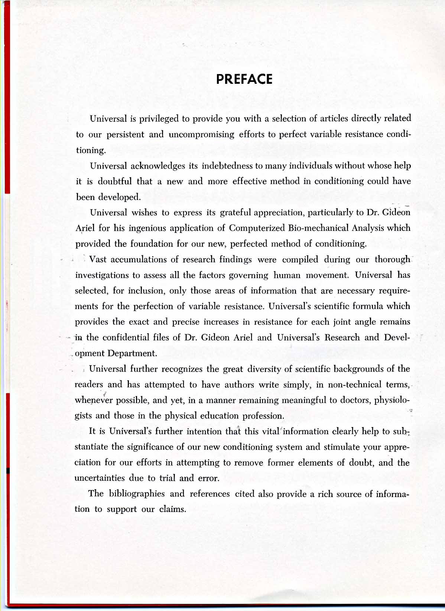

VARIABLE RESISTANCE EXERCISE:
A BIOMECHANICAL APPROACH TO MUSCULAR TRAINING
By Gideon B. Ariel, Ph.D.

The relationship between resistance and muscle strength has been known for a long time. Muscular strength may be defined as the force a muscle group can exert against a resistance in a maximal effort; and, any motion by the human requires muscular involvement. Forty to sixty per cent of the human body is composed of contractile tissue forming 437 different voluntary muscles, and the most fundamental function of these muscles is the ability to produce motion by their own contraction. The action of these muscles on the bones, which provides the leverage system, permits man to stand erect, carry out activities of daily living, and participate in athletic performances requiring optimal efficiency in muscular contraction and coordination. This motion of the musculoskeletal system is governed by both the strength of the muscles and skeletal structure.
In 1948 Delorme adopted the name, Progressive Resistance Exercise, for his method of developing muscular strength through the utilization of counterbalancing the weight of the extremity with a cable and pulley arrangement and, thus, gave load-assisting exercise to muscle groups, which would not perform antigravity motions. McQueen distinguished between exercise regimes for producing muscle hypertrophy and for producing muscle power. He concluded that the number of repetitions for each set of exercise determines the different characteristics of the exercise. Based on evidence presented in these early studies, hundreds of investigations have been published relative to muscular development through resistance exercise with various methods being introduced. Techniques for muscular development include isotonic exercises; isometric exercises eccentric contraction technique; oxford technique; double and triple progressive systems; super sets system; isokenetic exercise system; chains and barbells; springs system and many others. Each system has been supported and refuted by numerous investigations. Some of the best research is that performed by Berger who concluded that 6-7 repetitions 3 times a week is best for developing dynamic strength. Other excellent research was conducted, by Steinhause, who emphasized the need to increase the intensity, not the amount of work, in order to develop maximum strength.
The intent of this paper is not to discuss the merits of various training methods or systems, but rather to discuss the biomechanical principles that govern all types of resistance exercises, and to introduce a new concept in exercise equipment design, which allows optimum training benefits from the resistance exercise regardless of the system used.

BIOMECHANICAL CONSIDERATIONS

Biomechanics is the science, which investigates the effects of internal and external forces upon living bodies. When a person uses any resistance device whether it is a spring or a bar, there are two kinds of forces applied on this system. The internal forces produced by the muscular system and the external forces produced the resistance device, in this case the spring or the bar. When considering any human force system, muscles, bones, and joints, as well as externally applied resistance, must be considered. Consideration of the magnitude of the externally applied resistance cannot be the only consideration in muscular training. Rather, the magnitude, action line, direction, and point of application are all four characteristics, which must be considered to develop maximal muscular training routine. Physical educators and athletes deal constantly with muscle forces, both normal and super-normal, but how much is actually known about the actual magnitudes these forces? The actual forces produced by individual muscles cannot be predicted easily because of the indeterminate influence of a number of physiological and mechanical factors. These include length-tension and force-velocity relationships (Wilkie, 1968), as well as the location of the muscle attachments with respect the joint. One way to determine the muscular involvement in the exercise is to refer to the moments of force produced by all the muscles at the particular joint. It well known in resistance exercise that there exists a sticking point during which the apparent resistance is at its maximum. However, the absolute muscular force is relatively constant and varies slightly depending on its force length relationship. This variability of muscle length is of no significance when performing exercises with heavy loads. If this is the case, why is there a sticking point in the bench press, for example, above which the weight becomes light? This phenomenon will be discussed in more detail.

FORCE SYSTEM AND MOMENT OF FORCE

Since the human body is a system of linked segments, forces cause rotation of the parts about their anatomical axes. Both muscle and gravitational forces are important in producing these turning effects, which are fundamental in body movements in all sports and daily living. Pushing, pulling, lifting, kicking, running, walking and all human activities are results of rotational motion the links, which are made of rigid bones. Innumerable examples of forces acting on the body segments may be cited, as well as, mechanical devices, which are operated by forces. However, to illustrate the mechanical principle governing the human muscular system, the see-saw, (see Figure 1) is a familiar example.

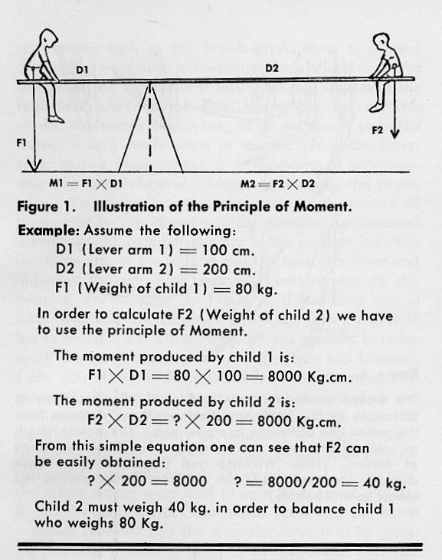
Figure 1 - Illustration of the Principle of Moment

This example illustrates the importance of the lever arm length in relation to the force or resistance applied. As can be seen in Figure 1 and by knowing this principle from personal experience, the weight of the child and his distance from the fulcrum are both important in determining the force needed to balance another child. This principle, widely used throughout the entire field of biomechanics, is the principle of moments. By definition, the moment of a force about any point is equal to the magnitude of the force multiplied by the perpendicular distance from the action line of the force to that point.
This perpendicular distance from the force to the fulcrum is known as the lever arm of the force. Dl and D2 in Figure 1, are the lever arms associated with Fl and F2 (Force 1 and Force 2). A moment is the product of the force and the lever arm of the force. The product of Dl (distance) and Fl (force) in Figure 1 is the moment associated with the left side of the system, and the product of D2 and F2 is the moment associated with the right side of the system. The system in this figure is considered to be in equilibrium only if the moment on the left is equal to the moment on the right. This equality may result in several ways. For example, Dl might be smaller than D2, and Fl greater than F2, or possibly Dl is greater than D2, so that F2 must be greater than Fl, or, Dl, D2, Fl, and F2 are equal. If we assume that Dl is 100 cm., D2 is 200 cm., and F2 equals 40 kg., then, to balance the system, Fl must equal 80 kg., since 200 x 40 must be equal to 100 x 80.
Since a moment is a force times a distance, it may be increased or decreased in either of two ways:
(1) By changing the magnitude of the force
(2) By changing its distance from the fulcrum

In the case of the teeter-totter, if two boys of equal weight are to balance one another, they must sit the same distance from the fulcrum of the board. If one boy plays with a child half his weight, this child must sit twice as far from the fulcrum in order to balance.
The magnitude factor may be changed in the human body by varying the resistance, however, the distance factor is genetically acquired and it is unlikely that one would alter the length of his arm or leg or the insertion of his muscle into the bone. Man is born with anatomical limits such as the normal force-distance relationships associated with muscle attachments. If the attachment of the distal portion of the biceps could be altered from its position of normal attachment at A to Position B (see Figure 2), then an appreciably greater force would be available for lifting weights, but a proportional reduction in the velocity for flexing the arm would accompany such a change.

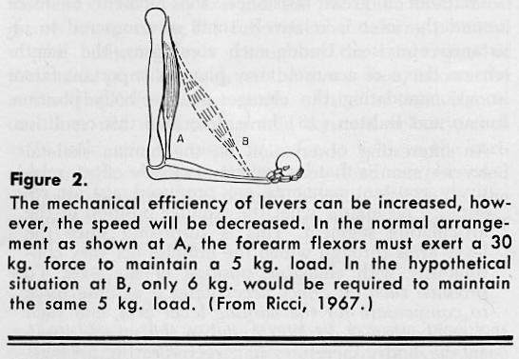
Figure 2 – The Principle of Moment

In the case of the biceps supporting the forearm at a 90-degree angle, the lever arm may be considered as the perpendicular distance from the tendon to the axis of the elbow joint (see Figure 3). In this instance the lever arm is anatomically fixed, but the magnitude of the muscle force can be varied to alter the moment.

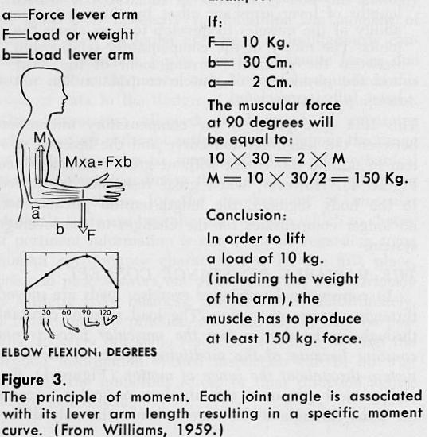
Figure 3 – The Principle of Moment

Genetically a person may be born with a short forearm but with the normal distance for insertion of elbow flexors. Such a person may be extremely strong in arm wrestling because of the short resistance arm as compared with the force arm of a normal person. His absolute muscular strength is as normal as his opponent since it is merely the mechanical advantage that he has that allows him to win in arm wrestling. Suppose the biceps muscle supports the forearm with a weight of the forearm of 5 kg. and its center of gravity located 12 cm. from the elbow joint, and the biceps has a lever arm of approximately 3 cm. Then, the biceps must pull with a force of over 20 kg. in order to lift the arm. From these examples one observes that the biomechanical principle governing human motion is much more important than the classic length-tension principle.
Without a great resistance, the moment of force around the joint is relatively small as compared to resistance exercises. Under such conditions, the length-tension curve of a muscle may play an important factor in accommodating the changes in the body position.
Inman and Ralston have described this condition: An interesting observation on the human skeletal lever system is that by maximum muscle effort, relatively constant moments are produced against resistance no matter what the angular position of the articulating segment. This is surprising since the lever arms through which the muscles act vary continuously with changing position of the part. To produce such an effect necessitates a varying force to compensate for the varying lever arm, and such a mechanism is actually found in the muscle itself. In the body, therefore, is a reciprocating arrangement of muscles and levers by which changing lengths of lever arms are offset by changes in the ability of the muscles to develop torques about the joints. The nicety of the compensatory relationship between the geometric arrangement of the lever and the physiology of muscle contraction has not been fully appreciated.
This is a description of the compensatory interaction between the length-tension curve and the leverage system in normal movement without great resistance (see Figure 4). However, when great resistance is applied to the body segment, the length-tension phenomenon no longer compensates for the changes in the leverage system.

THE VARIABLE RESISTANCE CONCEPT

In conventional resistance exercise, loads are moved through a range of motion. The load remains constant throughout the motion but the muscular force is not constant because of the modifying effects of the lever system throughout the range of motion (see Figure 4). For all practical purposes, the absolute muscular force is the same throughout the exercise since the only difference is the force arm on which the muscle pulls. When the force arm becomes greater due to angular changes of the limb, the muscle can lift a larger load; when the force arm becomes shorter, the muscle cannot pull as large a load not because of its strength, but because of the biomechanical disadvantage.

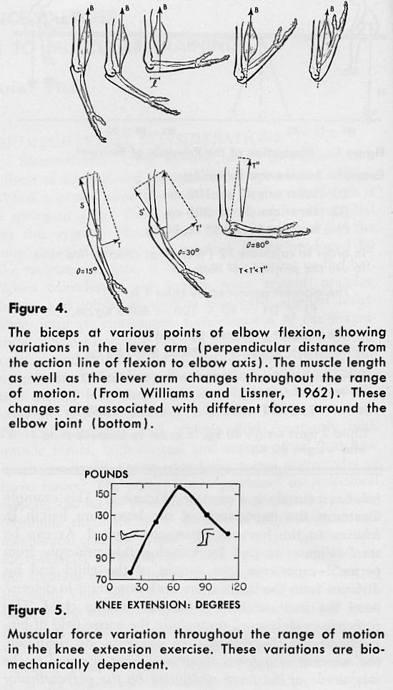
Figures 4 and 5 – The Principle of Moment

Figure 5 illustrates the variation in knee extensors force throughout the range of motion. As can be observed, the knee extensors had the greatest magnitude at 60 degrees, but does that mean that at 60 degrees the knee extensors are the strongest? On the contrary, this means that the combination of the lever arm at 60 degrees and the length of the resistance arm are entirely mechanically dependent, enabling the knee extensors to demonstrate maximum results. However, at 30 degrees the knee extensor contractile tissue are as strong, but because of the biomechanical disadvantage, they cannot produce the same, recorded output. This explains why when performing an exercise such as the bench press, there is a point where the resistance is maximum and below or above this point the resistance is less. This fact illustrates the important phenomenon that throughout an exercise stroke, the muscle is working at its maximum potential during a very small range of motion. In order to resolve such a phenomenon, it is necessary to accommodate the biomechanical changes by varying the resistance. To accomplish this, the concept of moment of force must be introduced into the exercise. As discussed previously, the moment of force is the product between the force arm of the muscle and the muscular force and indicates the dominant muscular involvement in the exercise. For example, in Figure 3, if the force arm is 2 cm. long and the resistance is 100 kg., then the muscle has to produce a 2 x 100 = 200 kg. cm. moment, in order to lift this resistance. However, if the force arm becomes 4 cm., only 50 kg. of force is needed from the muscle to resist 100 kg. In this latter case, the muscle does not work as hard and the training effect is less. Figure 3 illustrates the variability of moments in elbow flexion. In this figure one observes that maximum muscular involvement was obtained at 90 degrees. At 30 degrees, the elbow flexors were used to only 50 percent. Figures 6 and 7 obtained from the bench press and the squat exercises revealed that the muscular force is at its greatest potential in only 30 percent of the stroke. This fact demonstrates the vast waste found in traditional weight regimes since 70 percent of the exercise is relatively useless.
To facilitate maximum muscular involvement, it is necessary to vary the resistance. In several exercises, this resistance should vary by as much as 100 percent in order to maintain the moment at its maximum. The resistance should be varied according to the biomechanical data obtained under dynamic conditions. The method for obtaining such data is discussed elsewhere in the following article (Biomechanics). By varying the resistance, the goal of obtaining a relatively constant moment curve is attained.

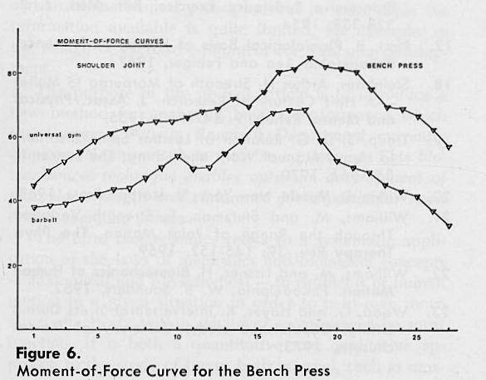
Figure 6 – The Principle of Moment

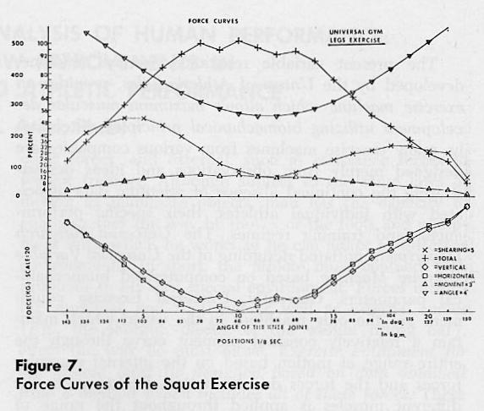
Figure 7 – The Principle of Moment

By having a constant moment curve in an exercise, the maximum mechanical means for receiving the full muscular training potential of the body segments throughout the total range of motion is provided and, at the same time, allows the natural ballistic characteristics of the motion. Hence, one does not need to maintain constant velocity, such as in isokinetic exercises, in order to achieve the variable resistance effect. Rather, any load can be used without changing the natural ballistic motion of the segment — a factor, which is extremely important for athletic performances.

THE VARIABLE RESISTANCE EXERCISE MACHINE

To design the proper layout of exercise machines with the appropriate resistance lever arm in accordance with the requirements of kinesiology and the anatomy of man, it is necessary to determine the moment of force in each particular exercise and simultaneously consider the muscular forces and the dynamic forces due to the motion. At present only Universal has utilized this type of data in the design of their exercise equipment. This information allowed development of apparatus, which assigns different resistances throughout the range of motion in order to accommodate the biomechanical changes occurring during the exercise. When designing exercise machines for the development of muscular strength, there are two alternatives from which to choose if pertinent information is not available regarding some human performance characteristics. In the first place, one can pick answers out of the thin air; this obviously is a pretty risky business, although it is, unfortunately, a fairly common practice. Alternatively, it may be possible to carry out some research project to develop the needed information. Visual inspection can in no way ascertain the numerous forces or their direction acting on the individual.

The present variable resistance exercise machine, developed by the Universal Athletic Sales, provides an exercise machine, which allows maximum muscular development utilizing biomechanical principles. Alternately, many exercise machines from various companies are designed merely from observations and ideas demonstrating the continued absence of scientific data associated with individual athletes, their specific performances, and training regimes. The Universal Research Department initiated designing of the Universal Variable Exercise Machine based on computerized biomechanical parameters. Currently, Universal Exercise equipment are the only machines in the world, which maintain a relatively constant moment curve through the entire range of motion based on the internal muscular forces and the forces due to motion. Resistance to the different muscles is applied throughout the range of motion for maintenance of optimal muscular resistance during the biomechanical changes occurring in the range of motion.

SUMMARY

The concept of strength variation through the range of joint motion presents a broader concept of muscular force development. A question should be raised regarding the extent to which muscle training is efficient when performed with the regular barbell or on equipment without scientific basis. Functional movements are frequently ballistic in nature, and the relationship of joint moment measurements to dynamic or phasic activity needs to be considered when designing exercise equipment to facilitate efficient muscular strength. Not only do force values vary among muscle groups, but, the rotational effect of a given group depends on the position of the joint it moves. Universal Research Department utilized extensive fundamental data of this nature and a computerized biomechanical analysis system to develop its new variable resistance exercise machine—a new generation in muscular training.

COMPUTERIZED BIOMECHANICAL ANALYSIS OF HUMAN PERFORMANCE:
APPLICATION FOR NEW IMPROVEMENTS IN
EXERCISE EQUIPMENT AND ATHLETIC PERFORMANCE

The history of man is filled with evidence of his efforts to create new techniques and equipment, which satisfactorily serve his purposes and to control more adequately the environment within which he lives and works. Over the years much of what physical educators, coaches and physical trainers knew about how man moved and performed was the result of visual observations and subject to subjective biases and opinions. Man's movements, especially in sport and physical training, are much, more complicated than can be accurately analyzed by the human eye.
A few typical questions might be posed which will illustrate what is meant by "taking human factor considerations into account" during the analysis of human performance. Such questions could include the following:
(1) Which muscles are involved when executing a block in football?
(2) Which muscles need special strength development for each individual track and field event?
(3) To what extent does the bench press exercise develop the elbow extensors?
(4) Which muscular exercise would best suit the development of the knee extensors (quadriceps) with minimal shearing force at the joint?
(5) How much resistance should be varied throughout a range of exercise motion to obtain the most efficient exercise routine?

The solutions to these and many other kinds of questions should be based on the availability of pertinent information about human capabilities and limitations, as well as, physiological, biological and biomechanical factors. The development of a body of information and principles that would be applicable to these and other problems is primarily dependent upon research. At present there is fairly substantial information available about some areas of human performance, such as physiology of exercise. There is at least partial information about certain biomechanical principles; but in some areas the information available is quite limited, for example, in the design of exercise equipment for muscular development.
The purpose of the present article is to introduce a new method for analyzing human performance, which the Universal Fitness Research Department currently employs to improve their exercise equipment. This biomechanical technique enables optimum development of muscular strength and endurance for a particular sport or for everyday fitness.
The term biomechanics refers to a systematic application of the laws of mechanics and biological concepts — anatomical and physiological — to problems of human motion in a given situation in order to help man move more effectively within whatever environment he must function. It is both a quantitative and qualitative approach to the study of forces both internal, such as muscular forces, and external, such as resistance forces in weight training. Although subject to the same laws of motion as inanimate objects, man has the capacity to change either the way he moves or the tools and equipment with which he works, so he can adapt to different environments. In sport, the athlete must contend with problems in his own special environment. Forces including muscular and frictional as well as external forces (e.g., the shot put, discus, or the weight lifting bar), affect the way he must move. Exercise equipment for the athlete must be designed based on data obtained from a method, which includes all of these forces. These problems have been under investigation for a long time; however, only since the development of biomechanics and the invention of the computer, have researchers been able not only to view but also to do a more thorough kinematic and kinetic analysis of human performance.

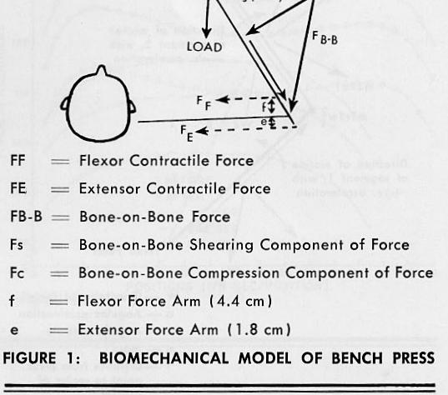
Figure 1 – Biomechanical Model of Bench Press

The Scientific Principles Underlying the Analytic Technique

When performing any exercise with the Universal Exercise Machine, the segments of the human body, which are used form a link system. For example, in the bench press the link system consists of the trunk, the upper arm, and the forearm with the weight in the hands. Figure 1 illustrates this link system. The laws of physics apply to any link system in motion regardless of whether the system is a human or machine. The different segments of this link system, when in motion such as in the bench press exercise, include muscular forces which act on each body part; and in addition to the muscular forces, there are inertial forces which are the forces produced by the motion itself.

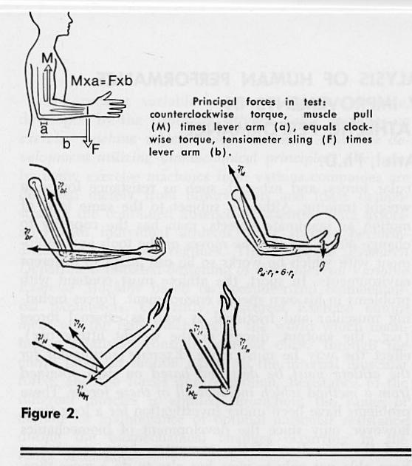
Figure 2 – Muscular and Inertial Forces

For example, Figures 2 and 3 illustrate the muscular and the inertial forces on the forearm during the curl exercise. These inertial forces would act upon any segment in motion in the human body.
If the human body had only one segment, then designing an exercise machine would be very easy since only the inertial and muscular forces on that segment would act upon it. However, the human body, when performing physical exercise, has more than one segment in use even if some of the segments are fixed. For example, when a link system consists of two segments, such as the upper arm and the forearm, then gravity, centrifugal, and tangential forces act upon each segment with an additional 3 forces resulting from the influence of the first segment upon the second. Figure 3 illustrates all of the forces acting on 2 segments in motion. In some resistance exercises as many as nine segments are considered in the analysis. Universal laws affect a link system such that each segment in motion has the aforementioned three forces and additional forces due to the influence of segments on each other (see Figure 3). In a link system of 7 segments such as in the shot-put throw, a total of 84 forces are involved in each sequence of the throw. An exercise machine developed from this type of information can maximize the training effect.

Analysis Procedure

The kinetic analysis involves the following steps:
(1) Obtaining cinematographic data
(2) Digitizing the data
(3) Measuring and utilizing anatomical data
(4) Utilization of the computer program for kinetic analysis and quantifying human performance
(5) Interpretation of the results

Slow motion cinematography is used to record any desired motion and then special tracing equipment enables data to be processed directly by a high-speed computer. Figure 4 illustrates the circuitry of the tracing equipment. The appropriate programming results in a segmental breakdown of information of the whole exercise motion. Data obtained includes the total body center of gravity, segment velocities and accelerations, and joint forces and moments of force. Figures 5, 6, 7, and 8 present computer graphic outputs of velocity, acceleration, moments of force and muscular force curves. A unique feature allows the interpretation of the data to show the significance of contribution of each body segment to the whole motion. Other available information shows the magnitude of the muscle action at each joint; the vertical and horizontal forces at all joints; the magnitude of the shearing force at the joint; the timing or coordination of motion between the segments; and the differences due to body builds. The combination of the moments of force, the interrelated patterns of the body segments, and the exercise performed gives a measure for designing the exercise equipment and providing the load necessary at each angle of the joint for the particular body segment.
This analysis provides a quantitative measure of the motion and allows for perfection and optimization of human performance on the exercise machine.
This information allowed development of apparatus, which assign different resistances throughout the range of motion in order to accommodate the biomechanical changes occurring during the exercise.
When designing exercise machines for the development of muscular strength and efficiency, there are two alternatives from which to choose if pertinent information is not available regarding some human performance characteristics. In the first place one can pick answers out of thin air; this obviously is a pretty risky business, although it is, unfortunately, a fairly common practice. Alternatively, it may be possible to carry out some research project to develop the needed information; such a project can, of course, range from those of superficial nature to those of a broad-scale, even basic-research, nature. Visual inspection can in no way ascertain the numerous forces or their direction acting on the individual. Consider the confidence, which an engineer would inspire were he to look at both sides of the river and visually determine the details of the bridge to be constructed.
Another goal in designing exercise machines is to optimize the resultant resistance force at the proper direction. When the force is determined only perceptually it is very likely that the design will lack maximal efficiency since guessing is involved. Presently, many exercise machines in various companies are designed merely from personal observations and ideas. There still exists the absence of scientific data relating to each individual athlete and his specific performance. It is almost impossible to design an appropriate exercise machine from just an idea or observation. Whether or not an athlete is using his body efficiently on the correct equipment cannot be determined by visual observation alone. Based on this approach, the Universal Fitness Research Department initiated designing of the Universal Exercise Machine based on computerized biomechanical parameters. Presently, Universal exercise equipment are the only machines in the world which maintain a relatively constant moment curve throughout the entire range of motion based on the internal muscular forces and the forces due to motion. Resistance to the different muscles is applied throughout the range of motion to maintain optimal muscular resistance throughout the biomechanical changes, which take place in the range of motion. Thus, biomechanical parameters enable development of the new variable resistance exercise machine to accomplish optimum muscular development for strength and speed.
Inquiry and research continue to unfold new avenues for perfecting and optimizing training routines for each individual sport, such as track and field, or for team sports. The use of this modern computerized biomechanical analysis as a sound scientific aid in the improvement of exercise equipment helps to remove the element doubt and the uncertainty of trial and error is replaced by accurate, scientific data -- a welcome change by one who seeks perfection.

COMPUTERIZED BIOMECHANICAL ANALYSIS OF THE VARIABLE RESISTANCE
EXERCISE MACHINE - THE CENTURION 19741

The previous technical reports revealed the need for a variable resistance exercise machine, which will maintain a relatively constant muscular movement curve throughout the entire range of motion based on the internal muscular forces and the forces due to motion. The previous data, also, revealed that there is a need to provide resistance to the different muscles throughout the range of motion in order to provide optimal muscular resistance throughout the biomechanical changes which take place, and, at the same time, to provide functional strength which is both ballistic in nature and involves multiple joint neuromuscular integration.
The present report provides an evaluation of Universal's new variable resistance exercise machine (The Centurion) considering the following variable resistance stations:
(1) Bench press
(2) Leg press
(3) Shoulder press

THE BENCH PRESS STATION

Universal's computerized biomechanical testing of the bench press exercise revealed the exact forces necessary for the perfection of a variable resistance machine at this station. Table 1 presents the data from Universal's variable resistance machine including the force and the moment data, elbow angle (data withheld), shearing and compression force. Figure 1 illustrates the computer graphic output for the muscular force, moment of force and elbow angle curves. From Table 1 and Figure 1, it can be observed that the muscular force is maintained nearly constant throughout the range of motion. The increase in angular displacement towards the end of the motion reveals that the ballistic nature of the motion is maintained without the loss of muscular resistance —Universal's perfect muscular training effect.

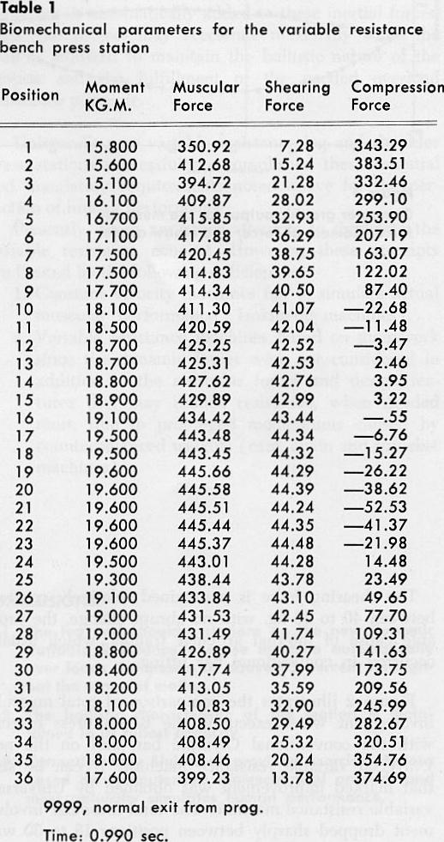
Table 1 – Biomechanical Parameters

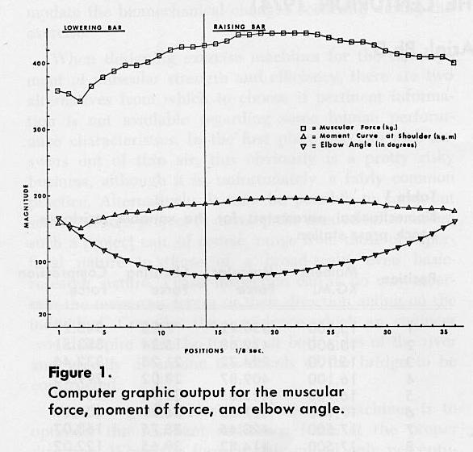
Figure 1 – Computer Graphic

The shearing force is maintained relatively constant between 40 to 20 kg.,with no abrupt change, the probable cause of internal articular trauma, which usually occurred in conventional bar lifting.
Figure 2 illustrates the comparison of total muscular involvement when executing the bench press exercise with the conventional Olympic bar, and on the new Universal variable resistance machine. It can be seen that marked improvement was obtained by Universal's variable resistance machine. The total muscular involvement dropped sharply between positions 18 to 30 with the conventional Olympic bar, while over 87 percent of the total muscular involvement was attained on the new Universal variable resistance exercise machine.

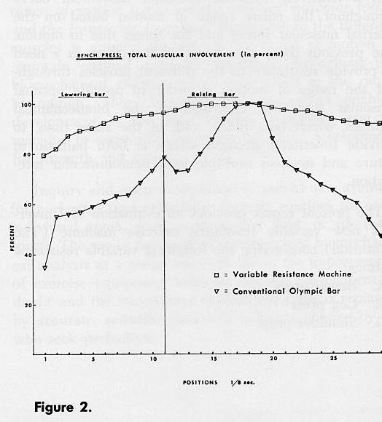
Figure 2 – Total Muscular Involvement

Conclusions:

(1) Universal's variable resistance exercise machine demonstrated a significantly higher muscular training affect.
(2) The ballistic characteristic of the motion was noted. This is first exercise machine capable of maintaining the dynamic characteristics of the motion, while insuring nearly maximum muscle efforts through the entire range of movement.
(3) The shearing force data revealed the safety factor the Variable Resistance Machine to be far greater than in the conventional methods of training.
(4) The Universal variable resistance bench press station demonstrated a perfect automatic loading effect enable total muscle training throughout the range motion.

UNIVERSAL CENTURION —
LEG PRESS & THE SHOULDER PRESS STATIONS

Computerized biomechanical analysis of Universal's leg and shoulder press stations on the new dynamic variable resistance machine revealed optimum conditions when compared with the conventional barbell or with any other exercise machine. These new variable resistance leg and shoulder press stations optimize the resultant force in the appropriate direction and at the same time minimize the shearing force. The total muscular performance exceeds 85 percent of maximum muscular movement involvement throughout the range of motion permitting maximum muscular training for the particular muscular system involved.
The incorporation of dynamic forces in Universal's design of the equipment permits maximum resistance and maintenance of the natural ballistic characteristics of the motion when performing the exercise. Hence, one does not need to maintain constant velocity, such as in isokinetic or slow performance exercises, in order to achieve the variable resistance effect. Rather, any load can be used without changing the natural multi-joint ballistic characteristics of the segments. This factor is extremely important for athletic performance and only Universal's new Dynamic Variable Resistance exercise machine possesses it.
When designing the accommodated resistance necessary for the leg press and shoulder press exercises both the muscular forces and the forces due to motion (dynamic forces) were considered. This unique feature allows maintenance of the natural characteristics of the acceleration pattern and at the same time permits the needed over loading effect. In conventional lifting, the subject is unable to accelerate the bar throughout the total exercise since the inertial forces will cause such a magnitude of forces toward the end of the motion that the bar will be thrown from the hands. However, when putting the shot, this stopping phenomenon does not occur since the athlete releases the shot at the end and the inertial forces are transferred to the projectile. When lifting a conventional bar, however, the subject must decelerate the motion towards the end of the lift in order to hold onto the bar. If the load is increased then the athlete might be unable to complete the stroke because of the biomechanical disadvantages in particular angles. If the dynamic forces are calculated and the resistance is automatically added to these inertial forces, then, the subject may accelerate maximally while the load is adjusted to maintain the ballistic nature of the motion and the fulfillment of the needed overload resistance principle.
Universal's new variable resistance leg and shoulder press stations successfully accomplished these essential and mandatory requirements noted above for the perfection of human performance.
Presently, there are other attempts to duplicate the variable resistance concept. However, these attempts are limited by the following deficiencies:
(1) Constant velocity machines fail to simulate actual muscular performance (Isokinetic machines).
(2) Variable resistance machines based on guesswork since the dynamic forces were not considered in addition to the muscular forces and design features that may reduce resistance, when needed most, due to prolonged momentums caused by counterbalanced weights (cam, chain and sprocket machines).
CONCLUSIONS:

(1) The leg and shoulder stations on the new Dynamic Variable Resistance exercise machine automatically over loads the muscle to above 85 percent throughout the range of motion.
(2) The ballistic characteristic of the motion is maintained to its fullest capacity.
(3) Currently, only Universal provides exercise stations based on computerized biomechanical analysis and most naturally simulates human performance.

INTRA-ARTICULAR SHEARING FACTOR DURING RESISTANCE EXERCISES
by Gideon B. Ariel, Ph.D.

The relationship between workload and muscle strength has been known for a very long time. The most important element in resistance exercise for strength gain is the persistent reinforcement of effort to limits beyond those easily met. From Berger's studies, it appeared that 6-7 repetitions, 3 times a week is best for developing dynamic strength. Steinhause emphasized the need to increase the intensity — not the amount of work—in order to develop maximum strength. A relatively recent concept in resistance exercise is the Isokenetic exercise in which the resistance is adjusted for each change of the muscular strength throughout the range of the motion.
Regardless of the type of training, any resistance exercise is associated with shearing forces at the joints.
In any force system the total force has various components. Some of these components are: vertical, horizontal, shearing and compression components. In the present article, the total force is made of forces due to muscular contraction and forces due to the motion (inertial forces). In physical fitness and athletics, coaches and trainers deal constantly with these muscular and inertial forces, but how much do we know about the actual magnitudes of these forces and of their components?
It was the purpose of the present article to illustrate a method of analyzing and calculating the various forces acting on the joints during resistance exercises. Modern biomechanical techniques have been applied to an analysis of lifting with specific emphasis upon dominant muscle involvement, muscle contractile force, joint torque and intra-articular stress. Special tracing equipment enabled the data to be processed directly by a high-speed computer. Application of Ariel's computerized kinetic analysis to the cinematographical data permitted the determination of forces and dominant moments of force.
The intra-articular stresses of any joint may be calculated through the use of a model. Examinations were made of X-rays representing the various joints. From the X-rays it is possible to determine the moment arm, which is directly correlated with the magnitude of the muscular force. Figure 1 presents a sample of an x-ray used to determine the knee joint model. The moment arm, by definition is the perpendicular distance from the joint center to the line of force generated by the muscle. (See x in Figure 1).
An important feature of the computer program used in the calculation of forces is its consideration of the forces due to motion (inertial forces), as well as, the forces due to muscular contraction. Summation of the inertial forces and muscular forces enabled the calculation of the bone-on-bone, shearing, and compression forces.

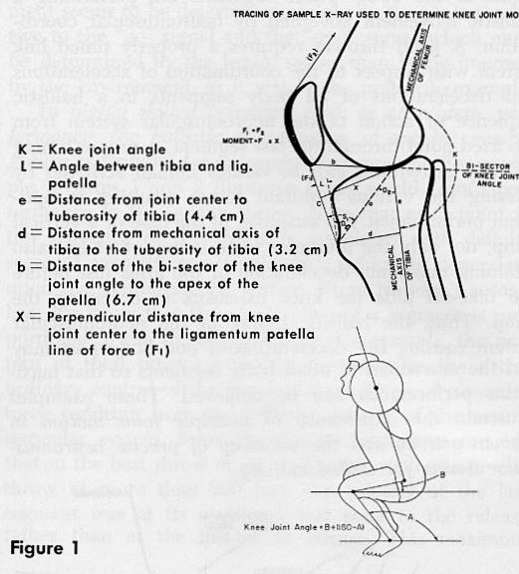
Figure 1 – Knee Joint

The bone-on-bone force is the total resultant force derived from summation of the forces due to the motion and the forces due to the muscular contraction. The bone-on-bone force can be partitioned into the shearing force and the compression forces by considering the mechanical axis of the bones. The shearing for is the force that represents the intra-articular stress the joint. In exercise against resistance, this force depends upon the following factors:
(1) Magnitude of the resistance (weight)
(2) Relationship between the muscular forces and the inertial forces
(3) Directions of the various forces
(4) Position of the body while executing the exercise
(5) Stabilization of the weight
(6) Structural design of the exercise machine

The greater the magnitude of the resistance, the greater is the bone-on-bone force and if this force at an inefficient angle, then the magnitude of the shearing force will be increased. This is particularly true when an athlete tries to lift an extremely heavy weight. Relatively heavy weights reduce the stability of the joints and cause both bending and intra-skeletal adjustments resulting in greater shearing force.
The forces due to motion are also important. If the pattern of motion results in forces, which change the direction of the vertical component of the muscular force, a greater shearing force will result. The direction of the various forces and the position of the body are very important in determining the bone-on-bone force and its direction, which directly affect the magnitude of the shearing force. Note that the direction, not the magnitude, of the bone-on-bone force is the important factor in determining the magnitude of the shearing factor.
Stabilization of the weight is important since it reduces the chance of faulty internal skeletal adjustment by the body while executing the exercise. Stabilization is never possible with conventional weight-lifting apparatus because the body must constantly make postural, as well as, weight-supporting adjustments.
One of the joints most vulnerable to shearing force is in the lower back region between the fourth and fifth lumbar vertebrates. Within the past decade there has been renewed interest in the prevalence and etiology of lower back pain associated with the lifting of weights. The following illustrates the method presently utilized in the construction of the Universal Exercise machine to eliminate the shearing force stress factor. Almost any weight lifting exercise in erect posture is associated with great force on the vertebrate column. Kotani found high incidence of spondylolysis, prolapsed disc, and other injuries to the vertebral column and its associated structures in competitive weight lifters. The risk of degenerative and traumatic lesions of the spine is, however, not confined to those engaged in competitive lifting as athletes in many different sports routinely incorporate weight training as part of their training routines. Young and inexperienced lifters represent another high-risk population, as noted by Troup.
The identification of the magnitude of forces and moments of force about certain joints is important when designing exercise equipment, so that safeguards for the prevention of detrimental shearing factors can be incorporated in the design.

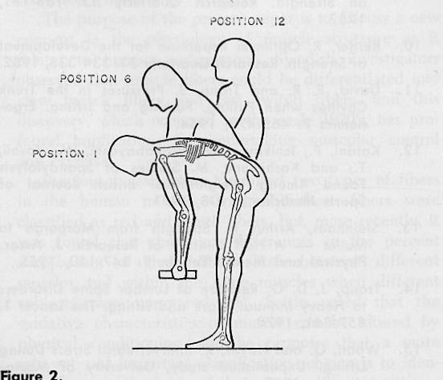
Figure 2 - Instantaneous Positions of the Lifting Motion

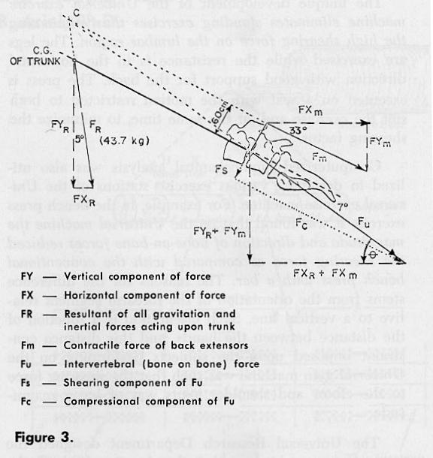
Figure 3 - Intervertebral Forces

The Universal Research Department utilizes biomechanical techniques permitting the determination of intra-articular forces from kinetic and kinematic motion analysis. The utility of this technique in determining joint forces and moments of force acting about the fifth lumbar during the lifting of a known weight can be observed in the following example. Figure 2 illustrates three instantaneous positions of the lifting motion and Figure 3 presents the intervertebral forces for one position. Fs represents the shearing force responsible for the degenerative and traumatic lesions of the pars inter-articularis. In this example, it was found that the contractile force of the back extensors muscles was 388.3 kg.; the shearing component was 36.5 kg.; and the bone-on-bone force, representing the intervertebral force (Fu), was 416.5 kg.
In a study of pressures in the trunk cavities when pulling, pushing, and lifting, Davis found that with increased stress on the vertebral column, the abdominal muscles are very active in relieving the load on the lumbar spine. Thus, the abdominal muscles counteract the shearing force to a certain extent. This factor indicates the importance of well-developed abdominal musculature to aid in the prevention of low-back pain in weight lifting. This would also provide rationale for the widespread use of the waist belt among weight lifters, since the function of the belt is to resist the shearing force on the lumbar region associated with pain.
The unique development of the Universal exercise machine eliminates standing exercises thus eliminating the high shearing force on the lumbar region. The legs are exercised while the resistance is in the horizontal direction with good support for the back. The press is executed on a scat with the motion restricted to both suit the exercise and, at the same time, to minimize the shearing factor.
Computerized biomechanical analysis was also utilized in designing various exercise stations of the Universal exercise machine. For example, in the bench press exercise it was found that on the Universal machine the magnitude and direction of bone-on-bone forces reduced the shearing force, as compared with the conventional bench press with a bar. The reason for the differences, stems from the orientation of the forearm segment relative to a vertical line. Such orientation is a function of the distance between the hands, and this distance constraint imposed upon the subjects performing on the Universal gym machine was such that the shearing force to the elbow and shoulder joints was of lesser magnitude.
The Universal Research Department designed the leg exercise machine so that the shearing force at the knee joint will be maintained at its minimum value. It was revealed that the vertical deep knee bend with a conventional bar was associated with a shearing force of great magnitude. In the horizontal deep knee be performed on the Universal leg press machine, the large shearing forces were not observed. It was found that some subjects, when performing squat exercise with the conventional bar, shifted their knees forward, while performing the squat exercise. This movement the knees forward while performing the squat produce great shearing forces. This type of knee shifting introduces mechanical factors, which influence the magnitude of the shearing forces and may be one of the causes knee injuries. On the Universal gym exercise equipment, this forward shifting of the knees is eliminated by the design of the apparatus. The magnitude of the shearing force also may influence the lifting performance. At times, a subject may appear to be weak not because muscular insufficiency, but because of a reduced vertical component or by the inhibiting influence of the shearing forces. For example, it was found that the strongest subjects always demonstrated less shearing force than did the weaker subjects. In addition, the shearing force associated with a bounce condition in the squat exercise with the conventional bar may be another cause of knee injuries. This factor is also eliminated from the Universal exercise machine.
The present article illustrates a few examples utilized by the Universal Research Department in perfecting an optimization of exercise equipment for better training effects and reduced injury expectancy.

