Appendix 24 – Renewal

55TRabbi Noach Isaac Oelbaum55T | 55TSendy Ornstein55T | 55TMendy Reiner55T
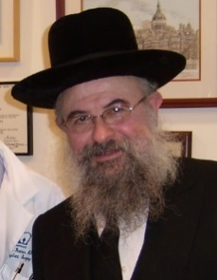 | 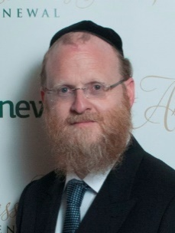 | 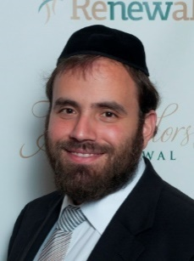
55TRabbinical Advisor55T | 55TPresident55T | 55TFounder & Chairman55T

55TRabbi Chaim Steinmetz55T | 55TMenachem Friedman55T | 55TAmbassadors of Renewal55T
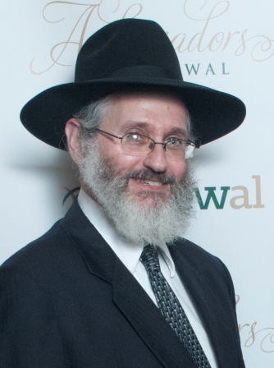 | 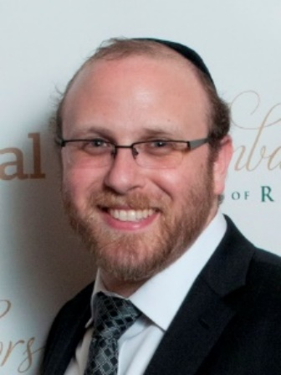 | 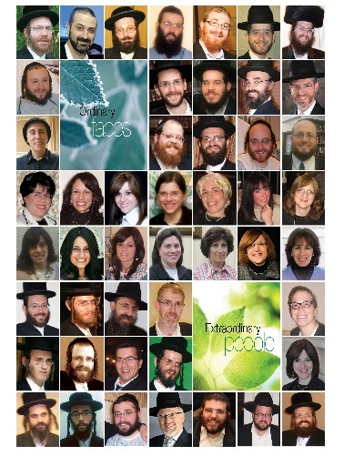
55TDirector55T | 55TProgram Director55T | 55Tmore55T

77TRenewal's ultimate goal is that no one in need of a kidney transplant should wait longer

