Ariel Dynamics, Inc.
DISPLAY MODULE

Revision 1.0



Contents
ARIEL DISPLAY PROGRAM
INTRODUCTION
WHAT’S NEW IN DISPLAY 1.0
SYSTEM REQUIREMENTS
SCREEN LAYOUT
THE APAS TOOL BAR
THE TOOL BAR
THE DISPLAY WINDOW LAYOUT
THE STATUS BAR
TO START THE DISPLAY PROGRAM
CREATING A NEW ANALOG DISPLAY FILE
PARTITION
CREATING A NEW 3D DISPLAY FILE
PARTITION
X VS Y GRAPH
LINEAR GRAPH
SEGMENT ANGLE GRAPH
JOINT ANGLE GRAPH
LENGTH GRAPH
CREATING ADDITIONAL VIEWS FOR DISPLAY
STICK FIGURE VIEW
VIDEO DATA VIEW
VIDEO + STICK DATA VIEW
TABLE DATA VIEW
GRAPH OPTIONS FOR DATA FILE
DATA
AVG/RMS
INTEGRAL
POWER
TEMPLATES
CREATING A NEW TEMPLATE
OPENING A TEMPLATE
EDITING TEMPLATES
REMOVE TEMPLATES
TOOLS FOR DISPLAY
ZOOM
LABEL
ALIGN
SAVING A DISPLAY FILE
RESTORING PREVIOUSLY CREATED DISPLAY FILE
DISPLAY OPTIONS
CHANGING THE FONT
MISCELLANEOUS OPTIONS
DISPLAY QUICK REFERENCE
DISPLAY MENUS
FILE COMMAND MENU
EDIT COMMAND MENU
VIEW COMMAND MENU
TEMPLATE COMMAND MENU
GRAPH COMMAND MENU
EXPORT COMMAND MENU
TOOL COMMAND MENU
WINDOW COMMAND MENU
OPTIONS COMMAND MENU
HELP COMMAND MENU

ARIEL DISPLAY PROGRAM

INTRODUCTION
Once an analysis sequence has been digitized, transformed and smoothed, the ARIEL DISPLAY module is a Windows based program used to obtain a complete presentation of image motion data for biomechanical analysis.
The DISPLAY module allows simultaneous presentation of the three-dimensional stick figures, displacement, velocity, acceleration, video images and numerical data tables as well as analog data signals.
The stick figures may be displayed in single frame, multiple frames or animation mode with multiple image sequences being viewed at the same time. The size, location and orientation of the stick figures for each sequence can be set in any manner desired to create comparison displays. Text labels can be added to the display to create complete illustrations and copies of the color graphic display may be printed from the color printer.
The DISPLAY software also allows normalizing the data signals in both time and amplitude.
Although a few of DISPLAY’s features appear complex, they are relatively easy to master once you understand the underlying concepts. This manual is arranged to teach you these concepts in a logical order by showing you, in step-by-step fashion, how to use the DISPLAY program.

WHAT’S NEW IN DISPLAY 1.0
A few of the new features you will see in DISPLAY version 1.0
1. Signal Normalization. Analog and kinematic signals can be normalized in both Time and Amplitude.
- Simultaneous AVI Display. AVI files can be synchronized with analog and 3D signals.
- Extended Graphing Options. Graphs can be generated in X vs Y format as well as the distance between any two points.
- APAS Tool Bar. A toolbar has been added to allow the user to activate individual APAS modules from within the main programs.
- Template Options. A template option has been added to allow the user to create analysis templates for use with other data files.
- Alignment Options. Figures can be aligned to correspond to a desired axis.

SYSTEM REQUIREMENTS
The following list provides the basic guidelines for the necessary components of the DISPLAY program to provide the best possible performance. The software requires a minimum of Microsoft Windows 95/98 or later and APAS-2000 Revision 1.0 or later.

1. Ariel Performance Analysis System (APAS) software used to collect kinematic data in *.3D and analog data in *.ANA file formats.

SCREEN LAYOUT
Prior to performing the DISPLAY analysis process, you should take the time to familiarize yourself with the format and contents of the various screens listed below:

THE APAS TOOL BAR
You can activate any of the APAS software modules from within the current program by selecting the icons located on the APAS tool bar. The tool bar is toggled on/off using the APAS Toolbar command in the VIEW menu. A check mark in the left column of the menu indicates that the toolbar is currently active. The toolbar can be re-located anywhere in the main program window by dragging it with the mouse. Clicking the appropriate icon can activate the following program modules. Icons are pictorial representations of programs, commands or functions.

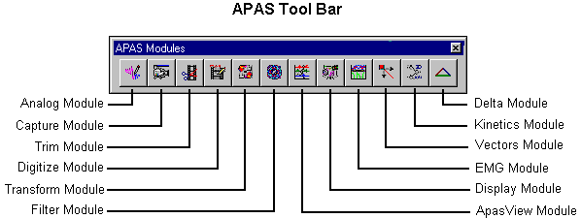

THE TOOL BAR
You can activate many functions by selecting the icons located on the DISPLAY program tool bar. The tool bar is located near the top of the window. The icons in the Display Tool Bar can be divided into three sections. Icons are pictorial representations of commands or functions. You can access the following commands by clicking the appropriate icon.

MAIN DISPLAY TOOL BAR
The Main Tool Bar icons can be used to activate general file commands.

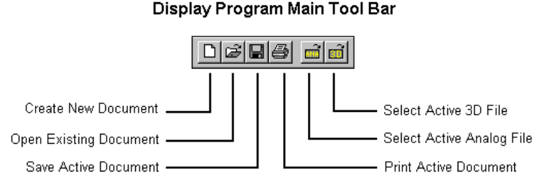

GRAPHING TOOL BAR
Sampled data can be displayed using the icons in the Graphing Tool Bar.
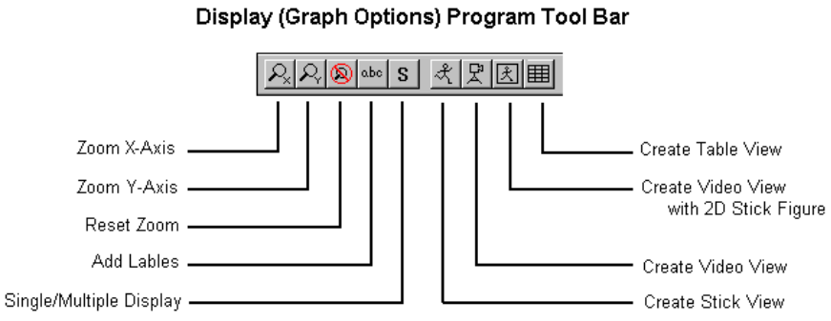

ANIMATION TOOL BAR
The icons in the Animation tool bar are used to "mimic" buttons on a VCR. When these icons are selected, all active windows will be updated with the command.
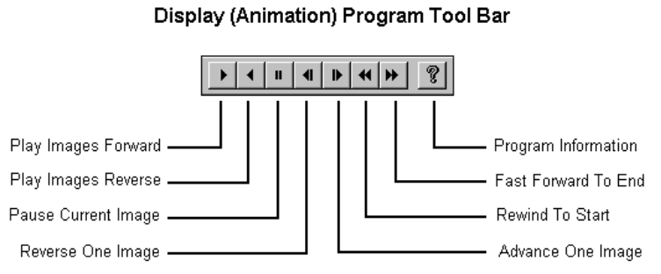

THE DISPLAY WINDOW LAYOUT
When a Display file is opened, additional windows will be displayed inside the main window. Multiple windows can be opened simultaneously. The DISPLAY Title will be displayed at the top of each Display Window. The Display Window title incorporates the *.DIS filename that consist of the *.ANA filename and the associated *.3D file being used.

THE STATUS BAR
The status bar provides information about the current DISPLAY file. The status bar is located at the bottom of the DISPLAY window.
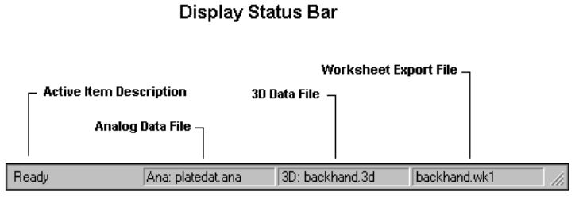
The right side of the DISPLAY Window Status Bar is divided into three fields. The first field displays the name of the currently active Analog file. If no analog file has been selected, no name will be displayed.
The second field displays the name of the currently active 3D file. If no 3D file has been selected, no name will be displayed.
The third field displays the name of the currently active worksheet file. If a worksheet file has not been specified for exporting the data, this field will remain blank.
The far left side of the status bar indicates the current status of the DISPLAY file. This field will usually state READY

TO START THE DISPLAY PROGRAM
1. Double-click the DISPLAY icon located in the APAS System window group. The main DISPLAY window will appear.

CREATING A NEW ANALOG DISPLAY FILE
The following steps are recommended for correct operation of the Display program.
- Choose the NEW command from the FILE menu. This will open a new *.DIS document with an empty list of Display data sets. A grid with 12 columns appears to display the active sample list.
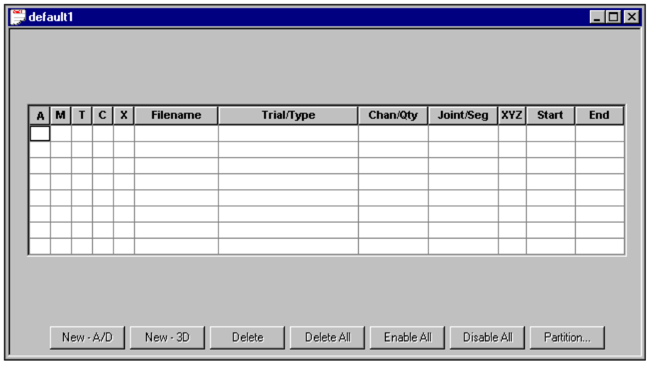
2. Select the ANALOG command from the FILE menu to specify an Analog (*.ANA) file for retrieving data sets. This selection can be changed at any time.
- Click on the NEW-A/D button below the “grid” and select a Save Trial and Channel from the active Analog file. Clicking the SELECT button will add the selected data set(s) to the list of data sets in the grid without leaving the dialog box. Select the OK button to enter the selected data set to the active data set display.
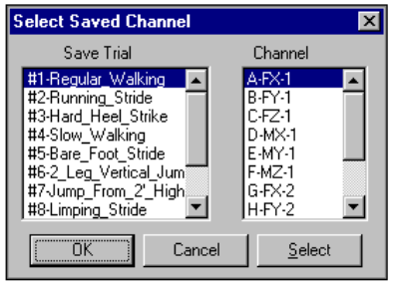
- Repeat Step #3 to select all data sets of interest.
The main "grid" displays information relating to the new data types. The first five columns are flags that are toggled by clicking on the grid element:
Column #1(A) - is used to mark individual entries as either active or inactive. Active channels will be graphed and displayed for analysis. If an entry is active, a "=>" will be displayed in the first column. If an entry is inactive, the first column will be blank. If the user selects FILE, SAVE AS and there are disabled channels, the program prompts the user whether or not to save disabled channels.
Column #2 (M) - is used to mark an individual entry as the Maximum Voluntary Contraction (MVC). Only one entry can be labeled as the MVC. The Maximum Voluntary Contraction channel is the channel where the subject has performed a maximum contraction. Marking a channel as the MVC is only required for normalizing using the MVC option.
Column #3 (T) - is used to mark an individual entry as the Trigger channel. Only one entry can be labeled as the Trigger. The Trigger channel is used in partitioning data. It typically is not an EMG channel but rather some other signal that helps one partition the analog data. An example would be a switch opening/closing to define an activity of interest.
Column #4 (C) - is used to for angle measurements. When this column is selected, the Complement angle will be displayed.
Column #5 (X) - is used to mark an individual entry as the X-axis for displaying X-Y graphs. Only one entry can be labeled as the X-axis.
Column #6 - is the Filename of the current data file.
Column #7 - is the Trial ID of the analog data file.
Column #8 - is the Channel ID of the analog data trial.
Column #9 - is left blank for analog data.
Column #10 - is left blank for analog data.
Columns #11/12 - are the start/end times for the analog data sample.

NEW-A/D - This button is selected to add a save trial from the currently active analog file.
NEW-3D - This button is selected to add a save trial from the currently active kinematic file.
DELETE - This button is selected to remove a save trial from the analysis table.
DELETE ALL - This button is selected to DELETE All the Save Trials in the analysis table.
ENABLE ALL - This button is selected to ACTIVATE All the Save Trials in the analysis table.
DISABLE ALL - This button is selected to INACTIVATE All the Save Trials in the analysis table. Disabled channels will not be graphed.
PARTITION - This button is selected to Partition the selected entries.
At this point, the program is ready to Graph the active data.

PARTITION
When studying biomechanical activity, it is often useful to analyze specific intervals of the entire signal. The Partition option allows the user to partition desired signals into smaller intervals for analysis. Multiple curves can be simultaneously partitioned. The following steps are recommended for partitioning biomechanical signals.
- Select the PARTITION button to display the Partition Channel menu.
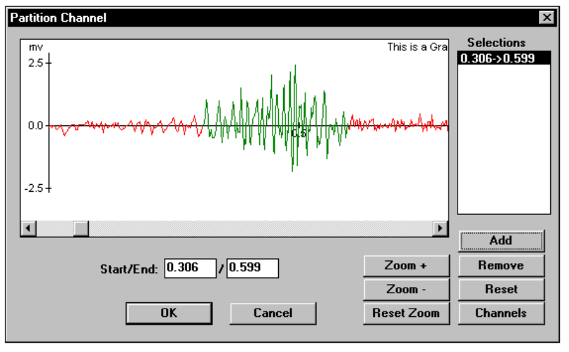
- Select the CHANNELS button to specify which data channels are active during the partitioning. Individual channels are selected by clicking in the Status column next to the desired channel. Selecting the Select All button can activate all channels. Selecting the Clear button can deactivate all channels. Select OK to proceed.
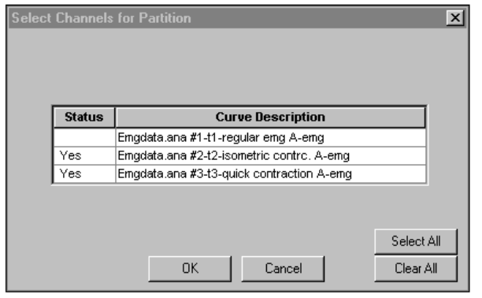
- Select the desired partition by clicking the left mouse button and dragging the cursor to highlight the desired partition. The partition will be seen as an alternate color.
- Select the Add button to enter the data in the partition list. Repeat step #3 for additional partitions.
- Select OK to return to the data entry table. The partition information will be updated in the table.

CREATING A NEW 3D DISPLAY FILE
The following steps are recommended for correct operation of the Display program.
- Choose the NEW command from the FILE menu. This will open a new *.DIS document with an empty list of Display data sets. A grid with 12 columns appears to display the active sample list.
2. Select the 3D command from the FILE menu to specify an APAS sequence (*.3D) file for retrieving data sets. This selection can be changed at any time.
- Click on the NEW-3D button below the “grid” and specify a 3D Data Trial from the active 3D file. Clicking the SELECT button will add the selected data set(s) to the list of data sets in the grid without leaving the dialog box. Select the OK button to enter the selected data set to the active data set display.
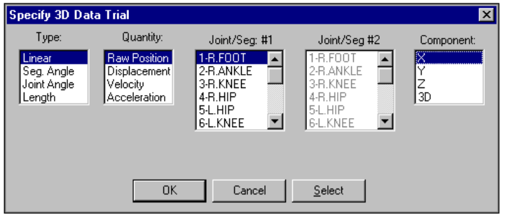
- Repeat Step #3 to select all desired data sets of interest.
The main "grid" displays information relating to the new data types. The first five columns are flags that are toggled by clicking on the grid element:
Column #1(A) - is used to mark individual entries as either active or inactive. Active channels will be graphed and displayed for analysis. If an entry is active, a "=>" will be displayed in the first column. If an entry is inactive, the first column will be blank. If the user selects FILE, SAVE AS and there are disabled channels, the program prompts the user whether or not to save disabled channels.
Column #2 (M) - is used to mark an individual entry as the Maximum Voluntary Contraction (MVC). Only one entry can be labeled as the MVC. The Maximum Voluntary Contraction channel is the channel where the subject has performed a maximum contraction. Marking a channel as the MVC is only required for normalizing using the MVC option.
Column #3 (T) - is used to mark an individual entry as the Trigger channel. Only one entry can be labeled as the Trigger. The Trigger channel is used in partitioning data. It typically is not an EMG channel but rather some other signal that helps one partition the analog data. An example would be a switch opening/closing to define an activity of interest.
Column #4 (C) - is used to for angle measurements. When this column is selected, the Complement angle will be displayed.
Column #5 (X) - is used to mark an individual entry as the X-axis for displaying X-Y graphs. Only one entry can be labeled as the X-axis.
Column #6 - is the Filename of the current data file.
Column #7 - is the TYPE (Linear, SegAngle...) for the 3D data file.
Column #8 - is the Quantity (Raw, Displacement, Velocity...) for the 3D data trial.
Column #9 - is the Joint(s) or Segment(s) for the 3D data file.
Column #10 - is the Component (X, Y, Z...) for the 3D data file.
Columns #11/12 - are the start/end times for the 3D data sample
NEW-A/D - This button is selected to add a save trial from the currently active analog file.
NEW-3D - This button is selected to add a save trial from the currently active kinematic file.
DELETE - This button is selected to remove a save trial from the analysis table.
DELETE ALL - This button is selected to DELETE All the Save Trials in the analysis table.
ENABLE ALL - This button is selected to ACTIVATE All the Save Trials in the analysis table.
DISABLE ALL - This button is selected to INACTIVATE All the Save Trials in the analysis table. Disabled channels will not be graphed.
PARTITION - This button is selected to Partition the selected entries.
At this point, the program is ready to Graph the active data.

PARTITION
When studying biomechanical activity, it is often useful to analyze specific intervals of the entire signal. The Partition option allows the user to partition desired signals into smaller intervals for analysis. Multiple curves can be simultaneously partitioned. The following steps are recommended for partitioning biomechanical signals.
- Select the PARTITION button to display the Partition Channel menu.
- Select the CHANNELS button to specify which data channels are active during the partitioning. Individual channels are selected by clicking in the Status column next to the desired channel. Selecting the Select All button can activate all channels. Selecting the Clear button can deactivate all channels. Select OK to proceed.
- Select the desired partition by clicking the left mouse button and dragging the cursor to highlight the desired partition. The partition will be seen as an alternate color.
- Select the Add button to enter the data in the partition list. Repeat step #3 for additional partitions.
- Select OK to return to the data entry table. The partition information will be updated in the table.

X VS Y GRAPH
When studying a biomechanical activity, an analysis technique that is sometimes used is to plot one signal against another. The APAS software designates this as an X-Y plot where the X-axis of the plot (normally designated with time values) is replaced with a user-selected graph.
The following steps are recommended for creating X-Y plots.
- Select the desired graph to be used for the X-axis and mark this by clicking in the 5th column of the display grid. This column is labeled as the X column. All other active graphs will be displayed on the Y-axis. NOTE: Only one entry can be designated as the X-axis.
- Select the GRAPH menu and the DATA command to display the Graph Data Options menu.
- In the General section, make certain the X-Y Plot is selected. If this option is not checked, the X-axis of the plot will still display in time units.
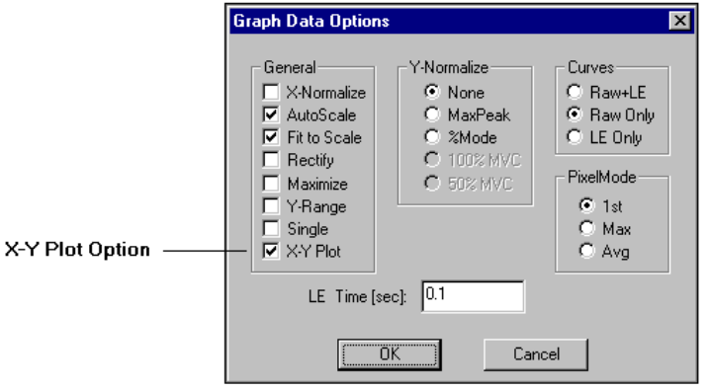
Graph Data Options Menu
4. Select the OK button to display the X-Y plot.

LINEAR GRAPH
Linear is selected to plot joint motion (displacement, velocity or acceleration) in the standard Cartesian coordinate system. An additional curve measure, Raw Position, may be selected for linear type curves. This measure represents the actual digitized position values prior to data smoothing. In the Cartesian system, motion is represented either by X, Y & Z coordinate components which are signed values with implicit direction, or by resultant “3D” magnitude which is an unsigned valued with no implicit direction. The coordinate system is the one selected for the “control points” used to calibrate the image space, and the units of measurement are those initially specified for this sequence.
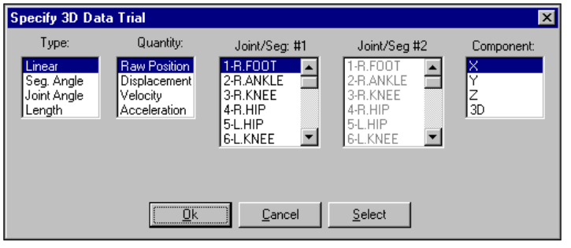
The following steps are recommended for creating Linear plots.
- Select the NEW -3D button below the display grid.
- Set the TYPE column to LINEAR.
- Set the QUANTITY column to the desired parameter. Available choices are Raw Position, Displacement, Velocity and Acceleration.
- Set the Joint/Segment #1 column to the desired joint. Available choices are determined by the Point ID’s that were established in the Digitizing module.
- Set the COMPONENT column to the desired parameter. Available choices are X, Y, Z and 3D (Magnitude).
- Click the OK or SELECT button. NOTE: Clicking the SELECT button will add the selected data set(s) to the list of data sets in the grid without leaving the dialog box. This allows additional entries to be made to the grid. Select the OK button to enter the selected data set to the active data set display and close the current menu.
- Select the GRAPH menu and specify the desired type of graph. Available choices are Data, AVG/RMS, Integral and Power. Refer to the section titled “Graph Options For Data File” for additional graphing options.
- Specify the desired graphing options and select the OK button to display the graph in a new window.

SEGMENT ANGLE GRAPH
The digitized figure can be described as segments linked together at the joints and is basically a system of moving segments or links. Segment Angle is selected to plot the motion (displacement, velocity or acceleration) of an individual SEGMENT about one endpoint in the polar coordinate system. In this system, motion is represented by an angular component about the pole (segment endpoint) as viewed along one of the coordinate axis directions. Angular units are always the same (degrees) regardless of the linear units chosen for this sequence. Segment angles are selected from the list of segments for a project as determined by the joint connection table.
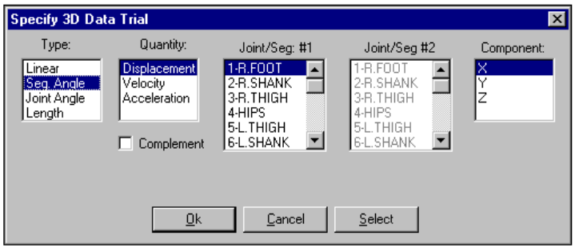
The following steps are recommended for creating Segment Angle plots.
- Select the NEW -3D button below the display grid.
- Set the TYPE column to SEG ANGLE.
- Set the QUANTITY column to the desired parameter. Available choices are Displacement, Velocity and Acceleration.
- Set the Joint/Segment #1 column to the desired segment. Available choices are determined by the segments that were established in the Digitizing module.
- Set the COMPONENT column to the desired parameter. Available choices are X, Y, and Z. For segment angle curves, this component represents the viewing axis.
- Select the COMPLEMENT option to display the complement angle
- Click the OK or SELECT button. NOTE: Clicking the SELECT button will add the selected data set(s) to the list of data sets in the grid without leaving the dialog box. This allows additional entries to be made to the grid. Select the OK button to enter the selected data set to the active data set display and close the current menu.
- Select the GRAPH menu and specify the desired type of graph. Available choices are Data, AVG/RMS, Integral and Power. Refer to the section titled “Graph Options For Data File” for additional graphing options.
- Specify the desired graphing options and select the OK button to display the graph in a new window.

JOINT ANGLE GRAPH
Joint Angle is usually selected to plot the motion (displacement, velocity or acceleration) of one segment relative to another about the joint that they share in common. Motion is reported in the polar coordinate system as a relative angular component about the pole (joint) either as viewed along one of the coordinate axis direction, or as viewed along the perpendicular to the plane of the two segments. Angular units are always the same (degrees) regardless of the linear units chosen for this sequence. Selecting 2 segments from the segment list specifies joint angles. In this way the angle between ANY two segments, not necessarily ones with a common joint, can be graphed.
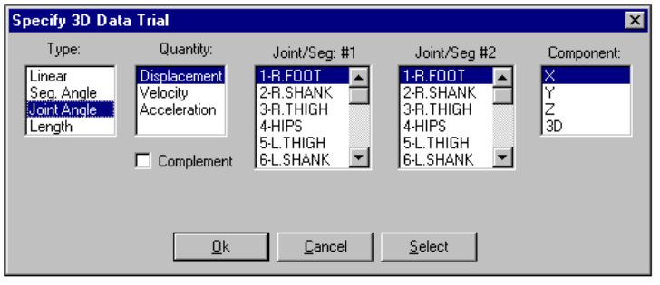
The following steps are recommended for creating Joint Angle plots.
- Select the NEW -3D button below the display grid.
- Set the TYPE column to JOINT ANGLE.
- Set the QUANTITY column to the desired parameter. Available choices are Displacement, Velocity and Acceleration.
- Set the Joint/Segment #1 column to the first desired segment. Available choices are determined by the segments that were established in the Digitizing module.
- Set the Joint/Segment #2 column to the second desired segment. Available choices are determined by the segments that were established in the Digitizing module.
- Set the COMPONENT column to the desired parameter. Available choices are X, Y, Z and 3D.
- Select the COMPLEMENT option to display the complement angle.
- Click the OK or SELECT button. NOTE: Clicking the SELECT button will add the selected data set(s) to the list of data sets in the grid without leaving the dialog box. This allows additional entries to be made to the grid. Select the OK button to enter the selected data set to the active data set display and close the current menu.
- Select the GRAPH menu and specify the desired type of graph. Available choices are Data, AVG/RMS, Integral and Power. Refer to the section titled “Graph Options For Data File” for additional graphing options.
Specify the desired graphing options and select the OK button to display the graph in a new window.

LENGTH GRAPH
Length is selected to plot the linear distance between two joints. The units of measurement are those initially specified for this sequence. Selecting 2 joints from the joint list specifies lengths. In this manner, the length between ANY two joints, not necessarily ones with a common segment, can be measured and graphed.
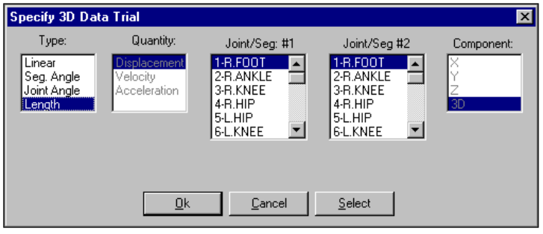
The following steps are recommended for creating Length plots.
- Select the NEW -3D button below the display grid.
- Set the TYPE column to LENGTH.
- Set the Joint/Segment #1 column to the first desired joint. Available choices are determined by the Point ID’s that were established in the Digitizing module.
- Set the Joint/Segment #2 column to the second desired joint. Available choices are determined by the Point ID’s that were established in the Digitizing module.
- Click the OK or SELECT button. NOTE: Clicking the SELECT button will add the selected data set(s) to the list of data sets in the grid without leaving the dialog box. This allows additional entries to be made to the grid. Select the OK button to enter the selected data set to the active data set display and close the current menu.
- Select the GRAPH menu and specify the desired type of graph. Available choices are Data, AVG/RMS, Integral and Power. Refer to the section titled “Graph Options For Data File” for additional graphing options.
- Specify the desired graphing options and select the OK button to display the graph in a new window.

CREATING ADDITIONAL VIEWS FOR DISPLAY
A complete analysis often requires data to be analyzed from many independent sources. The Display program allows the ability to simultaneously display various data windows to help provide the complete picture of the analysis. These data windows include graphs, stick figures, video and worksheet options. All data windows within a single project are automatically synchronized and can be animated either forward or reverse. Multiple projects can also be opened simultaneously and "locked" together if desired. A description of each of the data views is listed below. Graphing options will be discussed in the following section.

STICK FIGURE VIEW
The stick figure created by the TRANSFORM module may be displayed in a separate window. This figure can be either two-dimensional or three-dimensional depending on the number of camera views used for the transformation. Display modes include either Single or Multiple. The Stick-Figure view can be created using the following procedure.
- Make certain that a 3D data set is entered in the Display grid.
- Select the STICK FIGURE command from the VIEW menu (or select the Stick Figure icon located in the ToolBar). The stick figure will be displayed in a new data window.
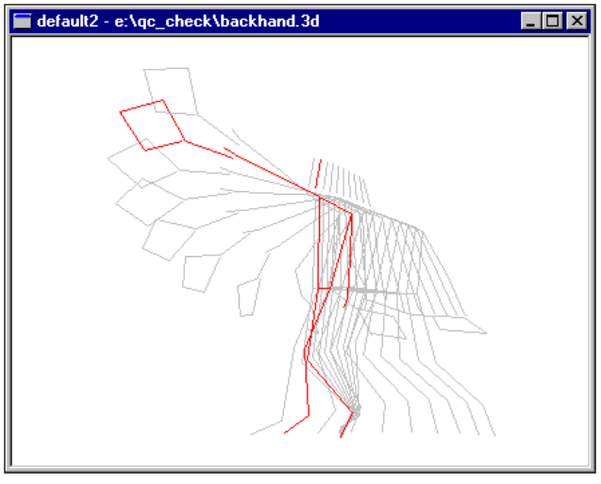
The Stick Figure can be toggled between Single and Multiple display by selecting the MULTIPLE command from the VIEW menu or by clicking the Single/Multiple icon located in the Toolbar. If the Multiple mode is selected, the stick figure for the entire time period is displayed in a light gray color. The stick figure for the current frame is displayed in red.

VIDEO DATA VIEW
Video data is captured to the hard drive for use in the Digitizing process. These AVI format files can be displayed in a separate data window and provides the ability to "see" where the data originated. The Video view can be created using the following procedure.
- Make certain that a 3D data set is entered in the Display grid.
- Select the VIDEO command from the VIEW menu (or select the Video icon located in the ToolBar). The Open menu will appear.
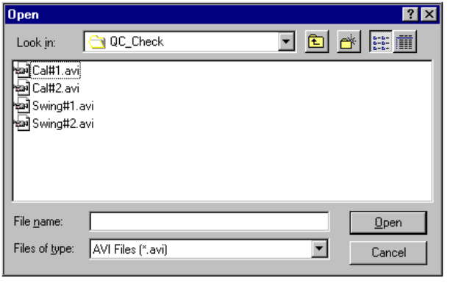

- Select the desired video file for display by highlighting the file name and selecting the OPEN button or by double-clicking the file name. The Select Synch Video Frame menu will appear.

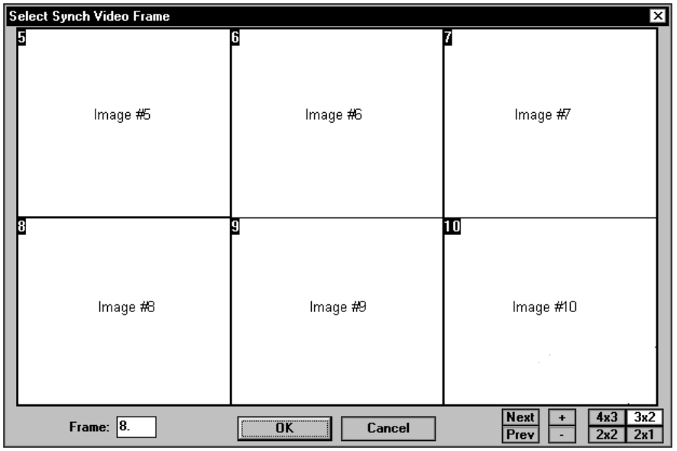

4. Select the Synch Video Frame using the cursor and the left button of the mouse. NOTE: Make certain that the selected synch frame matches the current time value displayed in the Toolbar, otherwise, the video images will not be synchronized with the other data windows. The video images will be displayed in the Synch Video Frame window. Selecting the buttons in the lower right corner of the window can change the format of the display. Double-clicking on one image will maximize it to the current window. Another double-click will reset the image size. Images can be advanced/reversed one-at-a-time by selecting the +/- button. Selecting the Next/Previous buttons will step advance by the number of images currently displayed.
5. Select the OK button at the bottom of the Synch Video Frame menu to display the video file in a new window.

VIDEO + STICK DATA VIEW
Video data is captured to the hard drive for use in the Digitizing process. These AVI format files can be displayed in a separate data window and provides the ability to "see" where the data originated. The Video + Stick view can be created using the following procedure.
- Make certain that a 3D data set is entered in the Display grid.
- Select the VIDEO+STICK command from the VIEW menu (or select the Video+Stick icon located in the ToolBar). The Open View File menu will appear.
- Select the desired view file (*.1t, *.2t etc) by highlighting the file name and selecting the OPEN button or by double-clicking the file name.
- A confirmation message will be displayed indicating the AVI file that was used for digitizing this view. Select the YES button to confirm the use of this AVI file. Select NO to select another AVI file for display.
- Once the AVI file is selected, a new window will be displayed with the 2D stick figure superimposed on the AVI file.

TABLE DATA VIEW
The Table data option allows the ability to see the numerical result of the data in a tabular "worksheet" format. This numerical data can be directly exported to a worksheet for additional analysis. The Table view can be created using the following procedure.

- Make certain that a 3D or ANALOG data set is entered in the Display grid.
- Select the TABLE command from the VIEW menu (or select the Table icon located in the ToolBar). The Table Options menu will appear.
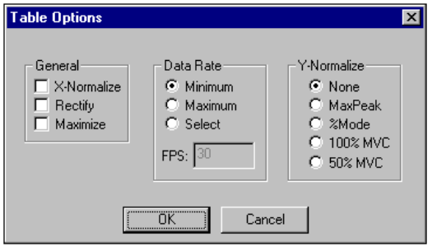
GENERAL
X-Normalize - Selected to normalize all selected graphs to the same time scale (X-axis). All the active graphs will be normalized to the same time scale as the graph with the smallest time period.
Rectify - Selected to perform a full-wave rectification on the "raw" signal.
Maximize - Selected to enlarge the window to the maximum size.

DATA RATE
Minimum - Selected to use the Minimum data rate for reporting the table data.
Maximum - Selected to use the Maximum data rate for reporting table data.
Select - Selected manually specify the data rate for reporting table data..
FPS - This field is only active with the SELECT option above. Enter the frame rate for reporting the tabular data.

Y-NORMALIZE
None - Selected to display the graph(s) without Y-Normalization being performed.
MaxPeak - Selected to normalize all the curves so that all curves will have a peak value for the envelope equal to the curve that un-normalized had the largest envelope value.
%Mode - Selected to scale each curve so that the peak value for the envelope curve is 100%.
100% MVC - Selected to perform the Linear Envelope of this data and normalize the other active channels to the MVC channel. It is often desired to normalize to 100% of this "maximum" contraction value. For example, if the MVC channel has a peak value (LE) of 4.0mv and 100% normalization has been selected, then other channels would be normalized so that their peaks would be 4.0 mv.
50% MVC - Selected to perform the Linear Envelope of this data and normalize the other active channels to the MVC channel. It is often desired to normalize to 50% of this "maximum" contraction value. For example, if the MVC channel has a peak value (LE) of 4.0mv and 50% normalization has been selected, then other channels would be normalized so that their peaks would be 2.0 mv.
3. Specify the desired Table Options and select the OK button from the Table Options menu to display the Tabular data in a new window.
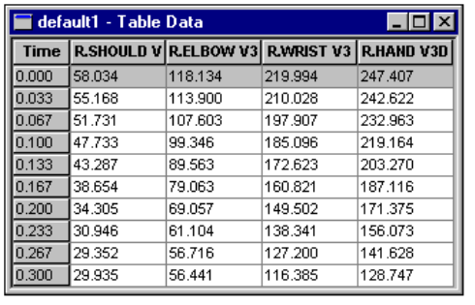
The highlighted row indicates the current time value and corresponding data values for each of the selected curves.

GRAPH OPTIONS FOR DATA FILE
Once the desired trials have been entered into the table, activated and partitioned (if desired), the data can be graphed utilizing several analysis options.
- Select the GRAPH menu to display the available graphing options for the display data.

DATA
The Data command provides several options for graphing and analyzing the "raw" data signal. When this command is selected, the GRAPH DATA OPTIONS menu will be displayed.
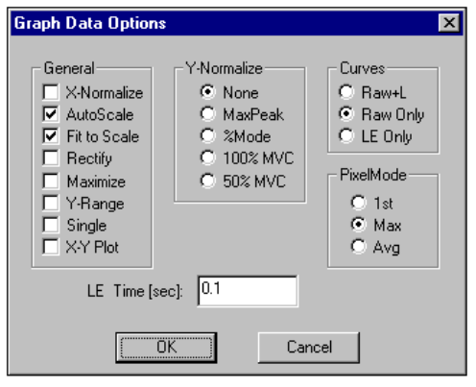

GENERAL
X-Normalize - Selected to normalize all selected graphs to the same time scale (X-axis). All the active graphs will be normalized to the same time scale as the graph with the smallest time period.
AutoScale - Selected to display the entire graph(s) with maximum resolution. The size of the graph remains constant, regardless of the size of the display window.
Fit to Scale - Selected to display the entire graph regardless of the size of the window. If the window size is adjusted, the graph will also adjust to fit the new size of the window.
Rectify - Selected to perform a full-wave rectification on the "raw" signal.
Maximize - Selected to enlarge the window to the maximum size.
Y-Range - Selected to scale the Y-axis to be expanded when the data range would normally leave a large empty area between the minimum data value and the origin. The graph is expanded by producing a break or discontinuity in the Y-axis, whenever the range of data values being graphed is an appreciable distance from the origin. Normally the axis is drawn on a continuous scale from the origin to the maximum data values.
Single - Selected to graph the active curves all on a single graph. If not selected, each active curve is graphed independently.
X-Y Plot - Selected to graph data sets in an X vs. Y format. In order to generate an X-Y graph one must have a data set with the "X" option indicated and must select "X-Y Plot" option.

Y-NORMALIZE
None - Selected to display the graph(s) without Y-Normalization being performed.
MaxPeak - Selected to normalize all the curves so that all curves will have a peak value for the envelope equal to the curve that un-normalized had the largest envelope value.
%Mode - Selected to scale each curve so that the peak value for the envelope curve is 100%.
100% MVC - Selected to perform the Linear Envelope of this data and normalize the other active channels to the MVC channel. It is often desired to normalize to 100% of this "maximum" contraction value. For example, if the MVC channel has a peak value (LE) of 4.0mv and 100% normalization has been selected, and then other channels would be normalized so that their peaks would be 4.0 mv.
50% MVC - Selected to perform the Linear Envelope of this data and normalize the other active channels to the MVC channel. It is often desired to normalize to 50% of this "maximum" contraction value. For example, if the MVC channel has a peak value (LE) of 4.0mv and 50% normalization has been selected, and then other channels would be normalized so that their peaks would be 2.0 mv.

CURVES
Raw + LE - Selected to graphically display the Raw data curve as well as the computed Linear Envelope (LE) curve.
Raw Only - Selected to graphically display only the Raw data curve.
LE Only - Selected to graphically display only the computed Linear Envelope curve.

PIXEL MODE
Due to the high sampling rate of analog signals, one pixel often corresponds to many A/D samples. The number of data points is divided by the available pixels to determine the number of data points represented by each pixel. Each "set" of pixels can be represented in various ways.
1st - Selected to use the First data point of each group to represent the entire group.
Max - Selected to use the Maximum data point of each group to represent the entire group.
Avg - Selected to use the computed Average of all the data point of each group to represent the entire group.

LE TIME (sec)
This field is used to enter the time interval for the Linear Envelope (LE). The LE is used to remove rapid signal fluctuations by averaging over an interval that is longer than the duration of individual "spikes" or fluctuations. It is similar in nature to a low-pass analog filter. The longer the time constant, the lower the cutoff frequency of this filter. Some experimentation may be necessary, however, a default value of 0.1 seconds will be displayed.

AVG/RMS
The AVG/RMS command provides several options for graphing and analyzing the Average signal. When this command is selected, the AVG/RMS GRAPH OPTIONS menu will be displayed.
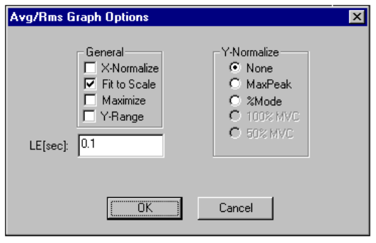

GENERAL
X-Normalize - Selected to normalize all selected graphs to the same time scale (X-axis). All the active graphs will be normalized to the same time scale as the graph with the smallest time period.
Fit to Scale - Selected to display the entire graph regardless of the size of the window. If the window size is adjusted, the graph will also adjust to fit the new size of the window.
Maximize - Selected to enlarge the window to the maximum size.
Y-Range - Selected to scale the Y-axis to be expanded when the data range would normally leave a large empty area between the minimum data value and the origin. The graph is expanded by producing a break or discontinuity in the Y-axis, whenever the range of data values being graphed is an appreciable distance from the origin. Normally the axis is drawn on a continuous scale from the origin to the maximum data values.

Y-NORMALIZE
None - Selected to display the graph(s) without Y-Normalization being performed.
MaxPeak - Selected to normalize all the curves so that all curves will have a peak value for the envelope equal to the curve that un-normalized had the largest envelope value.
%Mode - Selected to scale each curve so that the peak value for the envelope curve is 100%.
100% MVC - Selected to perform the Linear Envelope of this data and normalize the other active channels to the MVC channel. It is often desired to normalize to 100% of this "maximum" contraction value. For example, if the MVC channel has a peak value (LE) of 4.0mv and 100% normalization has been selected, and then other channels would be normalized so that their peaks would be 4.0 mv.
50% MVC - Selected to perform the Linear Envelope of this data and normalize the other active channels to the MVC channel. It is often desired to normalize to 50% of this "maximum" contraction value. For example, if the MVC channel has a peak value (LE) of 4.0mv and 50% normalization has been selected, and then other channels would be normalized so that their peaks would be 2.0 mv.

LE TIME (sec)
This field is used to enter the time interval for the Linear Envelope (LE). The LE is used to remove rapid signal fluctuations by averaging over an interval that is longer than the duration of individual "spikes" or fluctuations. It is similar in nature to a low-pass analog filter. The longer the time constant, the lower the cutoff frequency of this filter. Some experimentation may be necessary, however, a default value of 0.1 seconds will be displayed.

INTEGRAL
The INTEGRAL command is selected to perform one of several types of integration on the analog data signal. These integration options produce data curves representing the integral or area under the input curve in different formats. When this command is selected, the INTEGRAL OPTIONS menu will be displayed.
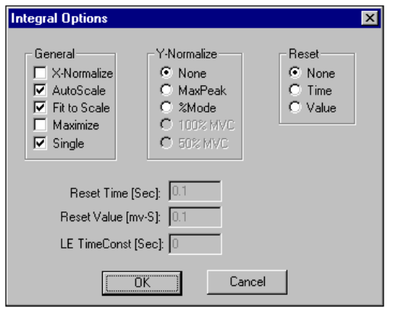

GENERAL
X-Normalize - Selected to normalize all selected graphs to the same time scale (X-axis). All the active graphs will be normalized to the same time scale as the graph with the smallest time period.
AutoScale - Selected to display the entire graph(s) with maximum resolution. The size of the graph remains constant, regardless of the size of the display window.
Fit to Scale - Selected to display the entire graph regardless of the size of the window. If the window size is adjusted, the graph will also adjust to fit the new size of the window.
Maximize - Selected to enlarge the window to the maximum size.
Single - Selected to graph the active curves all on a single graph. If not selected, each active curve is graphed independently.

Y-NORMALIZE
None - Selected to display the graph(s) without Y-Normalization being performed.
MaxPeak - Selected to normalize all the curves so that all curves will have a peak value for the envelope equal to the curve that un-normalized had the largest envelope value.
%Mode - Selected to scale each curve so that the peak value for the envelope curve is 100%.
100% MVC - Selected to perform the Linear Envelope of this data and normalize the other active channels to the MVC channel. It is often desired to normalize to 100% of this "maximum" contraction value. For example, if the MVC channel has a peak value (LE) of 4.0mv and 100% normalization has been selected, and then other channels would be normalized so that their peaks would be 4.0 mv.
50% MVC - Selected to perform the Linear Envelope of this data and normalize the other active channels to the MVC channel. It is often desired to normalize to 50% of this "maximum" contraction value. For example, if the MVC channel has a peak value (LE) of 4.0mv and 50% normalization has been selected, and then other channels would be normalized so that their peaks would be 2.0 mv.

RESET
Select one of the following Reset options for integrating the signal.
None - Selected to perform a summing integral or an integral with "No-reset." The curve value represents the cumulative integral of the input channel and thus is a monotonically increasing curve.
Time - Selected to perform a constant frequency resetting integral. The integral curve is cumulative for a specified "Time" interval, then is reset to zero and begins accumulating again. This produces a series of peaks at a constant interval whose amplitude indicates the level of activity of the analog signal.
Value - Selected to perform a constant amplitude resetting integral. The integral curve is cumulative until a specified "Value" is reached, then is reset to zero and begins accumulating again. This produces a series of peaks at a constant amplitude whose frequency indicates the level of activity of the analog signal.

RESET TIME (sec)
This field is used to enter the time interval for the Time Reset option.

RESET VALUE (mv-sec)
This field is used to enter the value for the Value Reset option.

LE TIME (sec)
This field is used to enter the time interval for the Linear Envelope (LE). The LE is used to remove rapid signal fluctuations by averaging over an interval that is longer than the duration of individual "spikes" or fluctuations. It is similar in nature to a low-pass analog filter. The longer the time constant, the lower the cutoff frequency of this filter. Some experimentation may be necessary, however, a default value of 0.1 seconds will be displayed.

POWER
The POWER command is selected to perform a power spectrum analysis of the data signal. This analysis produces a graph of power as a function of frequency based on a Fourier decomposition of the analog signal. Power is defined as the sum of the squares of the Fourier coefficients. Since analog signals may consist of many component frequencies, this type of analysis provides an indication of the dominant frequencies and their relative amplitudes within the composite signal. When this command is selected, the POWER GRAPH OPTIONS menu will be displayed.
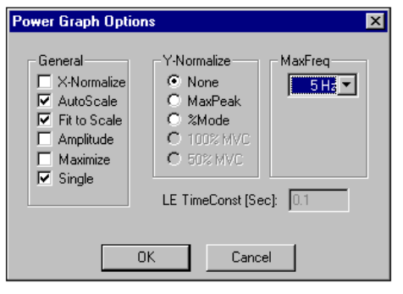

GENERAL
X-Normalize - Selected to normalize all selected graphs to the same time scale (X-axis). All the active graphs will be normalized to the same time scale as the graph with the smallest time period.
AutoScale - Selected to display the entire graph(s) with maximum resolution. The size of the graph remains constant, regardless of the size of the display window.
Fit to Scale - Selected to display the entire graph regardless of the size of the window. If the window size is adjusted, the graph will also adjust to fit the new size of the window.
Amplitude - Selected to perform an Amplitude analysis on the active channels. This analysis produces a graph of Amplitude as a function of frequency.
Maximize - Selected to enlarge the window to the maximum size.
Single - Selected to graph the active curves all on a single graph. If not selected, each active curve is graphed independently.

Y-NORMALIZE
None - Selected to display the graph(s) without Y-Normalization being performed.
MaxPeak - Selected to normalize all the curves so that all curves will have a peak value for the envelope equal to the curve that un-normalized had the largest envelope value.
%Mode - Selected to scale each curve so that the peak value for the envelope curve is 100%.
100% MVC - Selected to perform the Linear Envelope of this data and normalize the other active channels to the MVC channel. It is often desired to normalize to 100% of this "maximum" contraction value. For example, if the MVC channel has a peak value (LE) of 4.0mv and 100% normalization has been selected, and then other channels would be normalized so that their peaks would be 4.0 mv.
50% MVC - Selected to perform the Linear Envelope of this data and normalize the other active channels to the MVC channel. It is often desired to normalize to 50% of this "maximum" contraction value. For example, if the MVC channel has a peak value (LE) of 4.0mv and 50% normalization has been selected, and then other channels would be normalized so that their peaks would be 2.0 mv.

MAX FREQ
Select the Maximum Frequency for the computation of the power spectrum. Only the power component frequencies below the maximum frequency will be reported. This allows the user to scale the power spectrum to the frequency band most applicable to the signal being studied.
The largest value for the maximum frequency that can be detected in a power spectrum analysis is the Nyquist or "folding frequency" which is one-half the frequency of data measurement. Be aware that if there are frequencies in the input signal above the folding frequency, aliasing (high frequency signals "appearing" as low frequency signals) may occur. To properly interpret a power spectrum measurement on an analog signal, one must know the true range of frequencies in the data.

LE TIME (sec)
This field is used to enter the time interval for the Linear Envelope (LE). The LE is used to remove rapid signal fluctuations by averaging over an interval that is longer than the duration of individual "spikes" or fluctuations. It is similar in nature to a low-pass analog filter. The longer the time constant, the lower the cutoff frequency of this filter. Some experimentation may be necessary, however, a default value of 0.1 seconds will be displayed.

TEMPLATES
When analyzing multiple data files, it is often useful to generate the same results for each data file. The template option has been incorporated into the Display program to perform this function. A template file can be created with the desired results displayed in the data windows. Then by simply changing the file name, the same output is generated for successive files.

CREATING A NEW TEMPLATE
A template is created to define the type of data to be displayed in the data window. Templates are created using the steps listed below.
- Select the CREATE command from the TEMPLATES menu. The “Create a New Template” menu appears on the display.
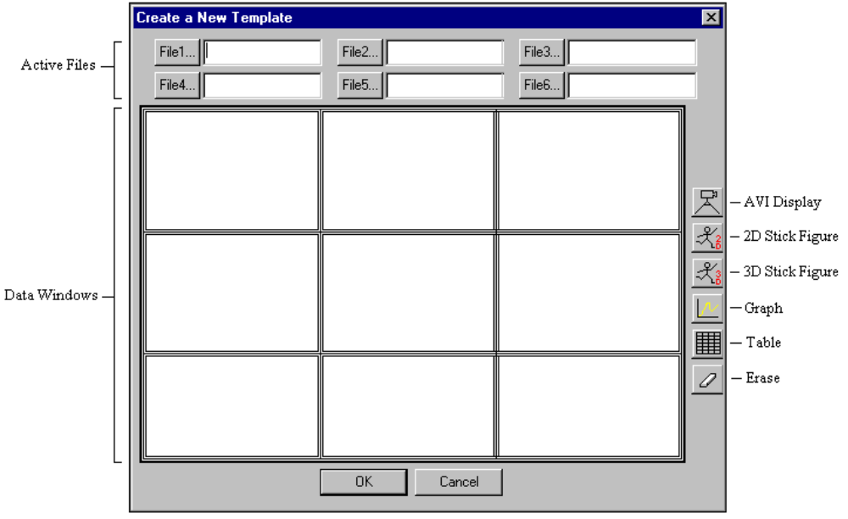

In this display there is a graphic that contains a 3x3 grid of windows, a column of 6 icons along the right side of the 3x3 grid, and an entry for 6 active files above the 3x3 grid. The 6 icons are a “camera’ for AVI display, a “stick figure” for 2D and 3D stick figure display, a “graph” for a graph display, a “grid” for numerical table display and an “eraser” to remove any display.
- Select the data file(s) of interest for the template. Any one of the 6 file entries are made by clicking on the appropriate “File” button and then selecting the appropriate file type and name with the standard “Open File” dialog.
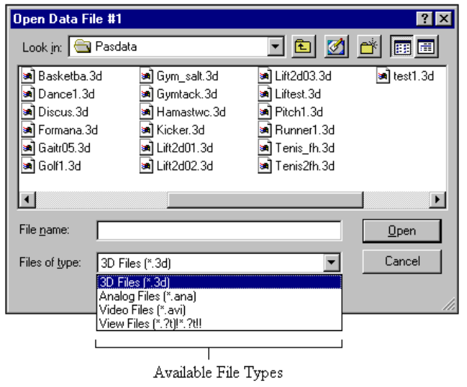

Available file types include *.3D (kinematic), *.ANA (analog), *.AVI (video) and *.?T (digitized stick figure). After a selection is made, it will appear in the edit box to the right of the file button.
3. Specify the type of data to be displayed in each data window. Each window in the 3x3 grid represents a data window that will appear as a 3x3 grid of data windows when the template is activated. The data type is specified by dragging one of the 6 icons to the right of the 3x3 grid and dropping it in one of the grid windows. The program will only allow drag/drop for an icon if the selected file type matches the icon. For example, if the user wishes the upper left window to be a graph display, the “graph” icon would be dragged to and dropped into the upper left window of the 3x3 grid. The program will allow this only if at least one of the 6 allowed files is a 3D file.
4. When the mouse button is released in a drag/drop operation, a dialog appropriate for the icon dropped will appear where the data needed will be entered. For example, if a “graph” icon is dropped, a dialog appears to identify which of the 6 files to use for data and the quantities to graph. After this is completed, the information for the 3x3 window will appear in the selected data window.
5. When the template is completely established, select the OK button. At this point, the program will prompt the user to provide a unique name for the template. The template is now complete and saved.

OPENING A TEMPLATE
Once a template is created, it can be used for displaying data from almost any data file. Follow the instructions below to utilize an existing template.
- Select the OPEN command from the TEMPLATES menu. A dialog will appear with all of the existing templates listed.

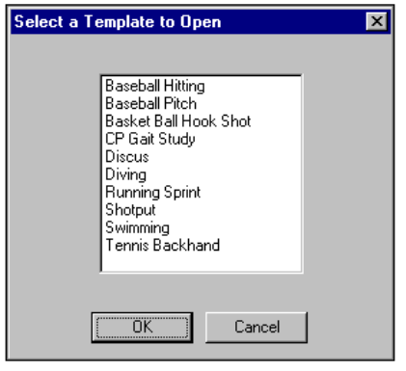

2. Select the desired template and then the OK button. A dialog will appear which is similar to the dialog that appeared when creating the template. The main difference is that the column of 6 icons is missing. The only items that may be changed are the 6 file entries. The idea is that all the data windows remain constant but the files for the data windows change.
3. Select the new data files to be used in the template by clicking any of the 6 File buttons and selecting new data files.
4. After the data files are selected, click the OK button. Assuming that new files have been entered, the program will prompt to save the template with a new name (keeping the original template intact). Selecting OK will save the new template while selecting CANCEL will not. At this point the data display appears.
NOTE: Once a template is opened and displayed, some things work a bit differently. While a template is active, the list of data trials listed in the primary view for the document is completely under computer control. The user cannot add or remove any entries or create new Stick/Video views. The user is restricted to the 9 windows generated by the APAS template. However, the normal actions of Play/Pause etc. Are still available. A “Normal” view can be generated from any of the 9 template views by double-clicking the desired data window with the left mouse button. While the 9 views are active, an attempt to make a hard copy will print out an image of the whole 3x3 window.

EDITING TEMPLATES
Individual templates can be modified using the Edit command. This command allows the user to change any of the parameters for a template and save the changes under the same template name.
1 Select the EDIT command from the TEMPLATES menu. A list of the existing templates will be displayed.

- Left-click on the template to be edited and select the OK button. . A dialog will appear which is similar to the dialog that appeared when creating the template.
- Make the desired changes to the template using the same functions as when the template was created.
- After the template editing has been completed, select the OK button to save the changes in the same template name.

REMOVE TEMPLATES
The actual templates are stored in a single file called “APAS Display Templates.tpl” in the APAS directory along with the APAS executable files. Deleting this file removes all templates. Individual templates can be deleted using the Remove command.
1 Select the REMOVE command from the TEMPLATES menu. A list of the existing templates will be displayed.

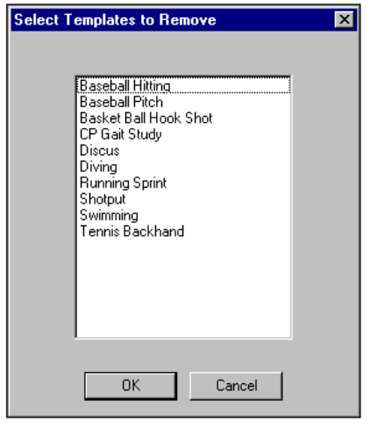

- Left-click on the template(s) to be removed. An item selected for removal will be highlighted. A single mouse click will act as a toggle to select/de-select an item for removal.
- Select the OK button to delete the selected templates.

TOOLS FOR DISPLAY
The Tools menu provides additional options for enhanced data analysis. Options include the commands to zoom the X and Y-axes, options to add text and numeric labels to the graph, and the ability to align the stick figures along the coordinate axes.

ZOOM
The Zoom command is selected to expand the X and/or Y-axis of the graph. This option is useful when attempting to isolate specific areas of the graph for study. It can also be useful for graphs of analog data where there may be thousands of data points in a single graph.
- Select the ZOOM-X and/or ZOOM-Y command from the TOOLS menu (or the ZOOM-X and ZOOM-Y icons from the toolbar). The Zoom-X command will expand only the X-axis of the graph while the Zoom-Y command will expand only the Y axis. These commands can be selected multiple times to maximize the resolution of the plot. NOTE: The Zoom commands are only allowed when the active window is a graph. These commands do not work with windows containing stick figures, video or tables.
- Select the UNZOOM command from the TOOLS menu (or the UNZOOM icon from the toolbar) to remove all zooming actions and return to the original graph.

LABEL
The Label command is selected to add/remove text labels to the plot or graph. In addition, numeric values and intervals as measured directly from data curves can be included as labels.
Adding Labels To The Graph
- Select the LABEL, ADD commands from the TOOLS menu (or the LABEL icon in the toolbar) to display the Enter Label Info menu.
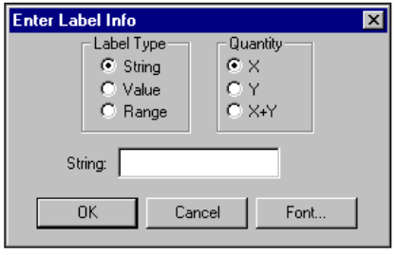

2. Specify the Label Type and Quantity
Label Types
String: Selected to create a normal text label. When this label type is selected, the text label is entered in the String field.
Value: Value is selected to create labels reporting the horizontal or vertical coordinate values of specified points on the current data curve graph. When this label type is selected, the user must specify an X (horizontal), a Y (Vertical) or X+Y (combination) coordinate value and then use the mouse to indicate the particular point(s) for which to calculate and report the values. This label will be “connected” to the specified points by a line.
Range: Range is selected to create labels reporting the value of horizontal or vertical intervals or “ranges” on the current graph. When this label type is selected, the user must specify an X (horizontal, Y (Vertical) or X+Y (Combination) range and then use the mouse to indicate the interval (starting and ending points) over which to calculate and report the range value. This label will be connected to this interval with a line to each endpoint.
Quantity
X: “X” is selected to create a label with a point or range values measured in X coordinate units. When this option is selected, the user must enter the desired point or range (two points) using the mouse. The numeric X value for that point or range will then appear on the graphic display for placement by the user.
Y: “Y” is selected to create a label with a point or range value measured in Y coordinate units. When this option is selected, the user must enter the desired point or range (two points) using the mouse. The numeric Y value for that point or range will then appear on the graphic display for placement by the user.
X+Y: “X+Y” is selected to create a label with a point or range value measured in X,Y coordinate units. When this option is selected, the user must enter the desired point or range (two points) using the mouse. The numeric X,Y value for that point or range will then appear on the graphic display for placement by the user.
FONT: The Font button is selected to change the font, style, size, color and effects of the labels.
3. Select the OK button to display the Label Create Instructions menu. This menu provides exact instructions for the selected Label Type. The example below shows the instruction for placing a String (text) label. Press the ESC key on the keyboard or click the right mouse button to abort the labeling process.
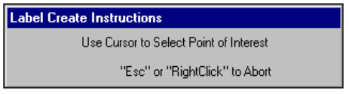

Removing Labels From The Graph
- Select the LABEL, REMOVE commands from the TOOLS menu to display the Remove Labels menu. All labels for the active graph are displayed in the “Label: column of the display. The “Use” column indicates which labels should be drawn on the graph.
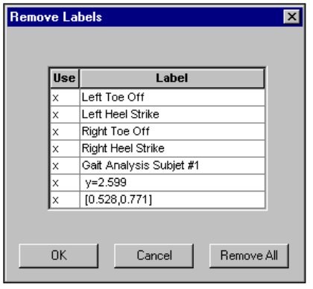

- Specify the Label(s) to be removed. The “x” in the first column indicates that this label will be placed on the graph. When the first column is blank, the label will be removed from the graph. Left click on either the x or the label to toggle the label on or off. Selecting the Remove All button will remove all labels from the graph.
- Select OK to redraw the graph with the specified changes.

ALIGN
The “Align” option allows the stick figure to be oriented in a direction determined by the data points themselves, rather than along one of the coordinate axes. When this option is selected, the user will be prompted to choose an orientation direction as a line defined by a single point in two different frames (i.e. the direction of movement of a point). The software performs a rotation of the image about the “Y” coordinate axis until the projection of the orientation direction line in the plane perpendicular to the rotation axis is aligned with the specified axis. The steps to “align” a stick figure are explained below.
As an example, consider a sequence of a golfer hitting a ball. Suppose the user desires to align the image so that the direction of the flight of the ball corresponds with the +X coordinate axis. The ball moves up and down (Y coordinate axis) as well as horizontally, however, we are only interested in the horizontal movement.
1. Select the ALIGN command from the TOOLS menu to display the “align” options menu. The Align command can only be selected when the active window is a stick figure.
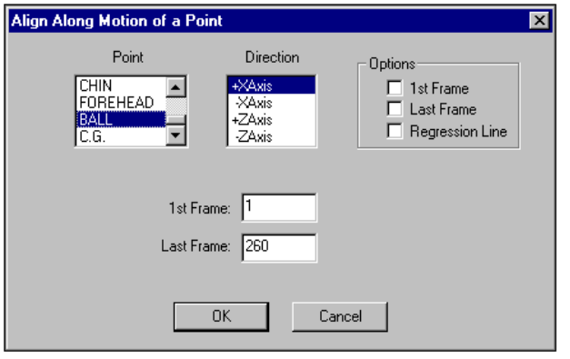

- Select the ball in the Point table and +X axis in the Direction table. The 1st Frame would be set to any frame up to the impact with the golf club while the Last Frame would be set to the last frame in the sequence where the ball is still visible (the farthest point of flight).
Several additional Options are also available for the align function. Selecting the 1st Frame option automatically sets the 1st Frame field to the first image in the sequence. Likewise, selecting the Last Frame option will automatically set the Last Frame field to the last frame in the sequence. In either case, the align software uses only the two points specified to determine the motion of a joint that will be aligned with the selected axis. When the Regression Line option is selected a regression line fitted to the motion using all frames is determined and used to determine the axis of motion.
- Selecting the OK button will align the golfer so that the path of the golf ball (projected in the horizontal plane) is aligned with the +X axis.
- Select the SAVE 3D command from the TOOLS menu to save the rotated data to an APAS 3D file. By default, the original file name will be entered when selecting the Save 3D command. If the OK button is selected at this point, the original file will be replaced with the rotated data. However, the user can also enter any other filename, thus keeping the original file intact. In this case, the APAS software will generate a matching CF file.

SAVING A DISPLAY FILE
Once the Display analysis file has been created, the entire file can be saved as a project (*.DIS) file for later use. The SAVE/SAVE AS commands can be used to save all the information that is used to create the analysis. This includes, MVC channel, Trigger channel, partitioning information as well as the associated analog and 3D files. There are two options for saving the DIS file:
1. Choose the SAVE command from the FILE menu. This command will Save the current information using a sequentially numbered default file name (default1.dis, default2.dis etc.) and Save it to the current drive and directory. The *.DIS extension will be added automatically.
OR...
2. Select the SAVE AS commands from the FILE menu. The Save As dialog box will appear showing the current file name, directory, drive and file type. At this point, you can enter the desired name for the Display file. Please note that the file must have the DIS extension.

RESTORING PREVIOUSLY CREATED DISPLAY FILE
Display files can be created and saved to retain the necessary information for displaying the biomechanical analysis. Files can then be Restored at a later time for comparison and/or analysis. There are two methods to Restore a previously created Display file:
1. Choose the OPEN command from the File menu. The OPEN File Dialog box will appear. Select the desired drive, directory and *.DIS file and click the OK button.
OR...
2. Select the File Open icon from the Display Tool Bar. The OPEN File Dialog box will appear. Select the desired drive, directory and *.DIS file and click the OK button.

DISPLAY OPTIONS

CHANGING THE FONT
The FONT parameters can be changed by the following process:
1. Select the FONT command from the OPTIONS menu. You will be presented with a Font menu of the available options. The options include Font, Font Style, Size, Effects and Script. Select the desired options with the left mouse button. Press the OK button to save the selected choice. Select the CANCEL button to abort this menu without saving the changes.

MISCELLANEOUS OPTIONS
The DISPLAY program options can be changed by the following process:
- Select the MISC command from the OPTIONS menu. The Select Program Options menu will appear.
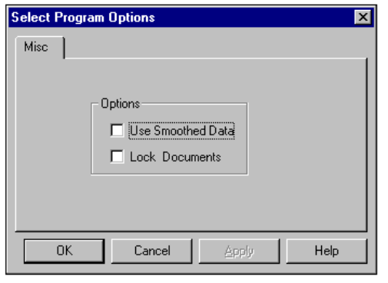
Use Smoothed Data
When this option is selected, the DISPLAY module will always use the smoothed data (assuming it exists) for presentation. For example, it is possible to specify that smoothing be done automatically (using default values) as the data is being processed in the Transform module. If the "Use Smoothed Data" option is selected in the Display module, the program will use the "smoothed" data even if the Filter module was never directly accessed.
Lock Documents
It is often desirable to have more than one document active at a time. A "document" is a file created using either the ARIEL Display module (*.dis file) or the ARIEL EMG module (*.emg file). Each document will have a set of data sets to graph. For example, a single gait analysis might consist of three separate documents:
1. One *.dis file for kinematic data obtained using the 3D option in the Display module.
2. Another *.dis file for force platform data created using the Display module.
3. Electromyogram (EMG) data obtained using the EMG program
All three documents could be opened simultaneously in the Display module. If the "lock" option is selected, then commands such as Frame Advance and Reverse, Rewind, FF, Play etc. are applied to all open documents. If not, the command is only applied to the active document. Graphs, tables, stick figures within a single document are always locked.

DISPLAY QUICK REFERENCE
CREATING A NEW DISPLAY PROJECT
1. Select FILE, NEW (or the New Document icon in the Tool Bar) to Open a new *.DIS document.
- Select FILE, ANALOG to open the desired analog file.
- Click on the NEW-A/D button below the "grid" and select a Save Trial and Channel from the active Analog file. Select the OK button to enter the selected data set to the active data set display.
- Repeat Step #3 to select all data sets of interest.
- Mark individual entries as either active or inactive by clicking the cursor in the 1st column of the grid. Active channels will be graphed and displayed for analysis.
- Mark an individual entry as the Maximum Voluntary Contraction (MVC) by clicking the 2nd column of the grid.
- Mark an individual entry as the Trigger channel by clicking the 3rd column of the grid.
- You are now ready to Graph, Export or Save the Display project.
GRAPHING DISPLAY DATA
- Select GRAPH, and the desired Graph type. Available choices are DATA, AVG/RMS, INTEGRAL and POWER.
- Specify the desired Graph options and select OK to display the graphed data.
- Repeat Step#1 for desired additional graphs.

EXPORTING DISPLAY DATA
Data can be exported to a Worksheet file as well as to an ARIEL format Analog file.
WORKSHEET
1. Select EXPORT, WORKSHEET, NEW to create a new worksheet file. Select EXPORT, WORKSHEET, OPEN to append to an existing worksheet file.
2. Select EXPORT, WORKSHEET, SAVE to save the desired data to the active worksheet.
3. Enter the desired Export Information and select OK to proceed.
- Select EXPORT, WORKSHEET, CLOSE to close the active worksheet
ANALOG
1. Select EXPORT, ANALOG, NEW to create a new .ANA file. Select EXPORT, ANALOG, OPEN to append to an existing Analog (.ANA) file.
2. Select EXPORT, ANALOG, SAVE to save the desired data to the active Analog file.
3. Enter the desired Trial ID Caption and select OK to proceed.
- Select EXPORT, ANALOG, CLOSE to close the active Analog file.

SAVING A DISPLAY PROJECT
- Select FILE, SAVE AS to save the Display project.
- Select FILE, EXIT to exit the Display program.

DISPLAY MENUS
Listed below are the various menus for the DISPLAY program. Select the desired menu to see a description of the available commands for each menu.

FILE COMMAND MENU
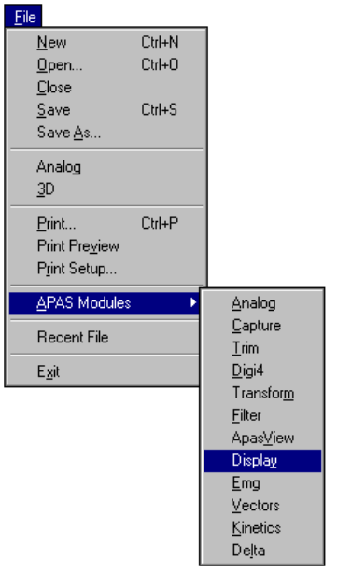
New
Selected to open a new *.DIS file for creating an DISPLAY project.

Open
Select the OPEN command to open an existing *.DIS file. . When this option is selected, the Open File dialog box will appear.

Close
Select the CLOSE command to close the currently open file.

Save
Select the SAVE command to SAVE the current *.DIS project file. When this option is selected, the Save File dialog box will appear.

Save As
Selected to SAVE the current file AS another name.

Analog
Selected to open a previously created ANA format ANALOG file to be used for the DISPLAY analysis.

3D
Selected to open a previously created 3D format DIGITIZED file to be used for the DISPLAY analysis.

Print
Select the Print command to send the current file to a printer.

Print Preview
Selected to check or examine the positioning on one or more pages. When you give the Print Preview command, a new window will be open showing the document position as it would appear on paper. To close the Print Preview window, select the Cancel button to go to the previous mode.

Print Setup
Selected to adjust the printer settings prior to issuing the PRINT command.

APAS Modules
Selected to open additional APAS modules while keeping the current program open. When this command is selected, the user will be presented with a list of APAS modules.

Recent File
Selected to open one of the most RECENT FILEs that were used. Files are selected by highlighting the desired file name and left-clicking the mouse. The highlighted file can also be selected by pressing the ENTER key.

Exit
Selected to EXIT the DISPLAY program and return to the APAS group in Microsoft Windows program manager.

EDIT COMMAND MENU
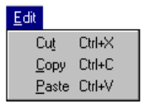

Cut
Select the CUT command to remove the selected item and temporarily copy it to the Windows Clipboard. The items are placed in the clipboard so that it can be Pasted into another area of the same application or into another Windows application. To avoid losing this item, you should Paste it before performing any additional editing.

Copy
Select the COPY command to make a COPY of the selected item and temporarily copy it to the Windows Clipboard. The items are placed in the clipboard so that it can be Pasted into another area of the same application or into another Windows application. To avoid losing this item, you should Paste it before performing any additional editing

Paste
Select the PASTE command to insert a copy of the item currently in the Windows clipboard. This item could have been cut or copied from almost any Windows application.

VIEW COMMAND MENU
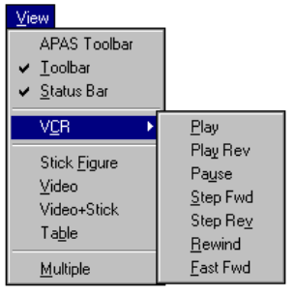
APAS Toolbar
Selected to toggle on/off the APAS toolbar. When this option is active, the APAS toolbar will be displayed and allow the user to select additional APAS modules while keeping the current program open. The toolbar can be positioned to the desired position by dragging it with the mouse.

Toolbar
Selected to display or remove the Display Toolbar located at the top of the view window. This command acts like a toggle switch. The check mark next to the Toolbar command indicates that the Toolbar will be visible. Selecting this option again, will remove the check mark and remove the Toolbar from view.

Status Bar
Selected to display or remove the Display Status Bar located at the bottom of the view window. This command acts like a toggle switch. The check mark next to the Status Bar command indicates that the Status Bar will be visible. Selecting this option again, will remove the check mark and remove the Status Bar from view.

VCR
Selected to activate "VCR-like" commands for animating the Display data. When this command is selected, an additional menu is displayed for the various animation options.

Stick Figure
Selected to create a new view window for displaying the stick figure.

Video
Selected to create a new view window for displaying the video image.

Video + Stick
Selected to create a new view window for displaying the stick figure superimposed on top of the video image.

Table
Selected to create a new view window for displaying the curve data in a table format. This format is similar to an Excel spreadsheet.

Multiple
Selected to toggle between Single and Multiple stick figures. When this option is selected and the Stick Figure option is activated, the stick figure will be displayed in the Multiple format. If this option is not selected, the stick figure will be displayed in the Single format. The current selection is indicated in the Display Tool Bar.

TEMPLATE COMMAND MENU
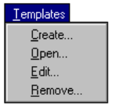
Create
Selected to create a new template file. When this option is selected, an additional menu will be presented that allows analysis templates to be created and saved.

Open
Selected to open an existing template for use with multiple data files. This command allows the user to only change the data files used for the template and then display the windows for the selected data files.

Edit
Selected to edit any of the template parameters and save the changes under the same template name.

Remove
Selected to Remove any of the existing templates. Multiple templates can be selected and deleted if desired.

GRAPH COMMAND MENU
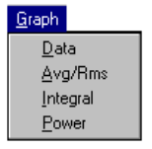
Data
Selected to display information pertaining to the “raw” data signal. When this option is selected, an additional menu will be presented that allows changing the display parameters.

Avg/RMS
Selected to display the combined Average and RMS curves calculated from the “raw” data signal. When this option is selected, an additional menu will be presented that allows changing the display parameters.

Integral
Selected to display the Integral curves calculated from the “raw” data signal. When this option is selected, an additional menu will be presented that allows changing the display parameters.

Power
Selected to display the Power spectrum curves calculated from the “raw” data signal. When this option is selected, an additional menu will be presented that allows changing the display parameters.

EXPORT COMMAND MENU
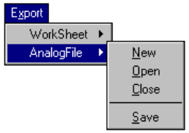
Worksheet
Selected to activate the worksheet option for data export. This option allows active data to be exported to a worksheet for further data processing.

Analog File
Selected to activate the Analog File option for data export. This option allows processed data to be exported to the *.ANA format file and saved as a new data file.

New
Selected to create a New worksheet/analog file for data export. When this command is selected, a menu will be presented to specify the drive, folder and file name for the worksheet/analog file.

Open
Selected to Open a worksheet/analog file for data export. When this command is selected, a menu will be presented to specify the drive, folder and file name for the worksheet/analog file.

Close
Selected to close the currently open worksheet/analog file.

Save
Selected to SAVE the selected date to the specified worksheet/analog file.

TOOL COMMAND MENU
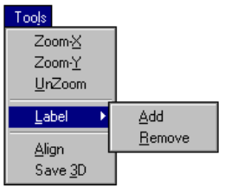
Zoom-X
The Zoom X command is selected to zoom the X-axis of the currently displayed graph. The Zoom command can be selected numerous times to maximize the resolution of the graph.

Zoom-Y
The Zoom Y command is selected to zoom the Y-axis of the currently displayed graph. The Zoom command can be selected numerous times to maximize the resolution of the graph.

UnZoom
The Unzoom command is selected to remove all zooming commands on the currently displayed graph.

Label
The Label command is used to select from a number of specialized labeling options. When this command is selected, an additional menu will be displayed to either Add or Remove the labels.

Align
The Align command is used to orient the stick figure image in a direction determined by the data points themselves, rather than along one of the coordinate axes.

Save 3D
The Label command is used to save the “aligned” data to a 3D file. By default, the original file will be replaced, however, the user has the option to save the changes to a new file, thereby keeping the original file intact.

WINDOW COMMAND MENU
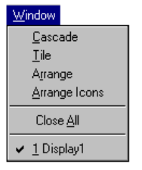
Cascade
Selected to arrange all programs that are window sized in an overlapping CASCADE. This will not arrange a program that has been minimized to an icon.

Tile
Selected to re-size the program windows to fit side-by-side on the screen. Since Windows will include all programs that are window-sized in the tile setup, it is best to minimize all programs that are not currently being used so it will not take up space on the screen.

Arrange
Selected to ARRANGE the Display views.

Arrange Icons
Selected to automatically ARRANGE ICONS in a straight row. The user has no control over where the icons are placed.

Close All
Selected to Close all the active view windows.

OPTIONS COMMAND MENU
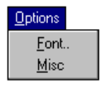
Fonts
Selected to set the Font, style, size and effects for the displayed graphics.

Misc
Selected to specify selected program options. These include specifying data sets to be used for display and locking multiple projects.

HELP COMMAND MENU
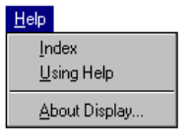
Index
Selected to provide an INDEX of Help related topics.

Using Help
Selected to provide instructions on using the Help Windows.

About DISPLAY
Provides information about the DISPLAY program

